Senses (chapter 10) Page 1

Sensory receptors

The cells that detect a sense stimulus (light, sound, taste, smell, touch,
etc.) and then change the stimulus into a nerve signal

• The sensory receptor sends its nerve signal to the brain

• In some sense organs the sensory receptors are sensory neurons.
The neuron detects the stimulus and carries the nerve signal to the
brain

√ In other sense organs, the sensory receptor is two cells: A
specialized epithelial cell (detects the stimulus) and a sensory
neuron (carriers the nerve signal)

• There are many types of sensory receptors. Each sensory receptor
specializes in detecting just one specific type of sense stimulus

Cutaneous receptors

The sense receptors in the skin for the sense of touch

• There are several types of cutaneous receptors

√ Pressure receptors (sense touch and texture)

√ Temperature receptors (different ones for sensing hot and
sensing cold)

√ Nociceptors/pain receptors (sense tissue damage)
Fig 10.4 and table 10.2

Proprioreceptors

Sensory receptors in muscles and joints that sense the body part’s
position

Senses (chapter 10) Page 2

Eyes (eyeballs)

The two ball-shaped visual organs

• Each eye has external muscles that control its voluntary movements

• Iris = The colorful structure (made of smooth muscle) that controls the amount of
light entering the eye by changing the size of the pupil

√ Pupil = The tiny opening in the iris where light enters the eye

• Humors = The clear fluids that fill the hollow areas of the eye

• Tunics = The three layers that make up the wall of the eye

√ Outer tunic = The sclera (white dense connective tissue) and the cornea
(a clear region in front of the pupil)

√ Middle tunic = The choroid coat (blood vessels)

√ Inner tunic = The retina (the light-sensing layer; made of nervous tissue)

• Lens = The structure that focuses light onto the retina

√ The lens is attached to a round group of muscles called the
ciliary body that adjusts the lens' focus

• The optic nerve conducts visual signals from the retina to the brain
Figs 10.27, 10.28, 10.45; Table 10.4

Special senses Page 3

Retina

The innermost tunic of the eye. The retina contains nervous tissue that
converts light into nerve signals

• The retina contains millions of photoreceptors (light-detecting
cells)

√ Rods = Black and white detecting photoreceptors

√ Cones = Color detecting photoreceptors

• Visual nerve signals from the photoreceptors pass through two non-light
detecting neuron layers of the retina (the bipolar cells and the ganglion cells)
before exiting the back of the eyeball through the optic nerve

• The blind spot (also called the optic disc) is where the optic nerve
exits the retina (there are no photoreceptors so no vision at this spot)
Figs 10.27, 10.36, and 10.37a

Color vision

There are only three cone types: Red-detecting, blue-detecting, and green
detecting

• All other colors that we see (yellow, orange, purple, etc.) are
produced by combinations of red, blue, and green signals

• Color blindness = Lack of one or more cone types

√ Much more common in males than females
Figs 10.36, 10.37a, and 10.41

Special senses Page 4

Detection of light

Photoreceptors contain opsin pigments (light-absorbing molecules)

• Opsins change shape (“bleach”) when struck by light

√ Bleaching generates the nerve signal

√ The bleached shape quickly reverts to unbleached shape
so that the photoreceptor can detect light again
Figs 10.38 and 10.39

Objects are in focus when their light's focal point is on the retina. The ciliary body can change the shape of the lens to control where the light's focal points are located.

• When the ciliary body is relaxed the far object focal point is on the retina and
near object focal point is behind the retina

√ This means that far objects are in focus and near objects are out of focus
when the ciliary body is relaxed

• When the ciliary body muscles contract the lens shape is changed so that all focal
points shift forward (the far object focal point is now in front of the retina and
the near object focal point is now on the retina). This is called Accommodation.

√ This means that far objects are out of focus and near objects are in
focus when the ciliary body is contracted
Figs 10.34 and 10.35

Special senses Page 5

Hyperopia (farsighted)

A vision disorder where far objects can be focused but near objects cannot

• Cause: The lens has an abnormal shape so that (when the ciliary body is relaxed)
all focal points (near and far objects) are behind the retina. All objects are
therefore out of focus when the ciliary body is relaxed.

• The far object focal point can be brought onto the retina by contraction of the
ciliary body, but the near object focal point cannot be brought onto the retina.

√ So far objects can be focused by contraction of the ciliary body but near
objects cannot

• Corrected by glasses/contact lenses that move all focal points forward
Fig 10.35

Myopia (nearsighted)

A vision disorder where near objects can be focused but far objects cannot

• Cause: The lens has an abnormal shape so that (when the ciliary body is relaxed)
the near object focal point is on the retina and the far object focal point is in front
of the retina.

√ Therefore near objects are in focus but far objects are out of focus when
the ciliary body is relaxed.

• Contraction of the ciliary body shifts all focal points in front of the retina. All
objects are therefore out of focus when the ciliary body is contracted.

• Corrected by glasses/contact lenses that move focal points backward
Fig 10.35

Special senses Page 6

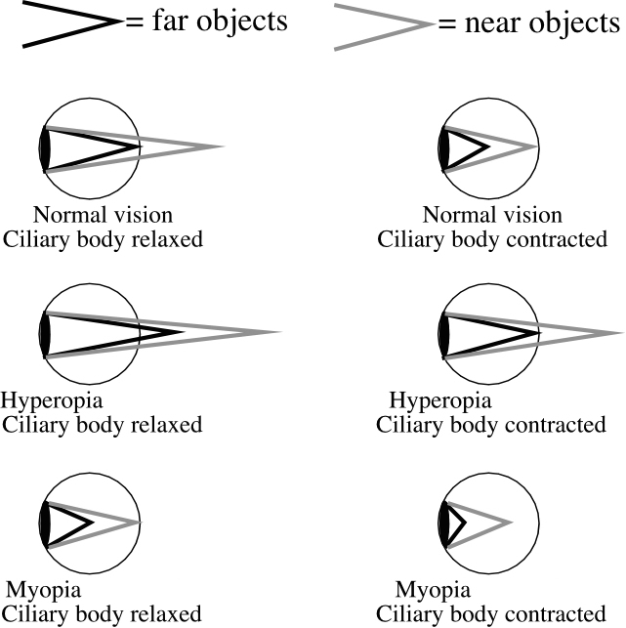

Special senses Page 7

Ear structures

• The outer ear = The pinna (the folded skin and cartilage visible as
the “ear” on the side of the head) and the auditory canal (the tube
leading inward to the middle ear)

• The middle ear = The tympanic membrane (ear drum) and the
ossicles (three tiny bones)

• The inner ear = A group of three chambers inside the temporal bone
for the senses of hearing and equilibrium. The three cavities are:

1) The semicircular canals = 3 curved tubes at the top of the
inner ear that are involved in equilibrium

2) The vestibule = The central chamber of the inner ear; it is
involved in equilibrium

3) The cochlea = A snail shell shaped tube below the vestibule;
It is for the sense of hearing

All three inner ear cavities are filled with fluids (mostly endolymph). All
three cavities contain hair cells (cells with hair-like cilia that generate nerve
signals when the hairs bend).
Figs 10.12 and 10.18

Sound

Vibrations in air

• Pitch (highness or lowness of sound) = The number of vibrations per
second (the frequency)

Special senses Page 8

Hearing

Detection of sound vibrations in the air

• Vibrations traveling through the air are channeled by the outer ear into
the auditory canal. The vibrations then pass through the tympanic membrane and
the ossicles of the middle ear. The vibrations then enter the inner ear at the
vestibule and become vibrations in the endolymph of the cochlea
√ The vibrations in the cochlea generate hearing sensory nerve signals,
which travel to the brain in the cochlear nerve

√ The brain interprets these sensory signals as sounds
Figs 10.12 and 10.18

Organ of Corti

The structure inside the cochlea that changes vibrations into nerve signals

• Each organ of Corti contains hair cells that sit on the flexible basilar membrane
but their hairs are attached to the inflexible tectorial membrane

• The endolymph vibrations in the cochlea cause the basilar membrane to
vibrate

• The vibrations in the basilar membrane bend the hair cell hairs, which
generates sound sensory nerve signals.
Fig 10.22

Special senses Page 9

Equilibrium

The sense of balance and movement

• Equilibrium is sensed by the otolith organs in the vestibule and by
the semicircular canals

The otolith organs (the utricle and the saccule)

Organs in the vestibule that sense linear movement (straight line
movement, such as up/down, left/right, backward/forward) and that
provide the ability to stand with balance

• Inside each otolith organ are structures called macula. Each macula contains hair
cells encapsulated in a gel that contains otoliths (dense granules of calcium)

√ Linear motion causes movement of the otoliths, which bends
the gel and the hair cell cilia, which generates a sensory nerve signal

√ Leaning and tilting of the head also causes the otoliths to move, providing
a sense of balance
Fig 10.15

The semicircular canals

Three half-circle canals that sense rotational movement (movement in circular
directions, such as spinning, turning, rotating)

√ The semicircular canals are filled with endolymph

√ Hair cells enclosed in a gelatinous cap (the cupula) are
located at the enlarged entrance each canal (the ampulla)

√ Rotation makes the endolymph flow, which bends the cupula,
which bends the hair cell hairs, which generates a sensory nerve signal
Figs 10.12 and 10.16

Special senses Page 10

Taste and smell senses
Both senses use chemoreceptors (sensory receptors that detect specific
molecules)

• Each chemoreceptor specializes in sensing just one type of molecule

√ Many types of chemoreceptors are present in the nose and the mouth so
many types of molecules can be smelled/tasted

Olfactory (smell) sense

The roof of the nasal cavity is lined with olfactory receptors
(chemoreceptors that detect molecules in the air)

√ There are about 380 different kinds of olfactory receptors,
each specializing in detecting a different molecule
Fig 10.9
Gustatory (taste) sense

• Taste buds = Clusters of taste cells (chemoreceptors that
detect molecules dissolved in saliva) on the tongue

• There are five kinds of taste cells
√ Salty = Detects Na⁺ ions

√ Sweet = Detects sugars (monosaccharides and disaccharides)

√ Sour = Detects acids (H⁺ ions)

√ Bitter = Detects alkaloid plant molecules (some of which are
poisonous) and bases

√ Umami = Detects meaty tastes (amino acids of proteins)

• Much of our “taste” sensation is actually smelling of food as we eat
Figs 10.7 and 10.8

