Respiratory system labs (Labs 42 and 43)
Do all of the following in exercises 42 and 43.

Lab 42
Figure 42.1: Skip 7 and 8. For 6 and 11, just name the organs shown in orange. 2 is the anatomy term for the mouth.

Figure 42.2: Label all blanks.

Assessment A: Answer all questions.

Assessment C: Answer all questions.

In addition to the above, Sketch and label the microscope slides of the trachea and the lung tissue that are on the side counter.

For the trachea slide, sketch and label the lumen, the epithelial tissue, the cartilage tissue, and the connective tissue. Refer to figures 42.3 and 42.4 for help interpreting this slide. Be as specific as possible about the type of epithelial tissue.

For the lung tissue slide, sketch and label the alveoli and the epithelial tissue. Refer to figure 42.6 for help interpreting this slide. Be as specific as possible about the type of epithelial tissue.

Lab 43
For lab 43, use the procedures that begin on the next page of this handout.. But you should still read lab 43 for background information and do the assessment questions for lab 43 that are listed below.

Assessment A: Skip questions 2, 3, 4, 5, 9, 11, and 12.
Assessment B: Skip questions 7 and 8.

Lung model activity
a) Obtain the mechanical lung model from the front desk.

b) Gently push up and down on the rubber sheet at the bottom of the model. Notice the effect this has on the pair of balloons inside the lung model. Answer the following questions about the lung model and its operation.

1) Describe what happens to balloons when you push up on the rubber sheet:

2) Describe what happens to the balloons when you pull down on the rubber
sheet:

3) The balloons in the lung model represent the ________ of the respiratory
system. The rubber sheet represents the __________ of the respiratory system. The upper part of the Y-shaped tube represents the __________, and the lower part of the Y-shaped tube represents the ___________ of the respiratory system. The plastic bell jar represents the __________ of the respiratory system.

B) Spirometry procedure
Obtain a laptop computer (with power supply), a spirometer (along with a bacterial filter and gray cardboard mouth tubes for the spirometer), and a box containing the green plastic Vernier LabPro interface (and a power supply and a USB cable).

A) Connecting the computer, the spirometer, and the Lab Pro box to one another

1) Connect the power cord to the computer and turn the computer on. Enter the laptop password if prompted.

2) Obtain a box that contains a black handheld spirometer (with a cable attached), a white plastic disposable bacterial filter (wrapped in a plastic bag), and gray disposable mouth tubes (in a ziplock baggie). See picture on next page.

3) Insert the white bacterial filter into the face of the spirometer that says Inlet. Next, insert a gray disposable mouth tube into the white bacterial filter. When these three are connected together correctly they look as shown below.
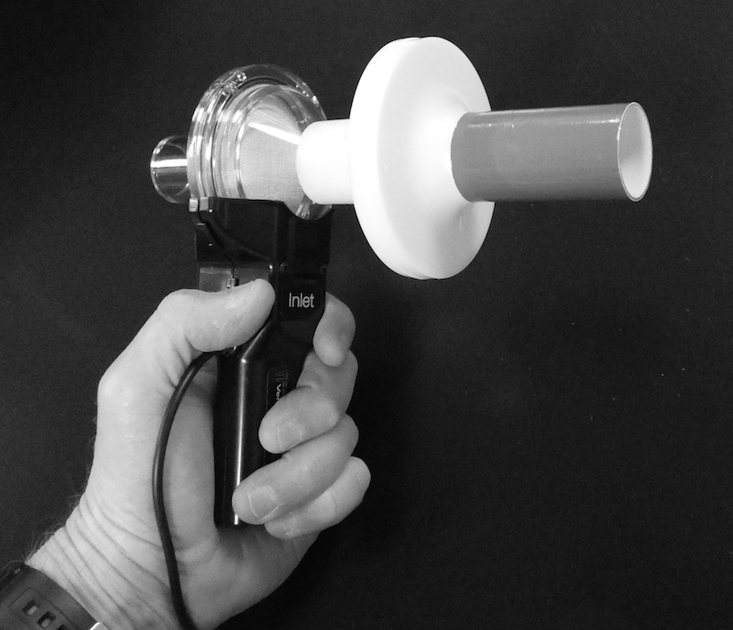

4) Open the white cardboard box that says Vernier LabPro. It contains a green plastic Vernier LabPro interface, a power chord for the green interface, and a USB cable. Plug the power cord into the green plastic Vernier LabPro interface.

5) Plug the spirometer chord into the green Vernier LabPro interface.

6) Use the USB cable to connect the green LabPro interface to the laptop.

B) Setting up the Logger Pro app for spirometry measurements

1) On the computer desktop, open the Logger Pro app by double clicking its icon.

2) On the top menu bar do File>Open>HumanPhysiologyWithVernier. Then select 19LungVolumes from the list of experiments. Then click the Open button.

3) A new screen appears that has Flow Rate on the left and Flow Rate versus Time on the right.

4) On the top menu bar is a small white window that says 1:FlowRate. Next to it is a pull down menu arrow. Click that pull down arrow and change the white window to Lung Volume. A new screen appears that has Baseline Adjust on the left, Lung Volume and Capacity graph on the upper right, and Flow Rate graph on the lower right.

5) Click on the Lung Volume graph. Anchor squares appear at its edges. Click-drag the anchor squares to enlarge the Lung Volume graph to cover up the Flow rate graph (you will not need the flow rate graph so it is okay to cover it up). When done correctly, the screen should look as shown below.

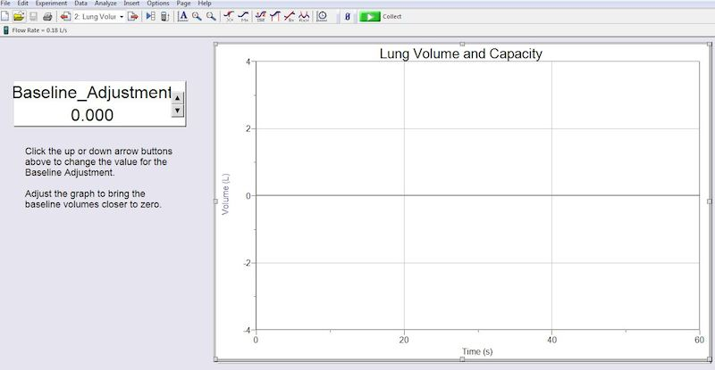

6) Adjust the Lung Volume graph so that the y-axis (the Volume axis) goes from -4 at the top to 4 at the bottom. This is done by clicking the Volume(L) words next to the y-axis. A small menu appears. On that small menu select More. A new window appears. On the right side of that new window is where you can set the Top and Bottom values to -4 liters at the top and 4 liters. Then click Okay.

7) Adjust the Lung Volume graph so that the x-axis (the time axis) goes from 0 to 60 seconds. This is done by clicking Time(S) words next to the x-axis. A small menu appears. On that menu select More. A new window appears. On that new window set the x-axis time to go from 0 to 60. Then click Okay.

8) If everything has been done correctly your screen should appear as is shown in the image on the top of this page.

C) Calibrating the baseline

1) Click the green Start button in the top menu bar to begin an experimental run. The button should turn red after you click it. If a pop up window appears, select Erase and Continue.

2) The volunteer should now do the following in this order:

a) Inspire a normal breath of air.

b) Put their mouth onto the gray mouth tube of the spirometer.

c) Begin normal breathing (normal expirations and normal inspirations) into the spirometer tube and keep doing normal breathing into the tube.

3) A curve of the volunteer's breath waves should begin to appear on the chart graph. The volunteer should continue normal breathing into the spirometer for 1 minute (until the red button becomes green). If the curve of breathing waves goes off the top or bottom of the chart graph before 1 minute then you may stop the experimental run early by clicking the red button.

4) Often the curve is not horizontal on the chart graph. In other words, the curve often slopes downward or upward, as shown below:
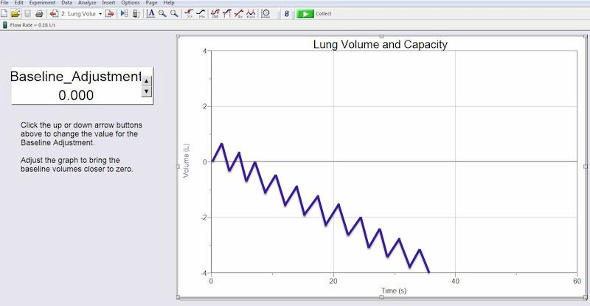

5) On the baseline adjustment window there are up and down arrows. Click on those arrows to make the curve as horizontal as possible. In other words, try to make the curve go along the horizontal zero line on the chart graph. You may not be able to make the whole curve horizontal, but try to make at least the first 4 or 5 breath waves horizontal (on the zero line), as is shown in the figure below.

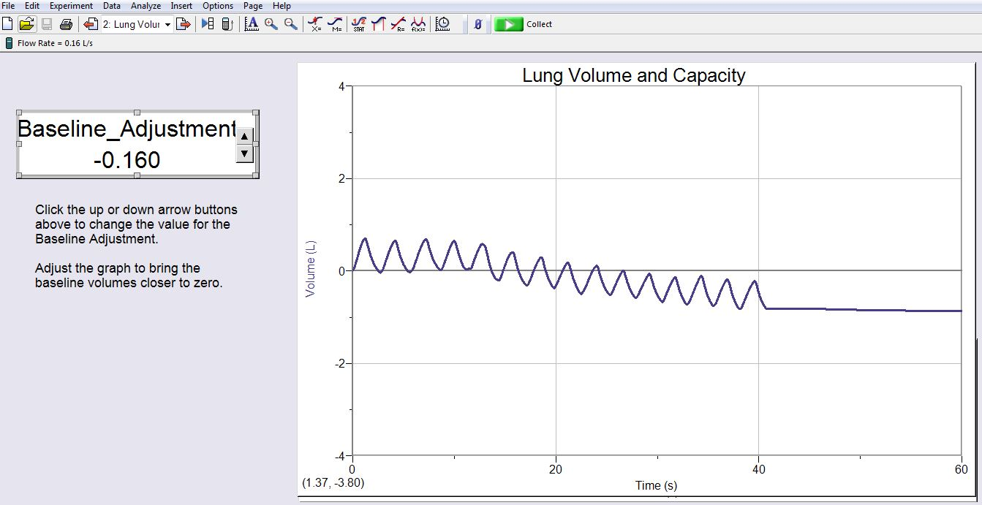

6) The baseline is now calibrated. In other words, the baseline adjustment that you set should be able to keep the first 4 or 5 breaths of your spirometry measurements horizontal for the rest of the experiment. But if you find that the first 4 or 5 breaths in any of your experimental runs are not close to horizontal then you should repeat this section (calibrating the baseline).

D) Measuring the volunteer's tidal volume (TV)

1) Click the green Start button in the top menu bar to begin an experimental run. The button should turn red after you click it. If a pop up window appears, select Erase and Continue.

2) The volunteer should now do the following in this order:
a) Inspire a normal breath of air.

b) Put their mouth onto the gray mouth tube of the spirometer.

c) Begin normal breathing (normal expirations and normal inspirations) into the spirometer tube and keep doing normal breathing into the tube.

3) A curve of the volunteer's breath waves should begin to appear on the chart graph. If the first 5 breath waves are close to horizontal then the volunteer should continue normal breathing into the spirometer for 1 minute (until the red button becomes green).

- If the first 5 breath waves are not close to horizontal then you need to recalibrate the
baseline. In this case, stop the experimental run early by clicking the red button then
recalibrate the baseline by repeating section (C).

4) If the first 5 breath waves are close to horizontal, then you are ready to find the tidal volume of one breath wave. First, click-drag to select the entire uphill slope of one breath wave. In other words, start click dragging at the bottom of one wave's uphill slope and end your click-drag at the top of the wave. A gray area appears on the part of the wave that you click-dragged. The gray selected area of the wave should appear similar to what is shown below.
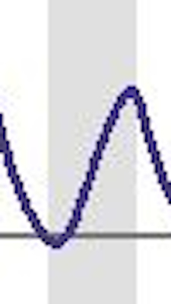

5) With the correct region of the breath wave selected in the gray area, click on the small STAT icon in the top menu bar (the STAT icon has a tiny blue curve with a 1 and a 2 in red). A small window appears. At the bottom of that window is a line of text that has ΔY followed by a number (see the figure below). The number after the ΔY is the volume (in liters) of that TV breath.
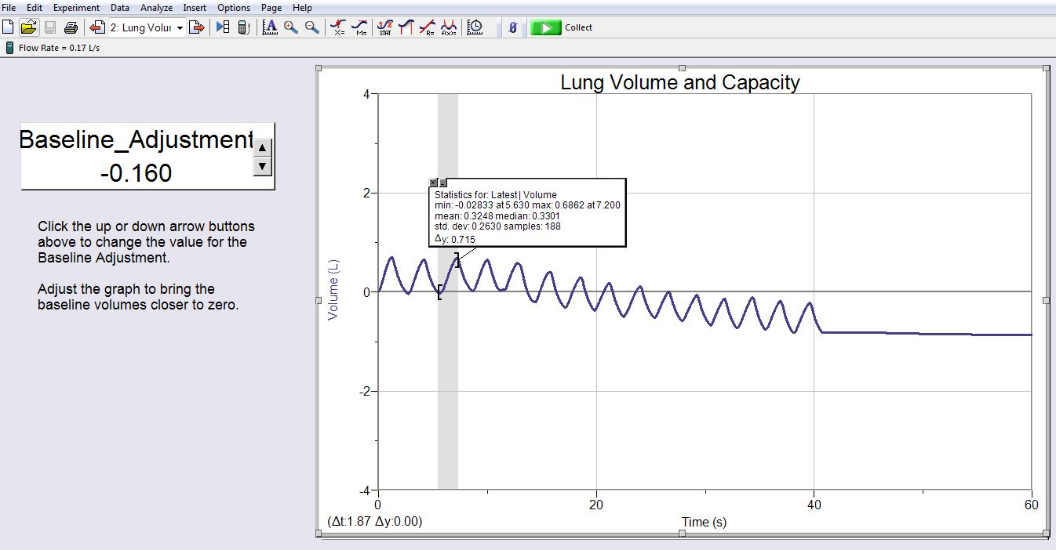

6) Record the volume of that TV breath in the data table at the end of this handout. But before you record the volume convert it from liters to milliliters by multiplying it by 1000. After you have recorded the volume, close the small window on the chart graph by clicking the tiny X in its upper left corner.

7) In the data table, calculate the volunteer's percent of predicted for TV.

E) Measuring the volunteer's inspiratory reserve volume (IRV)

1) Click the green Start button in the top menu bar to begin an experimental run. The button should turn red after you click it. If a pop up window appears, select Erase and Continue.

2) The volunteer should now do the following in this order:
a) Inspire a normal breath of air.

b) Put their mouth onto the gray mouth tube of the spirometer.

c) Begin normal breathing (normal expirations and normal inspirations) into the spirometer tube and keep doing normal breathing into the tube.

3) A curve of the volunteer's breath waves should begin to appear on the chart graph. If the first 5 breath waves are close to horizontal then the volunteer should proceed to step (4), below.

- If the first 5 breath waves are not close to horizontal then you need to recalibrate the baseline. In this case, stop the experimental run early by clicking the red button then recalibrate the baseline by repeating section (C).

4) After the 5 normal breath waves in step (3), the volunteer should do the following into the spirometer:
a) After a normal expiration, do a maximum inspiration. A maximum inspiration means that the volunteer should try to fill their lungs with absolutely as much air as their lungs can possibly hold

b) After their maximum inspiration, the volunteer can resume normal breathing again.

5) After step 4 is completed, the experimental run can be stopped by clicking the red button.

6) The curve on the chart graph should look something like what is shown below (but with no red arrow):
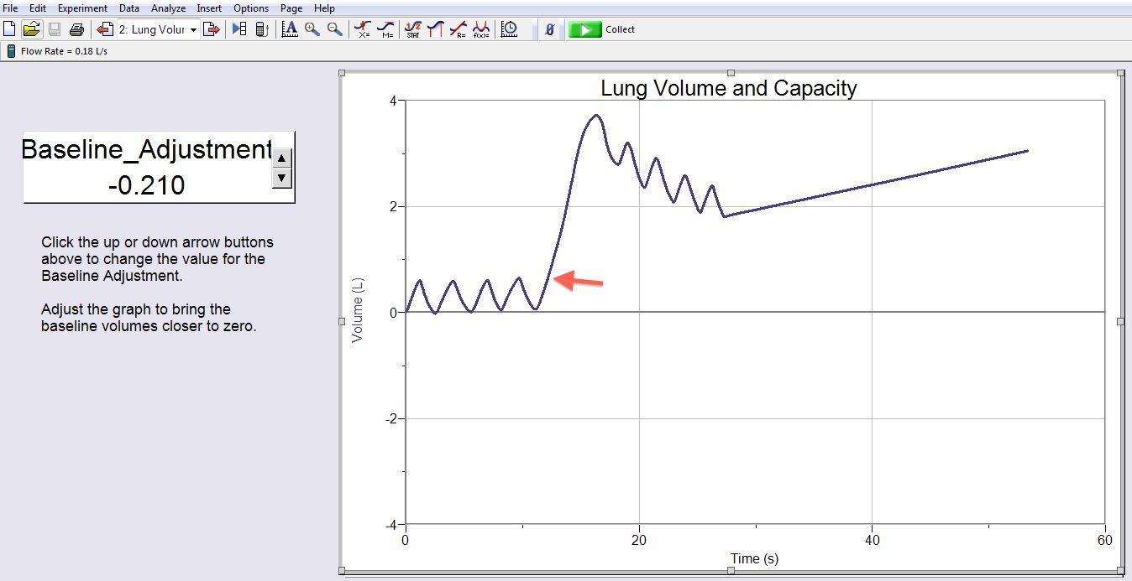

7) You are now ready to find the inspiratory reserve volume. Follow these steps:
a) Place the cursor on the upslope of the big inspiration wave, but place it at the level of the
peaks of the normal breaths (where the red arrow is pointing in the figure above).

b) Click-drag from that location on the upslope to the top of the big inspiration wave. If done correctly, the gray selected area of the wave should appear as shown below.
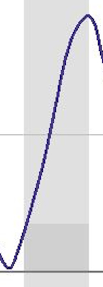

8) With the correct region of the breath wave selected in the gray area, click on the small STAT icon in the top menu bar. A small window appears. At the bottom of that window is a line of text that has ΔY followed by a number (see the figure below). The number after the ΔY is the volume (in liters) of that IRV breath.
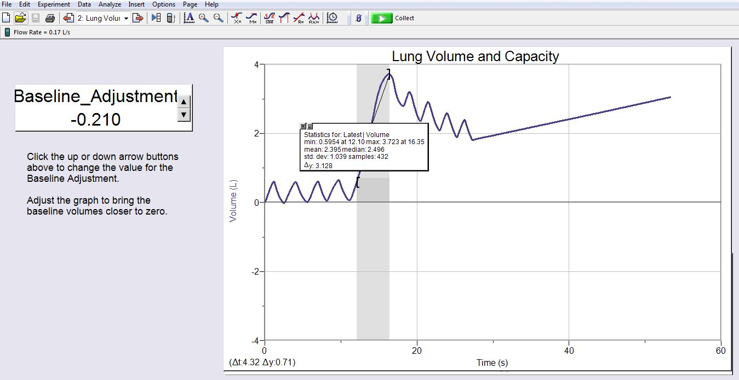

9) Record the volume of that IRV breath in the data table at the end of this handout. But before you record the volume convert it from liters to milliliters by multiplying it by 1000. After you have recorded the volume, close the small window on the chart graph by clicking the tiny X in its upper left corner.

10) In the data table, calculate the volunteer's percent of predicted for IRV.

F) Measuring the volunteer's expiratory reserve volume (ERV)

1) Click the green Start button in the top menu bar to begin an experimental run. The button should turn red after you click it. If a pop up window appears, select Erase and Continue.

2) The volunteer should now do the following in this order:
a) Inspire a normal breath of air.

b) Put their mouth onto the gray mouth tube of the spirometer.

c) Begin normal breathing (normal expirations and normal inspirations) into the spirometer tube and keep doing normal breathing into the tube.

3) A curve of the volunteer's breath waves should begin to appear on the chart graph. If the first 5 breath waves are close to horizontal then the volunteer should proceed to step (4), below.

- If the first 5 breath waves are not close to horizontal then you need to recalibrate the baseline. In this case, stop the experimental run early by clicking the red button then recalibrate the baseline by repeating section (C).

4) After the 5 normal breath waves in step (3), the volunteer should do the following into the spirometer:
a) After a normal inspiration, do a maximum expiration. A maximum expiration means that the volunteer should try to empty their lungs of absolutely as much air as their lungs can possibly expire.

b) After their maximum expiration, the volunteer can resume normal breathing again.

5) After step 4 is completed, the experimental run can be stopped by clicking the red button.

6) The curve on the chart graph should look something like what is shown below (but with no red arrow):
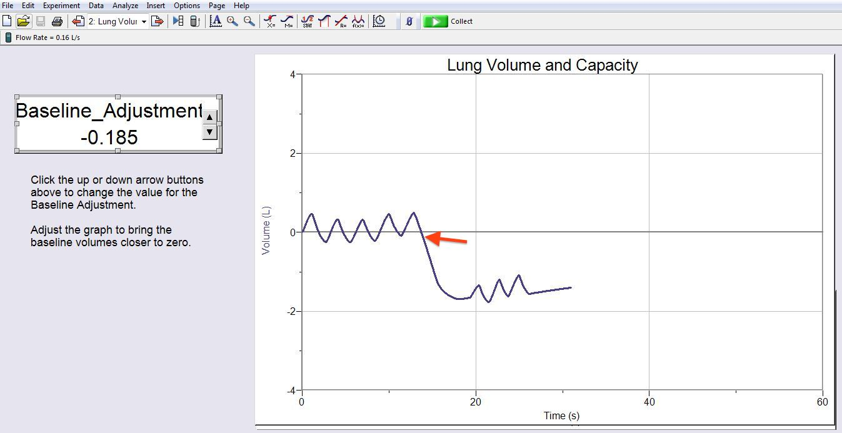

7) You are now ready to find the expiratory reserve volume. Follow these steps:
a) Place the cursor on the downslope of the big expiration wave, but place it at the level of the bottom of the nearest normal breath wave (where the red arrow is pointing in the figure above).

b) Click-drag from that location on the downslope to the bottom of the big expiration wave. If done correctly, the gray selected area of the wave should appear as shown below.
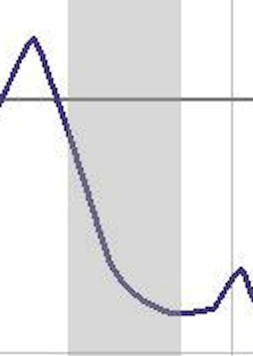

8) With the correct region of the breath wave selected in the gray area, click on the small STAT icon in the top menu bar. A small window appears. At the bottom of that window is a line of text that has ΔY followed by a number (see the figure below). The number after the ΔY is the volume (in liters) of that ERV breath.
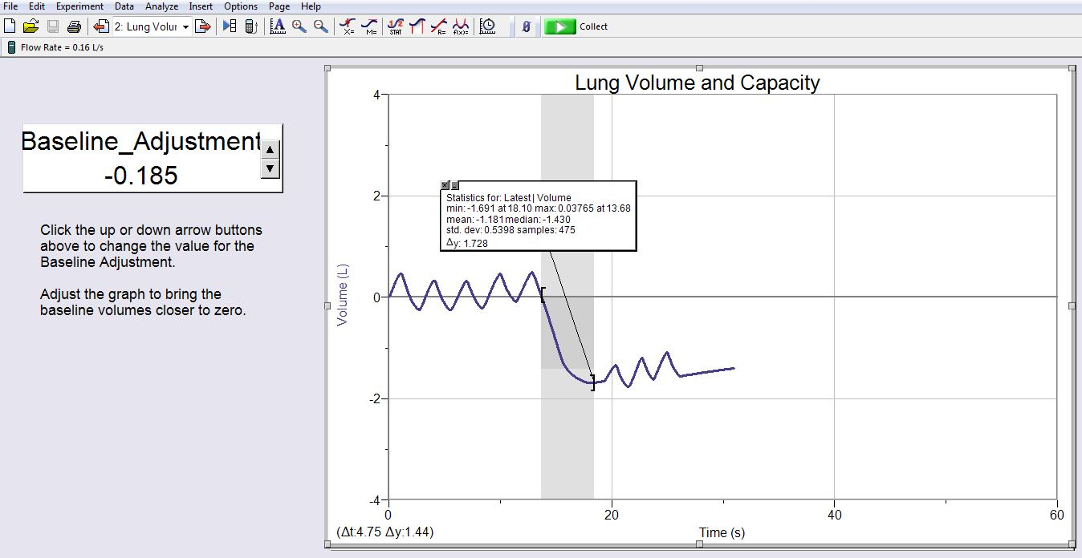

9) Record the volume of that ERV breath in the data table at the end of this handout. But before you record the volume convert it from liters to milliliters by multiplying it by 1000. After you have recorded the volume, close the small window on the chart graph by clicking the tiny X in its upper left corner.

10) In the data table, calculate the volunteer's percent of predicted for ERV.

G) Measuring the volunteer's vital capacity (VC)

1) Click the green Start button in the top menu bar to begin an experimental run. The button should turn red after you click it. If a pop up window appears, select Erase and Continue.

2) The volunteer should now do the following in this order:
a) Inspire a normal breath of air.

b) Put their mouth onto the gray mouth tube of the spirometer.

c) Begin normal breathing (normal expirations and normal inspirations) into the spirometer tube and keep doing normal breathing into the tube.

3) A curve of the volunteer's breath waves should begin to appear on the chart graph. If the first 5 breath waves are close to horizontal then the volunteer should proceed to step (4), below.

- If the first 5 breath waves are not close to horizontal then you need to recalibrate the baseline. In this case, stop the experimental run early by clicking the red button then recalibrate the baseline by repeating section (C).

4) After the 5 normal breath waves in step (3), the volunteer should do the following into the spirometer:
a) After a normal expiration, do a maximum inspiration. A maximum inspiration means that the volunteer should try to fill their lungs with absolutely as much air as their lungs can possibly hold

b) As soon as the volunteer has filled their lungs with a maximum inspiration, the volunteer
should then do a maximum expiration. A maximum expiration means that the volunteer should try to empty their lungs of absolutely as much air as their lungs can possibly expire.

c) After their maximum expiration, the volunteer can resume normal breathing again.

5) After step 4 is completed, the experimental run can be stopped by clicking the red button.

6) The curve on the chart graph should look something like what is shown below.
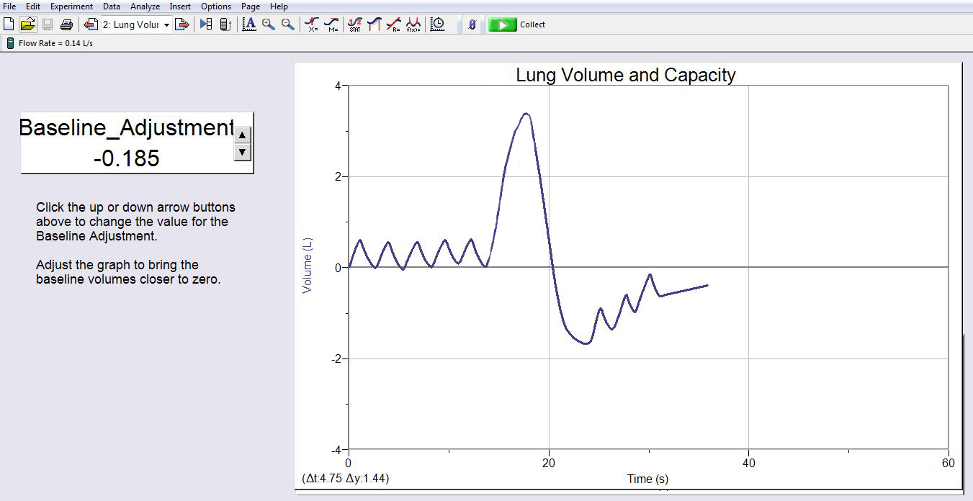

7) You are now ready to find the vital capacity. Follow these steps:
a) Place the cursor on the peak of the big inspiration wave.

b) Click-drag from that location on the peak to the bottom of the big expiration wave. If done correctly, the gray selected area of the wave should appear as shown below.

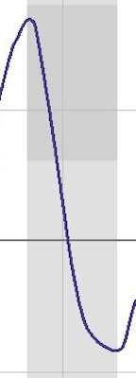

8) With the correct region of the breath wave selected in the gray area, click on the small STAT icon in the top menu bar. A small window appears. At the bottom of that window is a line of text that has ΔY followed by a number (see the figure below). The number after the ΔY is the volume (in liters) of that VC breath.
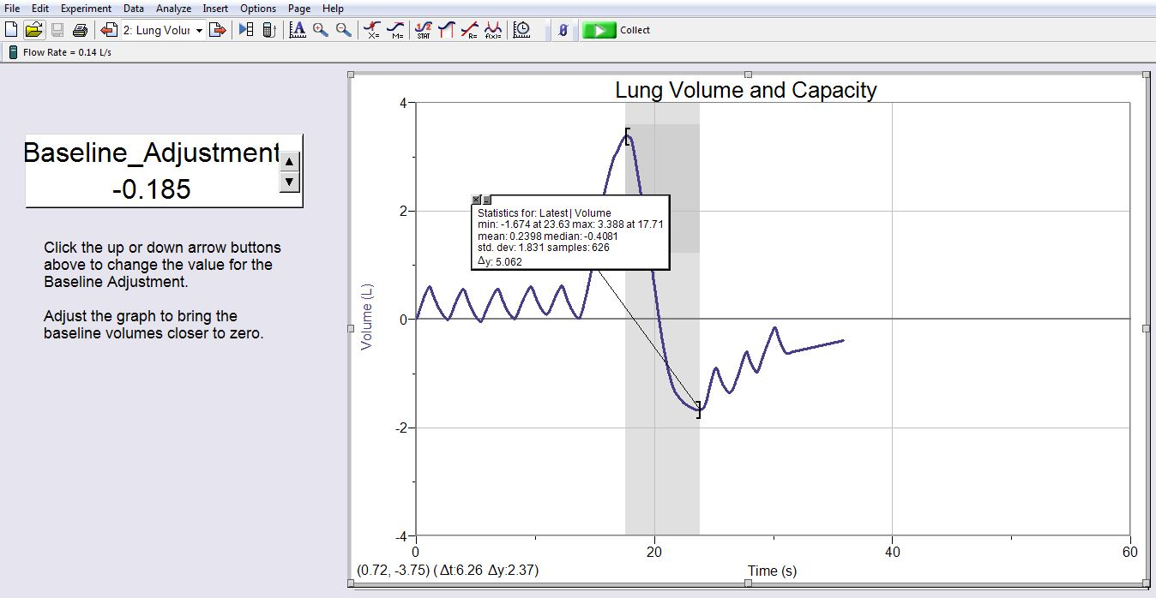

9) Record the volume of that VC breath in the data table at the end of this handout. But before you record the volume convert it from liters to milliliters by multiplying it by 1000. After you have recorded the volume, close the small window on the chart graph by clicking the tiny X in its upper left corner.

10) In the data table, calculate the volunteer's percent of predicted for VC.
(Note that you need to look up your volunteer's predicted VC in table 8.1 or table 8.2).

Spirometry data table:

Measurement: Predicted: Percent of predicted

Tidal Volume (TV): ml 500 ml %

Inspiratory Reserve Volume (IRV): ml 2600 ml %

Expiratory Reserve Volume (ERV): ml 1200 ml %

Vital capacity (VC): ml * ml %

*find predicted VC using table 43.1 or 43.2

