**These review questions are for the Anatomy Terms lecture topics. The questions were adapted from several sources, including 1700+ Review Questions for Anatomy and Physiology II (3rd edition) by R. Michael Anson, Ph.D.**

**Multiple choice questions:**

1) Which of the following is not descriptive of the anatomical position?

A) standing erectB) head facing forwardC) feet facing forwardD) arms hanging to the sideE) palms facing toward the thighs

2) Regarding directional terms that describe the positions of body structures, which statement is incorrect?

A) The umbilicus ("belly button") is inferior to the sternal (breastbone) region.B) The wrist is proximal to the elbow.C) The skin is superficial to the muscles.D) The foot is distal to the thigh.

3) A term that means "away from the midline" is:

A) distal

B) lateralC) medialD) proximalE) superior

4) The scapula (the shoulder blade, on the back part of your shoulder) is ______, ______, and _____ to the navel.

A) anterior, proximal, and medialB) superior, posterior, and lateralC) inferior, posterior, and distalD) anterior, medial, and posteriorE) superficial, medial, and deep.

5) The elbow is __________ to the wrist.

A) distalB) inferiorC) lateralD) medialE) proximal

6) The nose is __________ and __________ to the ears.

A) anterior, lateralB) superior, lateralC) inferior, posteriorD) anterior, medialE) superficial, medial

7) You are doing a handstand. Your head is __________ to your neck.

A) superiorB) inferiorC) superficialD) medialE) proximal

8) Which of these directional terms correctly describes the relationship of the ankle to the knee?

A) distal, inferior

B) superficial, superior

C) superficial, lateralD) medial, lateral

E) posterior, inferior

9) The ________ plane is horizontal (parallel to the ground).

A) transverseB) coronalC) sagittalD) frontal

10) The plane that divides the body into front (anterior) and back (posterior) portions is called

A) horizontalB) sagittalC) transverse

D) frontal

11) Another name for the frontal plane is the

A) coronal plane.B) oblique plane.C) sagittal plane.D) transverse plane.

12) The only plane that can divide the body into equal (mirror image) halves is the

A) frontal plane.B) oblique plane.C) sagittal plane.D) transverse plane.E) Serengeti plane.

13) The __________ plane divides the body into superior and inferior portions.

A) frontalB) obliqueC) sagittalD) transverse

14) A __________ plane passes lengthwise through the midline of the body, dividing it into right and left halves.

A) coronalB) frontal

C) sagittalD) transverse

15) The anterior cavity is composed of all of the following body cavities except the

A) thoracicB) abdominalC) spinalD) pelvic

16) The cavity that contains the heart and lungs is the ______ cavity.

A) mediastinumB) pericardial

C) thoracic

D) abdominalE) pelvic

17) The posterior cavity is subdivided into ________ different major cavities.

A) 2B) 3C) 4D) 5

18) Which of the following organs is located in the thorax (thoracic cavity)?

A) eyesB) urinary bladderC) lungsD) gallbladder

19) Which of these anatomical terms refers to the ankle?

A) cruralB) femoralC) carpalD) pedalE) tarsal

20) Which of these anatomical terms refers to the armpit?

A) axillaryB) brachialC) cervicalD) cephalic

E) digital

21) The sole of the foot is referred to as the ________ surface.

A) dorsalB) plantarC) medialD) lateral

**Answers to multiple choice questions:**

1) E

2) B

3) B

4) B

5) E

6) D

7) A (Remember: anatomical position is always assumed)

8) A

9) A

10) D

11) A

12) C

13) D

14) C

15) C

16) C

17) A

18) C

19) E

20) A

21) B

**Fill-in-the-blank review questions:**

1) In anatomical terms, the head is said to be superior to the heels *even during a somersault* because such descriptions always assume that the body is in the _____.

2) The knees are _____ to the ankles.

3) The spine is _____ to the breastbone.

4) The pinky fingers are _____ to the thumbs.

5) The eyes are _____ to the bridge of the nose.

6) The nose is _____ to the mouth

7) The mouth is _____ to the forehead.

8) The genitals are _____ and _____ to the hips.

9) The chin are _____ and _____ to the ears.

10) The lower back is _____ and _____ to the navel.

11) The hips are _____ to the ribcage.

12) The thumbs are _____ to the pinky fingers.

13) The chest is _____ to the shoulder blades.

14) The hands are _______ to the elbows.

15) The navel is _______ to the lower spine.

16) The shoulder blades are _______ to the entire chest.

17) The neck is _______ to the chest.

18) The pelvis is _______ to the ribs.

19) The breasts are _______ to the entire lungs.

20) The intestines are _______ to the neck.

21) The elbows are _______ to the wrists.

22) The calf is _______ to the shin.

23) The heart is _______ to the entire ribcage.

24) The ankles are _______ to the shins.

25) The nipples are _______ to the knees.

26) The brain is _______ to the entire skull.

27) The thighs are _______ to the feet.

28) The entire ribcage is _______ to the lungs.

29) The skin is _______ to the muscles.

30) Write the correct anatomical term in each blank. No terms are repeated.

The breastbone is ___________ to the shoulders.

The feet are __________ to the knees.

The belly button is ___________ to the breastbone.

31) A lumberjack cuts down a 100-foot tall redwood tree. His truck is only 50 feet long, so he needs to saw the tree into two 50-foot pieces to hall it to the mill. Circle the cut should he make on the tree.

Frontal Medial Transverse

32) Name the three body planes shown below:

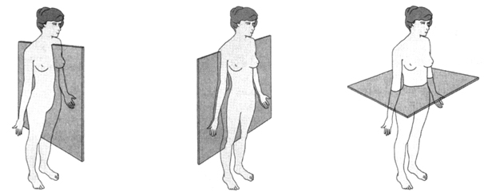

A B C

33) The _____ plane (also called the _____ plane) separates the anterior and posterior portions of an

object.

34) The _____ plane separates the superior and inferior portions of an object.

35) The plane (also called the _____ plane) separates the left lateral and the right lateral portions of an object at the midline.

36) The cranial cavity is within the _____ cavity.

37) The spinal or vertebral cavity is within the _____ cavity.

38) The thoracic cavity is within the _____ cavity.

39) The abdominopelvic cavity is within the _____ cavity.

40) The brain is found in the _____ cavity. (Use the most specific, ie smallest, cavity that is

appropriate.)

41) The spinal cord is found in the _____ cavity. (Use the most specific, ie smallest, cavity that

is appropriate.)

42) The lungs are found in the _____ cavity. (Use the most specific, ie smallest cavity that is appropriate.)

43) The heart is found in the _____ cavity. (Use the most specific, ie smallest cavity that is

appropriate.)

44) The bladder, some reproductive organs, and rectum are found in the _____ cavity. (Use

the most specific, ie smallest cavity that is appropriate.)

45) The major digestive organs are found in the _____ cavity. (Use the most specific, ie smallest,

cavity that is appropriate.)

46) The diaphragm muscle is the bottom of the ________ cavity and the top of the ______ cavity.

47) The pelvic cavity is within the _____ cavity, which is within the _____ cavity.

48) The ribs are the walls of the _______ cavity.

49) The _____ separates the abdominopelvic and thoracic cavities.

50) ''Nasal'' refers to the _____.

51) ''Oral'' refers to the _____.

52) ''Cervical'' refers to the _____.

53) ''Axillary'' refers to the _____.

54) ''Abdominal'' refers to the _____.

55) ''Brachial'' refers to the _____.

56) ''Pelvic'' refers to the _____.

57) ''Carpal'' refers to the _____.

58) ''Digital'' refers to the _____.

59) ''Pubic'' refers to the _____.

60) ''Patellar'' refers to the _____.

61) ''Crural'' refers to the _____.

62) ''Pedal'' refers to the _____.

63) ''Tarsal'' refers to the _____.

64) ''Orbital'' refers to the _____.

65) ''Thoracic'' refers to the _____.

66) ''Mammary'' refers to the _____.

67) ''Umbilical'' and “navel” refer to the _____.

68) ''Coxal'' refers to the _____.

69) ''Inguinal'' refers to the _____.

70) ''Femoral'' refers to the _____.

71) ''Cephalic'' refers to the _____.

72) ''Vertebral'' refers to the _____.

73) ''Plantar'' refers to the _____.

74) ''Dorsum” Or “Dorsal'' refers to the _____.

75) ''Lumbar'' refers to the _____.

76) ''Sacral'' refers to the _____.

77) ''Gluteal'' refers to the _____.

78) ''Occipital'' refers to the _____.

**Answer to fill-in-the-blank review questions:**

1) Anatomical position

2) Proximal

3) Posterior

4) Medial

5) Lateral

6) Superior

7) Inferior

8) Medial

inferior

9) Medial

Inferior

10) Posterior

inferior

11) Inferior

12) lateral

13) Anterior

14) Distal

15) Anterior

16) Posterior

17) Superior

18) Inferior

19) Anterior

20) Inferior

21) Proximal

22) Posterior

23) Deep

24) Distal

25) Superior

26) Deep

27) Proximal

28) Superficial

29) Superficial

30) Medial

Distal

Inferior

31) Transverse

32) A = Sagittal

B = Frontal

C = Transverse

33) Frontal

Coronal

34) Transverse

35) Saigittal

Medial

36) Posterior

37) Posterior

38) Anterior

39) Anterior

40) Cranial

41) Vertebral

42) Thoracic

43) Thoracic

44) Pelvic

45) Abdominal

46) Thoracic

Abdominopelvic

47) Abdominopelvic

Anterior

48) Thoracic

49) Diaphragm

50) Nose

51) Mouth

52) Neck

53) Armpit

54) Abdomen

55) Arm

56) Hips

57) Wrist

58) Fingers

59) Genitals

60) Knee

61) Calf

62) Foot

63) Ankle

64) Eye

65) Chest

66) Breast

67) Belly button

68) Hips

69) Groin

70) Thigh

71) Head

72) Spine

73) Sole of the foot

74) Back

75) Lower back

76) The back of the hips

77) The buttocks

78) Back of the head

**Short answer review questions:**

1) In what way is anatomical position very different from how most people stand?

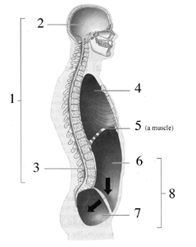

2) Name body cavities 1-9 below:

9

3) Name body regions 1-27 below:

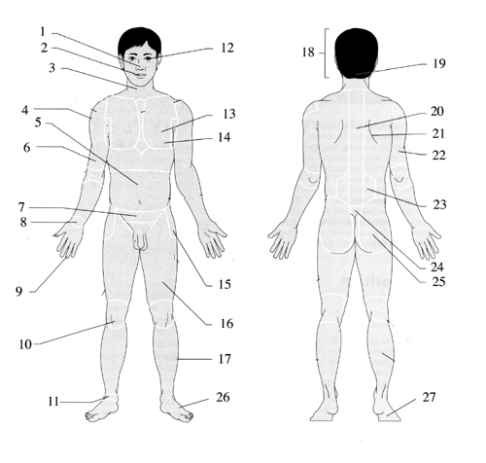

**Answer to short answer review questions:**

1) In anatomical position, the person stands with palms facing forward. Most people do not naturally stand that way.

2) 1 = Dorsal 5 = Diaphragm muscle

2 = Cranial 6 = Abdominal

3 = Vertebral 7 = Pelvic

4 = Thoracic 8 = Abdominopelvic

9 = Ventral

3) 1 = Nasal 15 = Coxal/Pelvic

2 = Oral 16 = Femoral

3 = Cervical 17 = Crural

4 = Axillary 18 = Cephalic

5 = Abdominal 19 = Occipital

6 = Brachial 20 = Vertebral

7 = Inguinal 21 = Dorsum

8 = Carpal 22 = Brachial

9 = Digital 23 = Lumbar

10 = Patellar 24 = Sacral

11 = Tarsal 25 = Gluteal

12 = Orbital 26 = Pedal

13 = Pectoral/Thoracic 27 = Plantar

14 = Mammary