These review questions are for the Integumentary system and the Membranes lecture topics. The questions were adapted from several sources, including 1700+ Review Questions for Anatomy and Physiology II (3rd edition) by R. Michael Anson, Ph.D.

Multiple choice questions:

1) Membrane organs usually are made of which two tissue types? (choose two answers)
a) Nervous
b) Muscle
c) Epithelial
d) Dense connective
e) Lose connective

2) Which is not one of the membrane organ types of the body?
a) Cutaneous
b) Synovial
c) Serosa
d) Mucus
e) Plasma

3) A ______ membrane is any membrane that stays wet and that is located in an organ which opens to the outside of the body. For example, the inner lining of the stomach is this type of membrane.
a) Cutaneous membrane
b) Synovial membrane
c) Serous membrane
d) Mucus membrane
e) Plasma membrane

4) The mucus-making cell type that keeps many mucus membranes slippery is the _____ cell.
a) Goblet cell
b) Mucocyte
c) Ciliated epithelial cell
d) Lymph cell
e) Plasma cell

5) The membrane type that surrounds joint cavities (the space between the bones of a joint) and makes a slippery fluid to lubricate the joint:
a) Articular membranes
b) Synovial membranes
c) Cartilage membranes
d) Osteomembranes
e) Serous membranes

6) The membrane type that is filled with fluid and that surrounds and cushions many internal organs:
a) Articular membranes
b) Synovial membranes
c) Cartilage membranes
d) Osteomembranes
e) Serous membranes

7) The side of the serosa (the serous membrane) that is attached to the organ that the membrane surrounds is called the _______.
a) Parietal serosa
b) Organoserosa
c) Embedded serosa
d) Visceral serosa
e) Synovial serosa

8) The side of the serosa (the serous membrane) that is attached to the wall of a body cavity is called the _______.
a) Parietal serosa
b) Organoserosa
c) Embedded serosa
d) Visceral serosa
e) Synovial serosa

9) The skin is also known as the
a) Dermal membrane
b) Cutaneous membrane
c) Superficial membrane
d) Keratinized membrane
e) Exo-laminar membrane

10) The two main layers of the skin are the…(choose two answers)
a) Keratin strata
b) Dermis
c) Hypodermis
d) Epidermis
e) Melanodermis

11) The organ system that includes the skin and all the organs in the skin (such as sweat glands, sebaceous glands, hairs, and nails).
a) Cutaneous system
b) Dermal system
c) Superficial system
d) Integumentary system
e) Epithelial system

12) The epidermis has several layers (strata) of epithelial cells. The deepest layer is called the
a) Stratum keratina
b) Stratum basale
c) Stratum endothelium
d) Stratum corneum
e) The substrata

13) The epidermis has several layers (strata) of epithelial cells. The most superficial layer is called the
a) Stratum keratina
b) Stratum basale
c) Stratum endothelium
d) Stratum corneum
e) The substrata

14) The cells that make a dark pigment that protects the skin from ultraviolet radiation.
a) Pigmentocytes
b) Cafecytes
c) Melanocytes
d) SPF cells
e) Obscuracytes

15) A person with very white skin has _______ melanocyte cells in their skin than a person with very dark skin.
a) More
b) The same number of
c) Fewer

16) At a cellular level, what is the reason that a very light skinned person has lighter skin than a very dark skinned person?
a) The lighter skinned person has white pigments that mask their brown melanin
pigment
b) The lighter skinned person has fewer melanocyte cells
c) The lighter skinned person has the same number of melanocyte cells as the dark
skinned person has but those cells make less melanin in the lighter skinned person
d) The lighter skinned person’s melanocyte cells are in the dermal layer, not in the
epidermal layer, so that the brown color is masked by the keratin-filled cells of the
epidermis.

17) The dermis is the lower layer of the skin. It is made of _______ tissue
a) Adipose tissue
b) Epithelial tissue
c) Muscle tissue
d) Elastic tissue
e) Dense connective tissue

18) Which of the following is not located in the dermis?
a) Blood vessels
b) Nervous tissue
c) Melanocytes
d) Sweat glands
e) Sebaceous glands

19) The two major pigments that give the skin its color. (choose two answers)
a) Melanin
b) Keratin
c) Collagen
d) Carotene
e) Rosen

20) Which is not the correct match between a skin abnormality and a color?
a) Jaundice, Yellow
b) Cholera, Green
c) Erythema, Red
d) Cyanosis, Blue

21) The skin glands that secrete an oily substance onto the hairs and the surface of the skin.
a) Oleocyte glands
b) Petrocyte glands
c) Vasanyl glands
d) Emollient glands
e) Sebaceous glands

22) Which two terms are the upper and lower parts of the hair? (choose two answers)
a) Stalk
b) Shaft
c) Root
d) Base
e) Trunk

23) When we are cold or frightened, our hairs raise upward because of ______.
a) Root plexi
b) Osmotic pressure
c) Increased blood pressure
d) Arrector pili
e) Basal growth

24) Nails and hairs are made of dead ______ cells filled with ______ protein.
a) Epithelial, Collagen
b) Fibroblast, Keratin
c) Dermalcytes, Elastin
d) Epithelial, Keratin
e) Cilial, Melanin

Answers to multiple choice questions:

1) C and D
2) E
3) D
4) A
5) B
6) E
7) D
8) A
9) B
10) B and D
11) D
12) B
13) D
14) C
15) C
16) C
17) E
18) C
19) A and D
20) B
21) E
22) B and C
23) D
24) D

Fill-in-the-blank questions:

1) Most membranes in the body are made out of two major tissue types: _______ and _______. Circle the answer that is usually the uppermost tissue layer of the membrane.

2) The four main membrane types in the body are ______, ______, ______, and ______.

3) Membranes inside the body that always remain wet or moist are called _____ membranes. All of these membranes are part of passages that lead to the outside of the body.

4) Name two organs that have mucus membranes as their inner lining.

5) The membrane type that encloses joints and makes a lubricating fluid for the joint is
called a(n) _____ membrane. This type of membrane is made entirely of _______ tissue.

6) The general name for the fluid-filled membrane type that surrounds many internal organs and allows the organs to move and flex inside body cavities: . Name two organs that are surrounded by this type of membrane: _________ and _________.

7) In the blank space after each membrane type on the left, write the letters of all descriptions on the right that match it. Some descriptions may match more than one membrane type. Write the letters of all matching descriptions.

Mucus membrane a) It has cells that make a fluid

b) The dermis is one of its
Cutaneous membrane layers

c) It is entirely connective
tissue

Serous membrane d) It is part of the
integumentary system

e) It has a parietal side
Synovial membrane
f) It is inside the body but it comes in contact with air, beverages, or food.

g) It is found at joints

8) Name all the organs of the integumentary system.

9) The skin contains two layers: from deep to superficial, they are the _____ and the _____. Underneath the deepest layer of the skin, is a layer of adipose (fat) tissue that is not considered part of the skin. This adipose layer is called the _______ or the _______.

10) The epidermis is composed of _____ tissue.

11) The dermis is composed of _____ tissue.

12) The hypodermis is composed of _____ tissue.

13) The layer of the epidermis that contains rapidly dividing cells is the _____ layer. (The cells produced in this layer are slowly pushed upward to replace the cells lost from the upper layers of the epidermis).

14) The deepest layer of the epidermis is the _____.

15) The most superficial layer of the epidermis is called the _____.

16) The thickest layer of the epidermis is the _______.

17) The majority of the cells of the epidermis are filled with _____, a hard plastic-like protein.

18) Melanocytes in the _____ (which epidermal layer?) produce the pigment ______.

19) Melanin can be decorative, but it's major function in skin is to _____.

20) Cells in the _____ layer of the epidermis are dead and filled with keratin protein. These cells constantly flake off and are constantly replaced by new cells from deeper in the epidermis.

21) Sunlight contains an invisible type of light called _______ light, which is damaging to the skin and can cause skin cancer.

22) The more melanin pigment a person has in their skin, the more ______ light is blocked.

23) What is the biggest risk factor for developing skin cancer?

24) People with lighter/darker (circle one word) skin are more likely to develop skin cancer.

25) The upper layer of the dermis has wavy upward projections (like little hills and valleys) that connect with the epidermis. These wavy shapes in the dermis are called ______.

26) The two major fibrous proteins found in the dermis are _____ fibers, which provide its strength, and _____ fibers, which are rubber band-like proteins that allow it to resume its original shape after stress or stretch.

27) Which layer of the skin contains blood vessels and nerve endings? _______

28) The blood vessels of the dermis provide nutrients and oxygen for the rapidly dividing cells of the _______ layer of the epidermis.

29) Excess heat can be removed from the body by dilation/contraction (circle one) of blood vessels in the dermis.

30) The pigments that contribute to skin color are the brown/black pigment _____ and the yellow pigment ______.

31) In addition to skin pigments, _____ also contributes to skin color, especially in fair-skinned
individuals.

32) An unhealthy yellow complexion, including a yellow tone to the whites of the eyes, is called _____ and is due to a buildup of _____ in the blood following liver malfunction.

33) Excessive blood in skin blood vessels (such as might happen if a person becomes overheated) causes _____, in which means red color in the skin.

34) Poor blood oxygenation causes _____, in which non-pigmented areas of the skin look blue.

35) Sweat glands cool the body. They release a solution made mostly of _____ and ______.
36) The ducts of _____ glands open into hair follicles, not directly onto the skin's surface.

37) The oily substance released by sebaceous glands is called ______.

38) The portion of the hair that is above the surface of the skin is called the _____.

39) The portion of the hair that is below the surface of the skin is called the _____.

40) The muscles that allow hairs to "stand on end" (and which cause goose bumps) are the
_____.

41) At a cellular level, hairs, fingernails and toe nails are composed of _____.

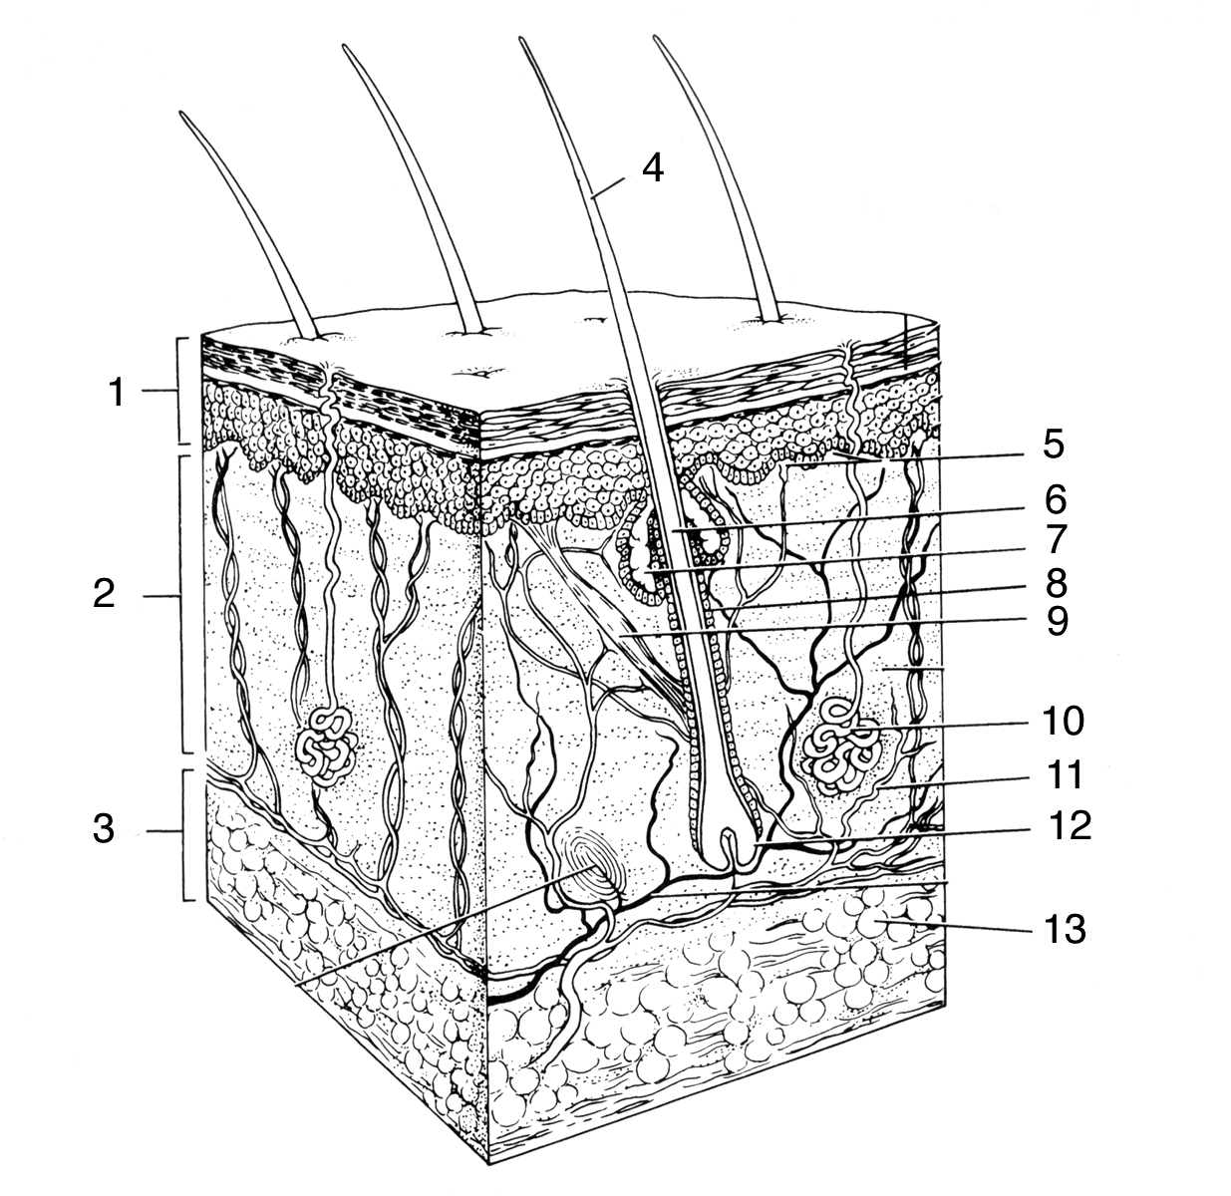
42) Study the drawing of the skin below then name parts 1 – 11 in the blanks below the drawing. You may skip 8, 12, and 13. Clues have been provided for some of the blanks.

1) (a layer of the skin)
2) (a layer of the skin)
3) (a tissue below the skin)
4) (the upper part of a hair)
5) (the bumps at the top of the dermis)
6) (the lower part of a hair)
7)
9)
10 )
11) (it carries nutrients to the skin)

Answers to fill-in-the-blank questions:

1) Epithelial (circled)
Dense connective tissue
2) Mucus (mucosa)
Synovial
Serous (serosa)
Cutaneous
3) Mucus
4) (Any two of the following)
Stomach
Mouth
Nose
Throat
Intestines
Lungs
Bladder
Vagina
5) Synovial
Dense connective tissue
6) Serous membrane (or serosa)
(Any two of the following)
Heart
Lungs
Digestive organs
7) AF
ABD
AE
ACG
8) The skin
Sweat glands
Sebaceous glands
Hairs
Nails
9) Dermis
Epidermis
Hypodermis
Subcutaneous fat layer
10) Epithelial tissue
11) Dense connective tissue
12) Adipose tissue
13) Stratum basale
14) Stratum basale
15) Stratum corneum
16) Stratum corneum
17) Keratin

18) Stratum basale
Melanin
19) Protect from ultraviolet (UV) light
20) Stratum corneum
21) Ultraviolet light (UV light)
22) Ultraviolet light
23) Exposure to UV light in sunlight
24) Lighter
25) Dermal papillae
26) Collagen
Elastin
27) The dermis
28) Stratum basale
29) Dilation (circled)
30) Melanin
Carotene
31) Blood vessels in the skin
32) Jaundice
Bile
33) Erythema
34) Cyanosis
35) Water
Salts
36) Sebaceous glands
37) Sebum
38) Hair shaft
39) Hair root
40) Arrector pili
41) Dead keratinized epithelial cells
42) 1 = Epidermis
2 = Dermis
3 = Hypodermis
4 = Hair shaft
5 = Dermal papillae
6 = Hair root
7 = Sebaceous gland
8 = skip
9 = Arrector pili
10 = Sweat gland
11 = Blood vessel

Short answer questions:

1) Explain briefly (2 – 3 sentences) the difference between the parietal serosa and the visceral serosa.

2) How does our skin protect the body from…
a) Damage by ultraviolet (UV) light?

b) Bacteria and toxins that we physically contact?

3) For each skin discoloration listed below, name the discoloration and describe what can cause it.
a) Yellow colored skin.

b) Blue skin and fingernails.

c) Red skin.

4) Name two functions of sebum (the oily substance released from sebaceous glands).

Answers to short answer questions:

1) A serosa is a fluid-filled membrane that surrounds and cushions an organ in the body. The face of the serosa that attaches to the organ being protected is the visceral serosa (“visceral” means organ). The face of the serosa that attaches to the wall of the body cavity is called the parietal serosa (“parietal” means wall).

2) (a) The melanin pigment, which is made by melanocytes in the epidermis, protects the body
from UV light.

(b) Bacteria and toxins that we contact are prevented from entering the body by the stratum corneum of the epidermis. This layer of dead keratinized epithelial cells is impenetrable to most bacteria and toxins.

3) a) Jaundice. It is caused by bile (a yellow pigment made by the liver for digestion of fats). When a person has a liver disease or a blocked bile duct, the bile accumulates in the skin, causing jaundice.

b) Cyanosis. If a person not not getting enough oxygen, their blood can turn a blue color. This causes blue color of the skin. It is most visible in fair-skinned individuals.

c) Erythema. Excess blood in the skin blood vessels (such as occurs when a person is hot or embarrassed) causes erythema.

4) Sebum softens the skin and hairs. It also has anti-bacterial properties which help keep the
skin and hair follicles from getting infected.

