Biological molecules (Chapters 2, 3, and 4)

Organic molecules
Molecules containing carbon atoms

Biological Macromolecules
Large organic molecules that are vital components of all living things
• The four major types are lipids, carbohydrates, proteins, and nucleic
acids

• Each of the four macromolecule types is a polymer:

Macromolecule Monomers

Lipids Fatty acids and glycerol

Carbohydrates Monosaccharides

Proteins Amino acids

Nucleic acids Nucleotides

Monomer
Any small organic molecule that can become linked to another
monomer

Polymer
A chain of linked monomers

Carbohydrate (saccharide)
A monosaccharide (simple sugar), a disaccharide (two monosaccharides linked together), or a polysaccharide (many monosaccharides linked together)
• The body uses carbohydrates for energy

Monosaccharide (simple sugar)
Any small molecule with the general formula C_{n}H_{2n}O_{n}
• Most simple sugar names end in “-ose”
√ Examples: Glucose, fructose, galactose, ribose
• Glucose is the most abundant simple sugar
√ Glucose is our “blood sugar”
√ Cells use glucose as their main fuel
• Glucose is usually shown as a hexagon:
Fig 2.12

Disaccharide
A carbohydrate made from two monosaccharides joined together
• Maltose = glucose + glucose
• Sucrose (table sugar) = glucose + fructose
• Lactose (milk sugar) = glucose + galactose
Fig 2.13

Polysaccharides
A large number of glucoses joined together
• Made to store glucose (to store energy)
• Starch = The glucose polysaccharide in plants
√ Bread, pasta, rice, corn, and potatoes are high in starch
• Glycogen = The glucose polysaccharide in our body
√ Glycogen is stored mostly in the liver and the muscles
Fig 2.13

Lipids
Hydrophobic macromolecules
• Examples: Fat, oil, grease, wax
• Lipid molecules are composed of many more carbon atoms than
oxygen atoms
√ This is what makes lipids hydrophobic
• Major functions: Energy storage, insulation, cell membranes
• Fatty acid and glycerol are the building block molecules of most
lipids
• Fatty acid = A molecule containing a long “tail” of only carbon and
hydrogen atoms
• Glycerol = A three-carbon molecule
√ Each carbon is a docking site for one fatty acid
Figs 2.14, 2.15, 2.16

Triglyceride (fat and oil)
Three fatty acids joined to a glycerol molecule
• Fats and oils are used for energy storage and insulation
Fig 2.14

Phospholipid
Two fatty acids and a phosphate joined to a glycerol molecule
• Phospholipids are usually diagramed as a circle with two tails
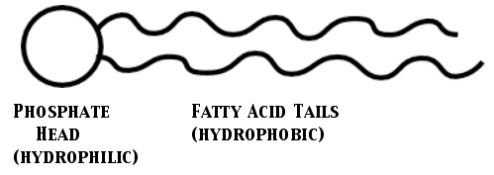

• The main function of phospholipids is to form cell membranes
√ Cell membranes are phospholipid bilayers (two layers of
phospholipids)
√ The phospholipid tails prevent most solutes from passing
through the membrane
Fig 2.15

Steroids

Lipids with a backbone of 4 fused rings of carbon in this shape:
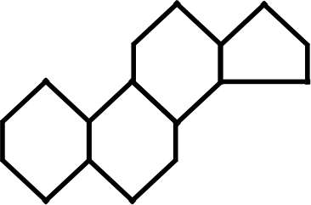

• Examples: cholesterol, steroid hormones (estrogen, testosterone,
progesterone, corticosterone), vitamin D
Fig 2.16

Proteins
Polymers of amino acids
• There are 20 different types of amino acids, but all have this general
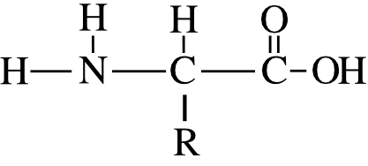
structure:

√ The R part of the structure is different for each of the 20
amino acids
• Proteins are the most abundant macromolecules in the body
• Proteins have many diverse functions in the body
√ Major types of proteins: enzymes, receptors, channel proteins,
and fibrous proteins
Figs 2.17, 2.18

Enzymes
Proteins that perform chemical reactions in the body
• Each enzyme is highly specific to carry out one and only one
chemical reaction
• Active site = The crevice in an enzyme where it binds the molecules
it changes and carries out its chemical reaction on them
√ Each enzyme is specific for only one reaction because
only one molecule is the right shape to fit into its
active site
√ After the enzyme finishes its chemical reaction, it releases the
Product molecules (the molecules it has made). The enzyme
repeats its chemical reaction over and over again.
• Most enzymes are named after the molecule they react with followed
by the ending “ase”
√ Examples: Lipase = An enzyme that reacts with lipids
Sucrase = An enzyme that reacts with sucrose
Fig 4.5

Receptors
Proteins in the cell membrane that detect molecules outside the cell
• Each receptor is highly specific to detect one and only one
molecule because only one molecule fits into its binding site
• When a molecule is detected, the cell is “preprogrammed” to
perform some action in response
- The intracellular region of the receptor triggers the cellular
response

Channel proteins (also called carrier proteins and pores)
Proteins in the cell membrane that form a tunnel to allow solutes to pass through the membrane
• Each channel protein is highly specific to transport only one solute
molecule type
Figs 3.14 and 3.18

Fibrous (structural) proteins
Rope-like proteins that provide strength and framework to tissues
• Examples:
√ Collagen = An extremely strong fibrous protein, abundant in
tendons and ligaments
√ Elastin = An elastic (rubber band-like) fibrous protein
√ Keratin = A hard fibrous protein abundant in nails, hair, and
the skin
Fig 5A and 5.14

Nucleic acids
Polymers of nucleotide monomers
• DNA and RNA are the two types of nucleic acids
• The genes (the “blueprints” of life inside each cell) are made of
DNA
√ Each gene is a recipe for one of the cell’s proteins
√ Double helix = two intertwined DNA strands
√ Chromosomes = Structures in the cell made of a long
piece DNA
- Each chromosome contains hundreds of genes
Figs 2.20, 2.20, and 4.12

Adenosine Triphosphate (ATP)
A high energy molecule inside the cell that supplies proteins with the
the energy needed to carry out their work
• An RNA nucleotide with 3 phosphate ions
• The energy is released when one of the three phosphates is removed.
- This changes ATP into ADP and an unattached phosphate
• The ADP is “recharged” into ATP using the energy of glucose and
other nutrients
Fig 2.22, 4.7, 4.8

