Proteins Name:

This laboratory handout contains exercises about proteins, one of the most important macromolecule (large molecule) types in our bodies. To do this laboratory, you will need a packet of amino acid cards. Obtain these cards by printing out the last 4 pages of this web handout and cutting out the cards with scissors. It will also help to have your textbook handy and to read through the section on proteins.

The worksheet is divided into eight sections. Most sections begin with a few paragraphs that explain a concept about proteins, followed by an exercise that uses the cards in the protein packet to illustrate the concept. Each section builds on the concepts of the earlier sections, so it is important that you fully understand each section before proceeding to the next one. If you have questions about any section’s concept or exercise, please email me your questions to let me help you.

It will be very helpful if you view the lecture video L15 ProteinsPart2 before you begin this laboratory exercise.

1) Proteins and amino acids

Proteins are large molecules found in the cells of all living things. They carry out all the processes that are necessary to sustain life.

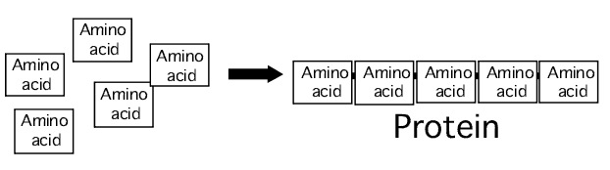
Proteins are actually made up of smaller molecules called amino acids. You can think of a protein as simply a chain of amino acids linked together.

Each cell in your body contains thousands of different proteins. Although the number of amino acids varies from protein to protein, on the average there are about 400 amino acids linked together per protein.

2) Similarities among amino acids

There are twenty different types of amino acids (the building blocks of proteins). All life forms on earth, from the smallest bacteria to the largest mammals, use the same twenty amino acid types to construct their proteins!

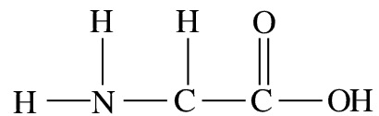
All twenty of the amino acids have similarities in their chemical structure. The illustration below shows the atoms that all amino acids have in common.

The nitrogen atom with the two hydrogen atoms attached to it (on the left side of the amino acid) is called the amine group. On the right side of the amino acid is a carbon atom with two oxygen atoms attached to it (the oxygen on the right has a hydrogen attached to it). This carbon, the two oxygens, and the hydrogen are called the carboxylic acid group. In the middle of the amino acid, between the amine and the carboxylic acid, is a carbon atom with a hydrogen attached to its top. This is called the central carbon. Circle and label the amine, central carbon, and carboxylic acid in the illustration above.

The amine, central carbon, and carboxylic acid are together sometimes called the “backbone” of the amino acid. Since all amino acids have these same three chemical groups, we can say that all amino acids have the same “backbone.”

Each card in your packet (except the ones marked “ligand” and "membrane") represents an amino acid. Take out a few of the cards from the packet and inspect them. There are atoms in addition to the backbone atoms on each amino acid, but for now you can ignore these extra atoms. Be able to identify the backbone of each pictured amino acid. (Note that one of the hydrogen atoms on the amine has been left out on each card).

Each of the twenty amino acids has a name and a three-letter abbreviated form of its name (much like a person can be called “Timothy” or “Tim”). Look for the name of each amino acid (and its three letter abbreviated name) in small gray letters next to the amine group.

3) Differences between amino acids

Although all twenty amino acids have exactly the same backbone, all twenty differ from each other in the atoms that are attached to their backbone. The central carbon of the backbone is the attachment point for the differing parts of amino acids.

The illustration below shows two amino acids, called Glutamate and Alanine. Note that they both have the same backbone. Attached to (and below) each one’s central carbon, however, is a group of atoms that is not identical. The group of atoms attached to the central carbon is called the R group or side chain of the amino acid.

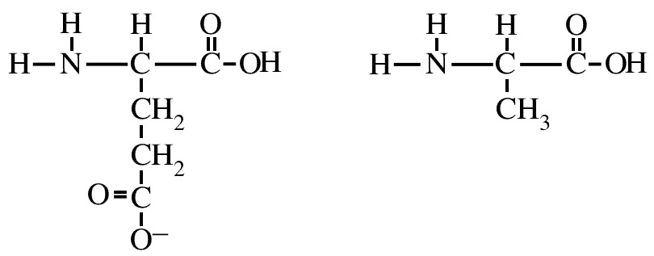

Glutamate Alanine

The R group is the only thing that makes one amino acid different from another. There are twenty different amino acids because there are twenty different R groups.

Select two different amino acid cards from the pack and draw their R groups attached to the central carbon of the backbones below. Write the correct three letter name below each one.
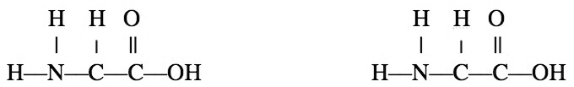

4) Amino acids can be classified by their R groups
Each of the twenty amino acids has a unique R group. Nevertheless, biologists have grouped the amino acids into four main classes based on chemical similarities of their R groups.

The four classes of amino acids (based on their R groups) are listed below:

• R groups with a positive ionic charge (usually a positively charged
nitrogen)

• R groups with a negative ionic charge (usually a negatively charged
oxygen)

• R groups with uncharged but polar bonds (such as O–H and N–H
bonds)

• R groups with uncharged and non-polar bonds (These R groups
contain only C–H and C–C bonds)

For example, the amino acids Arginine and Lysine (shown below) are in the class of amino acids that have R groups with a positive ionic charge.
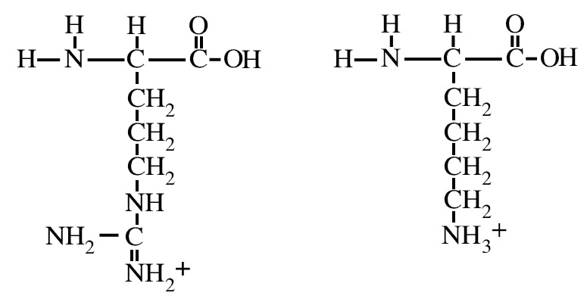

Arginine Lysine

Go through the pack of amino acid cards and find two examples of each amino acid class. Next to each of the four class descriptions at the top of this page, write the names of the two amino acid examples of that class.

5) Amino acids link together by peptide bonds
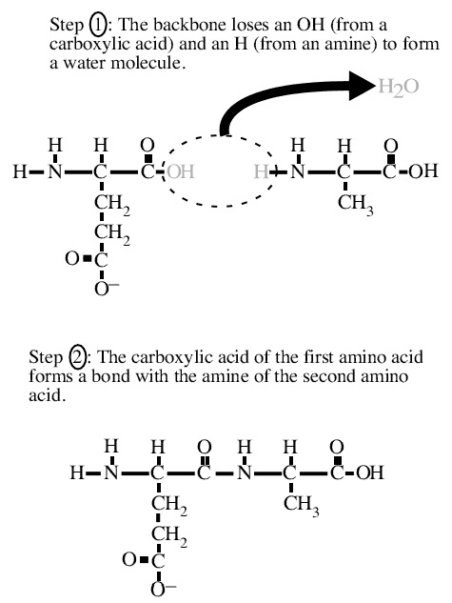
Recall from section one of this handout that a protein is simply a chain of amino acids linked together. But how exactly do amino acids link? The illustration below shows the chemical reaction that joins together two amino acids.

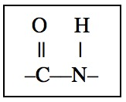
Notice the steps that must occur for two amino acids to join together: The carboxylic acid of the first amino acid must lose its OH and the amine of the second amino acid must lose its hydrogen. After this has occurred, the carbon on the first amino acid forms a new covalent bond to the nitrogen of the second amino acid. This new bond is called a peptide bond (shown below). The peptide bond is the bond that links amino acids together into proteins.

Take any two amino acids from the pack and link them together by a forming a peptide bond. To do this, simply slide the second amino acid over the right side of the first, until the OH on the first is covered (representing the OH being removed). The nitrogen on the second forms a peptide bond with the carbon on the first.
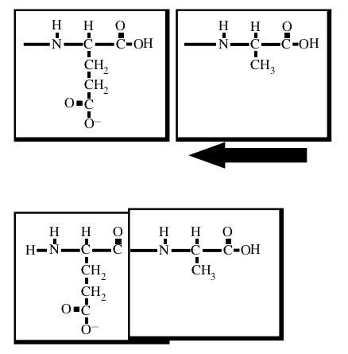

Notice that there is a carboxylic acid at the right end of the two joined amino acids. The OH of this carboxylic acid can be removed and a peptide bond can be formed to a third amino acid.
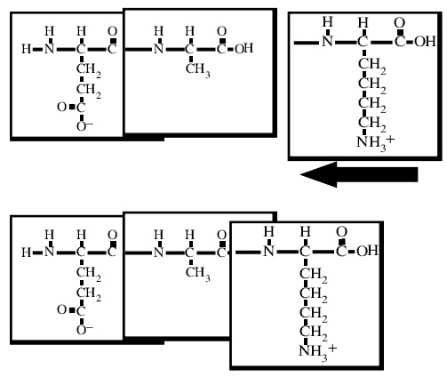

New amino acids always attach to the carboxylic acid of the polypeptide chain. Every time a new amino acid is added to the protein chain, a new carboxylic acid comes with it, so it is always possible to add another amino acid. Therefore there is no theoretical limit to the number of amino acids a protein can have.

Using any of the amino acids, construct a protein eight amino acids in length on your desktop. The same amino acid may appear more than once in the protein. The linked backbones of the amino acids are sometimes called the backbone of the protein. Answer the following questions about your protein’s backbone:

How many free (unlinked) amine groups are present in your protein’s backbone?_________

How many free (unlinked) carboxylic acid groups are present in your protein’s backbone?_________

How many peptide bonds are present in your protein’s backbone?_________

If you wished to add a ninth amino acid to your protein, what end would it add on to? ____________________

6) Chemical properties of the amino acids

You have previously learned the chemical principle that opposite charges attract. For example, a positively charged sodium ion (Na⁺) and a negatively charged chloride ion (Cl–) will be pulled together by electrostatic attraction (the attraction between their opposite charges). The same chemical principle of “opposites attract” also applies to amino acid R groups: R groups with positive ionic charges will be attracted to negative ionic charges. Arginine and lysine (the amino acids with + charged R groups shown in section 4), for example, would be attracted to any negative ion (such as Cl–). And conversely, amino acids that have R groups with negative ionic charges will be attracted to any positive charged ion (such as Na⁺).

Other chemical principles that you have learned also apply to amino acid R groups. Recall that polar covalent bonds (such as O–H and N–H) have partial electrical charges (written as δ⁺ and δ–) which allow them to be electrostatically attracted to other polar molecules and to ions. Also recall that molecules that have all or mostly non-polar bonds (C–H and C–C) are hydrophobic and will be attracted only to other non-polar molecules.

These chemical principles are summarized in the table below. They will be important for understanding the remaining sections of this laboratory.
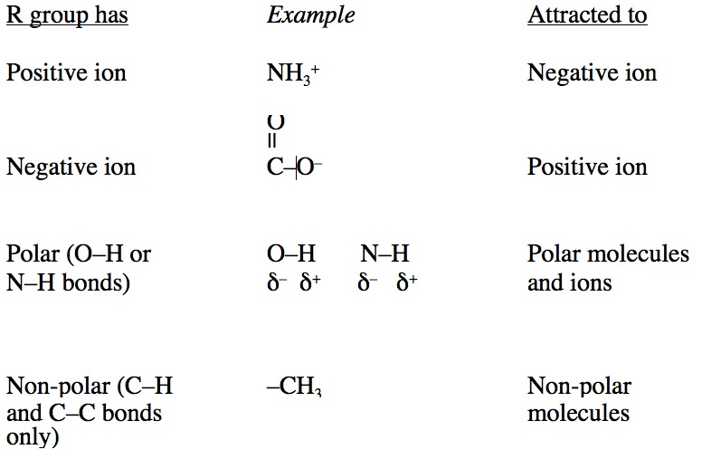

7) Transmembrane proteins

You have learned that cells are the basic units of life, and that the outer boundary of each cell is the plasma membrane. Recall that the plasma membrane is composed of molecules called phospholipids. A diagram of a phospholipid is shown below.
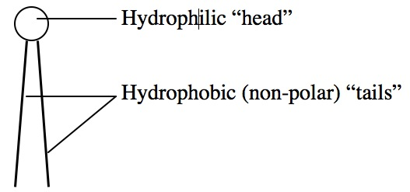

The “tails” of phospholipids are made of only C–H and C–C covalent bonds, which means that they are non-polar and hydrophobic.

The plasma membrane of the cell is a phospholipid bilayer (two layers of phospholipids arranged tail to tail).
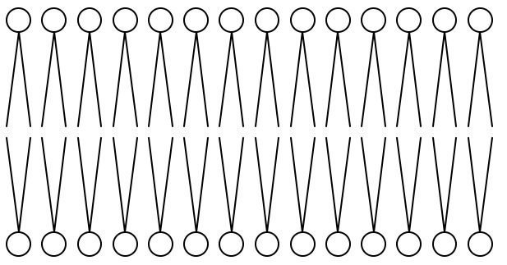

Because of this arrangement, the middle of the plasma membrane is composed entirely of non-polar “tails” and is extremely hydrophobic.

Embedded in the plasma membrane are special types of proteins called transmembrane proteins. These proteins span the plasma membrane. Receptor proteins and channel proteins are examples of
transmembrane proteins.
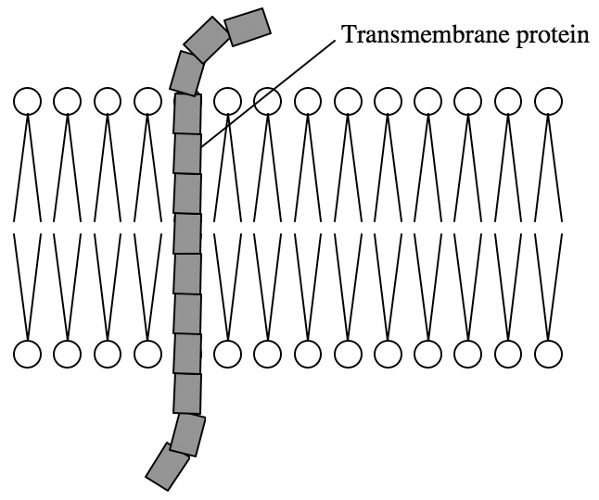

In order to stay embedded in the hydrophobic interior of the plasma membrane, these proteins must have amino acids with non-polar (hydrophobic) R groups in the region that spans the membrane. Amino acids with ionic or polar R groups would not be attracted to the hydrophobic “tails” of the membrane’s interior and therefore would not be stable in the plasma membrane.

Take out the cardboard plasma membrane from your packet and lay it on your desk. Now construct an eight-amino acid transmembrane protein that spans the membrane. The amino acids that are not in the membrane can be any type, but the amino acids that cross through the membrane must have non-polar R groups. The transmembrane region of your protein must be of 3 – 4 consecutive amino acids. (Be sure your protein goes through the membrane, from the inside of the cell to the outside).

Write the sequence of amino acids of your protein (using the three letters abbreviations of their names).
______ ______ ______ ______ ______ ______ ______ ______

Circle the amino acids above that span the membrane. Show your instructor your assembled protein before continuing.

8) Biologically active proteins have binding sites

Proteins are the “workers” of the cell. They carry out all the processes that are necessary for the cell to function. In much the same way that workers in a factory must grasp hold of parts and tools to do their job, many proteins in a cell must grasp other molecules to carry out their functions. Proteins that grasp molecules are called biologically active proteins. The molecule that a biologically active protein binds (grasps) is called the ligand or substrate of the protein.

There is a region on each biologically active protein called the protein’s ligand binding site (or just “binding site”). This is the location on the protein where it grasps its ligand molecule. In order for the protein to function correctly, its binding site and the ligand molecule must fit together like a lock and key. In other words, the shape of the binding site must match that of the ligand molecule. Equally important, the amino acids in the binding site must have R groups that are attracted to the ligand.
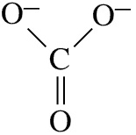
To illustrate this concept, consider the ligand molecule carbonate ion (shown below).

Notice that carbonate ion has two negatively charged oxygen atoms. A protein that binds carbonate ion must have R groups in its binding site that are attracted to negative ions. These R groups would have to have positive ionic charges or polar bonds. (Review the principles of chemical attraction in section six of this handout, if necessary). One possible binding site for carbonate ion is shown below.
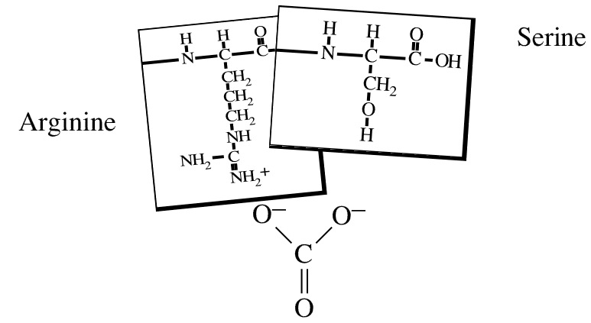

Notice that the positively charged nitrogen (at the tip of Arginine’s R group) is attracted to the ligand’s negative oxygen ion by electrostatic attraction. The hydrogen at the tip of Serine’s R group carries a partial positive charge (because it is part of a polar O–H bond), so it is attracted to the ligand’s other negative oxygen.

Find the ligand A card in your packet and place it on your benchtop. Construct an eight-amino acid protein with a binding site (of 3 – 4 consecutive amino acids) for this ligand. Make a slight bend in the protein backbone at the binding site (as is shown in the illustration above) to help the binding site R groups get close to the ligand. Remember, amino acids in the binding site must have R groups that are attracted to the ligand (The other amino acids in your protein can have any kind of R group).

In the spaces below, write the sequence of amino acids of your protein (using the three letters abbreviations of their names). Draw a box around the amino acids that are the ligand binding site. Show your instructor your assembled protein before continuing.
______ ______ ______ ______ ______ ______ ______ ______

Repeat this exercise with ligand B. Show your instructor your assembled protein before continuing.
______ ______ ______ ______ ______ ______ ______ ______

Some transmembrane proteins are also biologically active proteins. These proteins must span the membrane and have a ligand binding site. Lay the plasma membrane card and the ligand C card on your benchtop. Construct an eight amino acid transmembrane protein that spans the membrane and has a binding site for ligand C outside the membrane.
Circle the amino acids that span the membrane and draw a box around the amino acids that bind the ligand. Show your instructor your assembled protein before continuing.

______ ______ ______ ______ ______ ______ ______ ______

Protein review Questions (From lecture outlines and textbook);
1) When a protein is boiled, none of its amino acids are harmed and they remain linked together in their correct order. Nevertheless, the protein loses its ability to bind its ligand. Explain why a boiled protein can’t bind ligand.

2) Explain in what way receptors and membrane channel proteins differ in function. Also, list two ways they are similar (including what type of amino acids both proteins would have in their middle areas).

3) Explain why some proteins have quaternary structure and others don’t.

4) To operate efficiently, cells sometimes need to adjust the rate of certain enzymes. Describe a common way a cell can activate (speed up) an enzyme, and describe a common way enzymes are slowed down (if they are making too much of their product). Hints: Cells don’t use pH or temperature to regulate enzymes. Look at figure 6.18 in the textbook for the answers.



