Lipids

a) Introduction
Macromolecules are large molecules found in all living things. There are four major macromolecule types: Carbohydrates, Lipids, Proteins, and Nucleic acids. This lab will review the lipids and show some of their uses. It may be helpful to review your lecture notes on lipids and the textbook section on lipids.

There are three major types of lipids: Triglycerides, phospholipids, and steroids. All three types of lipids have one thing in common: They are hydrophobic molecules. Recall that “hydrophobic” means does not mix with water. For example, vegetable oil is a lipid and, as you know from experience in the kitchen, it does not mix with water.

b) Glycerol and fatty acids
Most lipids are made by linking together smaller “building block” molecules. The two major building block molecules of lipids are glycerol and fatty acids.

Glycerol is a three-carbon molecule. Each of the three carbons has an OH functional group. Fatty acids are a long chain of carbons with a carboxylic acid functional group at one end of the chain. Most fatty acids are about 18 carbons long.
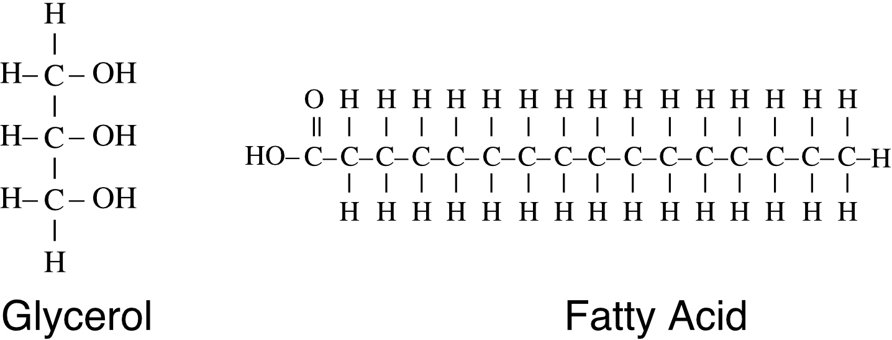

Notice that in the fatty acid shown above, each carbon atom is linked to its neighboring carbon atoms by only one covalent bond. Fatty acids of this type are called saturated fatty acids. Some fatty acids, however, have two covalent bonds (a “double bond”) between some of the carbon atoms. This type of fatty acid is called an unsaturated fatty acid. Two unsaturated fatty acid are shown on the next page.

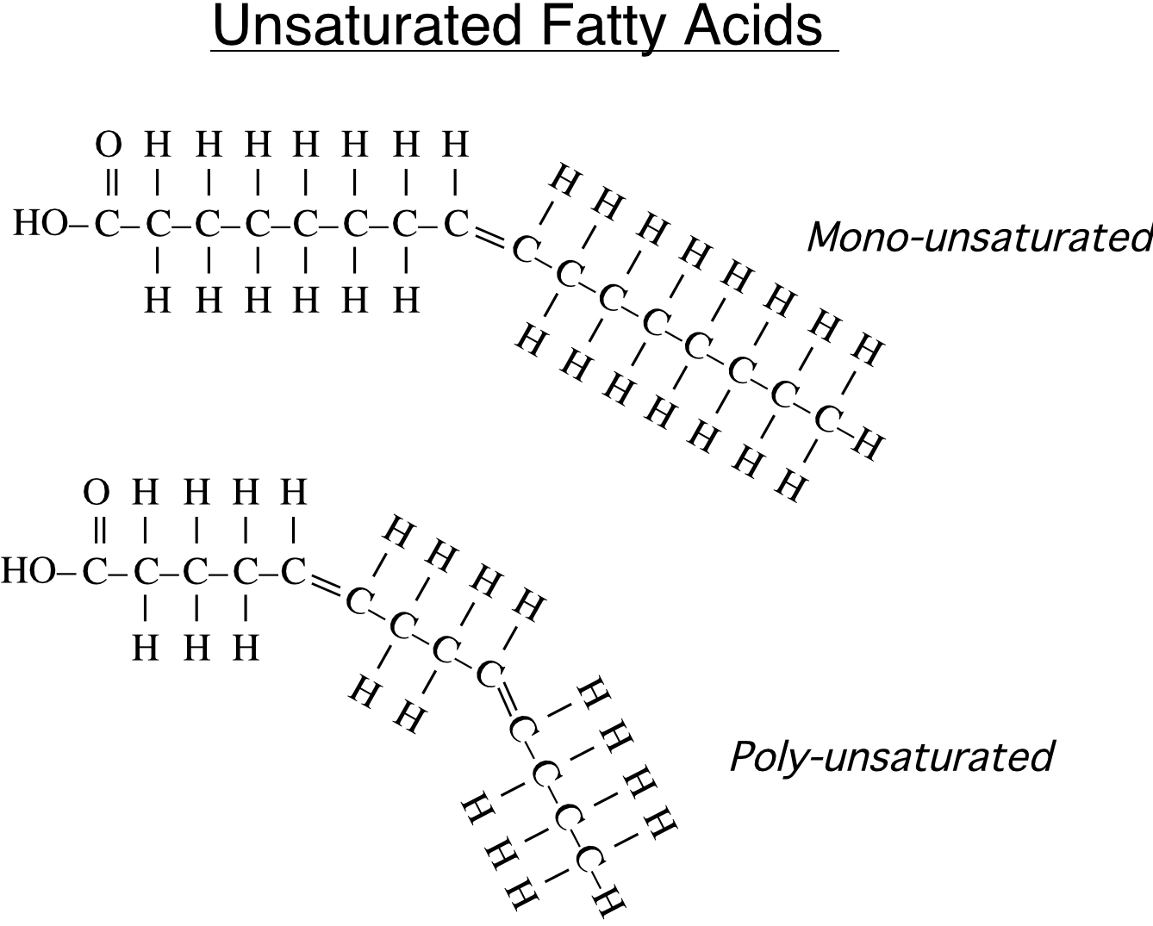

The unsaturated fatty acid shown at the top has only one double bond. This type is called a mono-unsaturated fatty acid. The unsaturated fatty acid shown at the bottom contains two double bonds. This type is called a poly-unsaturated fatty acid.

What are the effects of having double bonds in the fatty acid? In terms of diet, it is more healthy to eat foods rich in unsaturated fatty acids than foods with saturated fatty acids. In general, the more double bonds that are present in the fatty acid, the healthier it is for you. This is because diets high in saturated fatty acids have been linked to heart disease (clogged arteries), where clumps of fat clog your blood vessels and can cause heart attack or stroke. You can remember this with the saying “Saturated fats will saturate your arteries.”

As you can see from the illustrations, double bonds bend the fatty acid molecule, and the more double bonds the more bent the fatty acid. This bending plays an important role in determining if a lipid is solid or liquid. We will return to this issue in section (e) of this handout.

c) Triglycerides (fats and oils)
One of the major types of lipids is the triglyceride. All fats and oils that come from living things are triglycerides. Some examples are body fats and the oil that occurs naturally on our skin. Other examples are oils from plants, such as olive oil, corn oil, and sunflower oil.

Triglyceride molecules are made from one glycerol and three fatty acids. To be more specific, each of the OH groups on the glycerol molecule serves as a docking site for one fatty acid. The fatty acids link to the glycerol by a dehydration reaction (meaning a water molecule is created for each fatty acid that links to the glycerol). Three water molecules are created in the process.
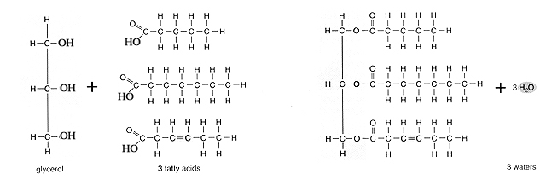

Triglyceride

The main function of triglycerides in living things is energy storage. The fats in your body and the oils in nuts and vegetables serve as a way to store calories for future need. A second function of triglycerides (and fats in particular) is insulation to help us retain body heat.

d) Phospholipids
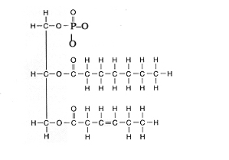
Another important type of lipid is the phospholipid. This type of lipid molecule is similar in structure to triglycerides, except that one of the three fatty acids is replaced by a phosphate functional group.

The main function of phospholipids is to form cell membranes. In other words, the membrane of a cell is constructed mostly of phospholipids.

e) Steroids
The last of the three major lipid types are the steroid lipids. This type of lipid is very different in structure from the lipids we have discussed so far. Unlike triglycerides and phospholipids, Steroids are not made from glycerol and fatty acid molecules. Instead, all steroid lipids contain a “backbone” of 4 linked rings of carbon. The diagram below shows the steroid backbone. Every corner in the diagram represents one carbon atom.
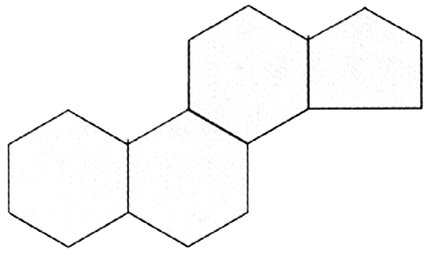

Steroids have many functions in living things. Cholesterol, which is a steroid, is part of cell membranes in animals. Too much cholesterol in our diets, however, can lead to clogged arteries and possibly a heart attack. Many important hormones, such as testosterone and estrogen, are also steroids.

e) Laboratory exercise: Why are some triglycerides oils (liquids) and others fats (solids)?
As you read in section (c) above, triglycerides are macromolecules that are made of one glycerol joined to three fatty acids. All fats (such as body fat, cooking lard, and grease) and all oils (such as corn oil, soybean oil, and olive oil) are triglycerides.

Since all oils and fats are triglycerides, you may wonder why oils are liquids and fats are solids. In other words, if they are all the same thing (one glycerol linked to three fatty acids) why do some have a higher viscosity (thickness) than others?

1) Go to the counter where three fat or oil samples have been placed in test tube racks.

2) Determine the viscosity each sample. Your instructor will do this for you by pipetting up 10 ml of each triglyceride then allow the oil to drain out of the pipette removing the pipette device. (Obviously for fats, this won’t work). Rank the three samples in order from highest viscosity to lowest viscosity:
1) ___________________
2) ___________________
3) ___________________

3) Now obtain the cards showing typical triglyceride molecules of each sample. After inspecting the cards, do problem 5 in the review questions section. Show your
instructor your answers to problem 5 before starting the next section.

f) Laboratory exercise: Using soap to break apart triglycerides.
Historians are not sure when soap was first invented, but it is certain that by the time of the Roman Empire people had discovered how to make soap and how useful soap is for cleaning.

At a molecular level, soap is made of fatty acids. The only difference between the fatty acids in triglycerides and the fatty acids in a bar of soap is that the soap’s fatty acids are not attached to a glycerol molecule and they do not have a hydrogen attached to the oxygen at their end. Instead, the oxygen at the end contains a negative ionic charge. This makes the oxygen-end of the fatty acid very hydrophilic, while the other end of the molecule (the “tail” of carbons and hydrogens) is very hydrophobic.
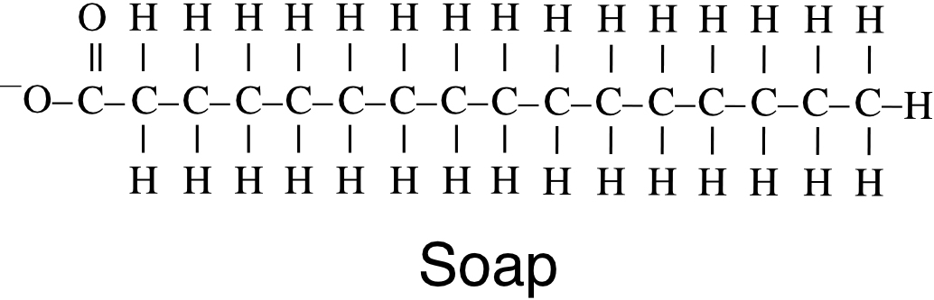

As a simpler way to draw a soap molecule, the hydrophilic end can be shown as a circle and the hydrophobic tail as a wavy line:
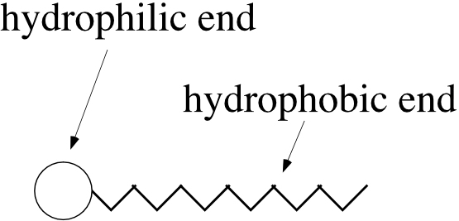

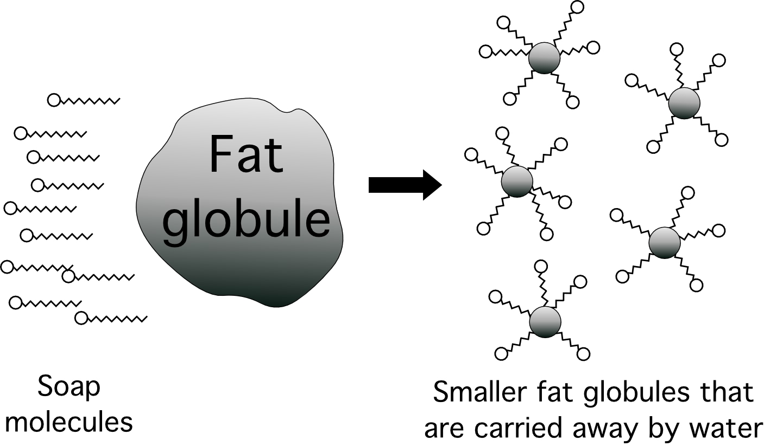
How do soaps help clean? Many times the materials that we want to wash away (such as dirt on our hands and clothes or grease on our dishes) are hydrophobic substances such as globules of fat and oil. These globules do not wash away easily because hydrophobic things don’t mix with water. Soaps break apart fat and oil globules into much smaller globules because the long end of the soap molecule is hydrophobic (and therefore mixes into the hydrophobic fat globule) but the oxygen end of the soap molecule is hydrophilic (and mixes with the water). The soap therefore serves as a sort of bridge between the fat and the water. This breaks the fat globule into smaller globules that the water can carry away. The process of breaking apart large fat globules so that they will disperse in water is called “Emulsification.”

Use the following procedure to demonstrate the action of soap on a triglyceride:
1) Obtain two large plastic test tubes and a wax pencil. Label one test tube “Soap” and the other test tube “No soap.”

2) To both test tubes, drizzle 1 ml of red oil down the wall of the test tube. The goal is to evenly coat the wall with a film of oil.

3) Half fill both test tubes with water from the sink. To the test tube labeled “Soap” add 10 drops of Dawn soap.

4) Cap both test tubes and then gently mix by inversion for 30 seconds.

5) After mixing gently for 30 seconds, observe the walls of the tubes.

In which tube was more of the oil removed from the wall of the test tube? ___________ (If you can’t clearly tell which tube had more oil removed from its walls, you can also look at the water. The tube with more red dispersed in the water is the tube that had more oil removed from its walls).

6) When done, thoroughly clean all test tubes with soap and a test tube brush.
g) Laboratory exercise: Making soap from triglycerides.

Since triglycerides (fats and oils) contain fatty acids, they can be used as the starting material for making soap. There are two steps that are needed to transform triglycerides into soap. First, the fatty acids in the triglyceride must unlinked from the glycerol molecule that they are attached to. Secondly, the hydrogen atom attached to the oxygen in the fatty acid must be removed. Surprisingly, just one chemical does both steps simultaneously. Sodium Hydroxide (NaOH, a strong base that is also known as “lye”) detaches the fatty acids from glycerol AND removes the hydrogen from the fatty acids:
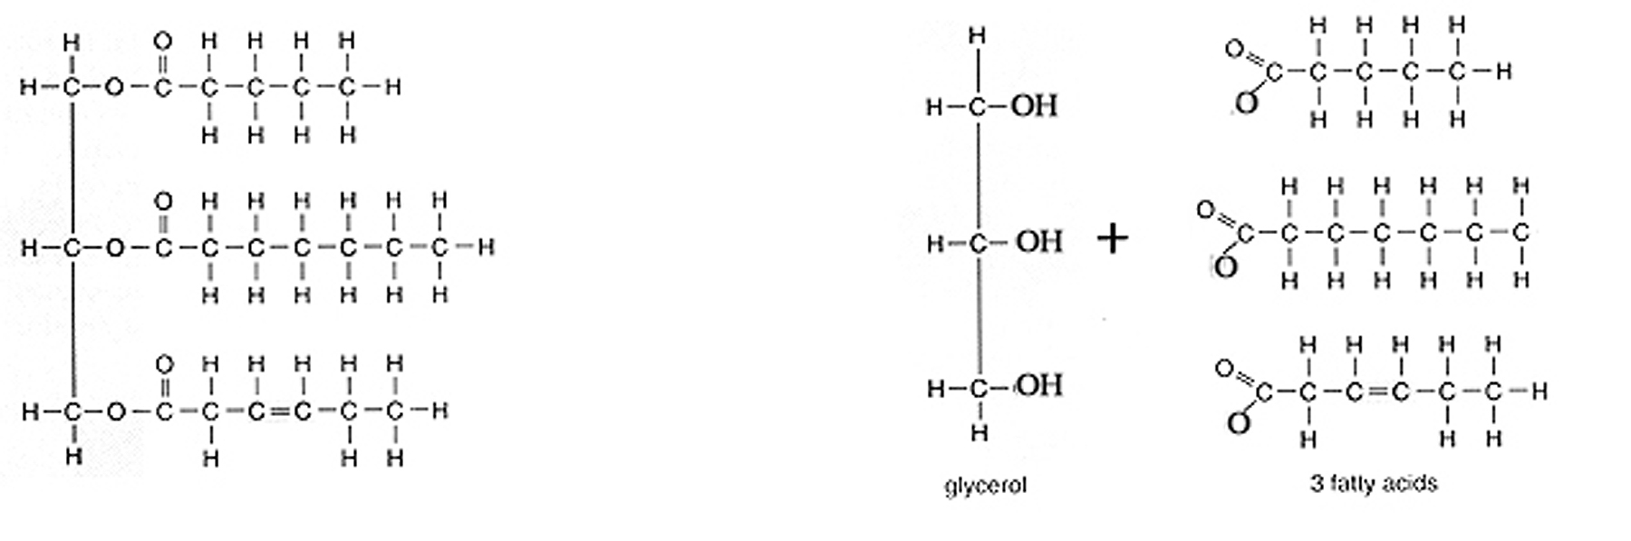

3NaOH

Triglyceride

The fatty acids in the diagram above become the soap. Notice that it takes three NaOH molecules to turn one triglyceride molecule into soap because each triglyceride molecule has three fatty acids that must be detached. You may wonder what happens to the glycerol molecule that the above reaction produces. The glycerol becomes part of the soap too. It acts as a moisturizer that helps keep the soap from getting too dry.

The process of making soap from triglycerides is called saponification. You will use olive oil as the triglyceride in the saponification procedure described below.

1) You will start with 30 ml of 6M NaOH. Calculate how many moles of NaOH are present in 30 ml of 6M NaOH.
__________

2) Use the “chemical equation” 1 tryglyceride + 3NaOH -> Soap to calculate how many moles of triglyceride you will need to exactly react with the moles of NaOH you calculated in (1) above.
__________

3) Inspect the olive oil triglyceride on the next page and then calculate the molecular formula and the molecular weight of the olive oil triglyceride molecule. (To calculate the molecular weight, you can use these approximations: Each hydrogen = 1 gram/mole, each carbon = 12 grams/mole, and each oxygen = 16 grams/mole).

__________

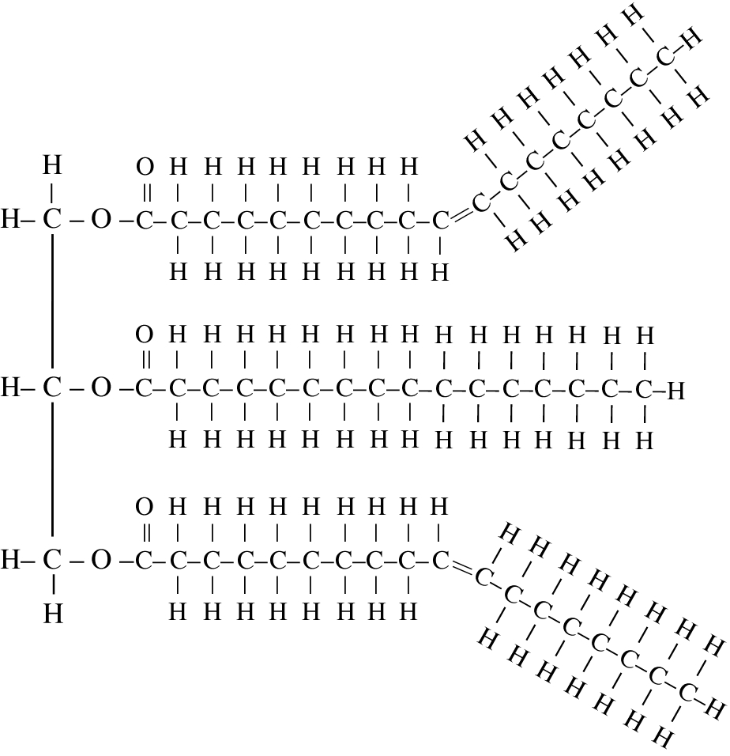

4) Using the molecular weight of olive oil that you calculated in (3) above, calculate how many grams of olive oil you need to have the required number of moles of olive oil. You calculated the moles of olive oil in (2), above.

__________

5) Just to ensure that all the NaOH is consumed, there should be a 10% excess of the triglycerides. Add 10% to the grams you calculated in (4) above.

__________

6) Show your instructor your calculations before beginning saponification reaction.

7) Everyone in your group must put on safety goggles, even group members who are not handling any chemicals.

8) Obtain a beaker, a glass stirring rod, a disposable 1 ml pipette, and a thermometer.

9) Place the beaker on an electronic balance and tare (zero) the balance. Carefully pour in the required grams of olive oil into the beaker. Be sure to include the 10% extra.

10) Place the beaker on a hot plate set for medium heat. Stir the olive oil gently with the thermometer while it heats. Heat it to 45º C.

11) Volunteer a member of your group to be the person who handles the NaOH. That person should put on safety glasses and gloves.

12) The volunteer should obtain a test tube containing 30 ml of pre-heated 6M NaOH. (The pre-heated NaOH is in a 45º C water bath). Caution: NaOH is extremely corrosive. If any NaOH spills on you, rinse it immediately with lots of water and inform your instructor.

13) Using the pipette SLOWLY add the NaOH one squirt at a time into the olive oil while stirring. Add one squirt, stir until it is fully mixed in, then add the next squirt. This step should take over two minutes!
Describe what happens when you mix the NaOH and the triglycerides:

14) Continue to stir the mixture gently for 5 minutes while it cools. If they are available, you may add colors and scent oils to the mixture.

15) After 5 minutes, stop stirring the mixture.

16) Test the pH of the soap with a piece of pH paper. Be careful not to allow the soap to touch your skin. pH = ________. Is this pH acidic, basic, or neutral? _______

17) Pour the soap into a shape mold. Over the next several days, the soap will harden and its pH will become closer to neutral. You can check your soap’s pH during future lab periods. When the pH drops below 8.5, the soap is safe to handle.

18) Clean and wash all equipment. Return it to where you found it. Wash the empty NaOH tubes and the Styrofoam cups in the sink then put them on the equipment cart. Clean your desk top with soap and water.

h) Review questions
1) Draw glycerol and draw a fatty acid in the space below:

2) After each description below, write T if it applies to triglycerides. Write P if it applies to Phospholipids, and write S if it applies to steroids. Some blanks may require more than one answer.
a) They contain glycerol: _________
b) They contain fatty acids: _________
c) They have a “backbone” of 4 fused rings of carbon: _________
d) They include oils and fats: _________
e) Cholesterol is an example: _________
f) They are found in cell membranes: _________
g) They are hydrophobic: _________

3) Phospholipid and triglyceride molecules are very similar in structure. What is the main difference between the two molecules?

4) After each statement, write S if the answer is saturated fatty acids, write M if the answer is monounsaturated fatty acids, and write P if the answer is polyunsaturated fatty acids. Some blanks may require more than one letter.
a) They are the most bent fatty acid molecules: ____________
b) A diet high in them is linked to heart disease: ___________
c) They have only one double bond: __________
d) They have a hydrophobic tail of only carbons and hydrogens: ___________
e) They can be part of a triglyceride molecule: ___________
f) Triglycerides with many of them tend to be fats: __________
g) Triglycerides with many of them tend to be oils: __________

5) In section (e) of today’s lab, you viewed cards that showed typical triglyerides of corn oil, olive oil, and pig lard. Re-inspect these cards to fill in the following table.

Which substance has the most saturated fatty acids? _______

Which substance has the most unsaturated fatty acids? _______

For each of the three substances, calculate the average number of double bonds per
triglyceride. If you are not sure how to do this ask your instructor to help you.

Corn oil Olive oil Lard
Average number of
double bonds per triglyceride:

In the table above, write "Highest viscosity" on the substance that has the highest viscosity. Write "Lowest viscosity" on the substance that has the lowest viscosity.

Fill in each blank in the following sentence with the words Lower or Higher.

For triglycerides, the ________ the number of double bonds per triglyceride, the
________ the viscosity, and the ________ the number of double bonds per triglyceride, the ________ the viscosity.

6) What is the difference between the fatty acids in soap and the fatty acids in fats?

7) Suppose you had a dish with bacon grease (fat) stuck to it. If you placed the dish in pure water, would the water remove the grease from the dish? Explain, at a molecular level, why or why not?

8) If you placed the dish in water containing soap, would the water remove the grease from the dish? Explain, at a molecular level, why or why not?

9) Define Saponification. Describe the chemical reaction that takes place during saponification.

10) Define emulsification.

11) The triglyceride molecules of a certain oil have a molecular formula of C₃₉H₇₄O₆.
Calculate how many grams of this oil you would need to react with 50 ml of 3M NaOH.

12) If you had 100 grams of an oil that had a molecular formula of C₇₂H₁₁₀O₆ how many ml of 6M NaOH would you need to turn it into soap.

13) Clogged drains are often blocked by grease, which is fat and oil. Drain cleaners contain NaOH. Describe exactly how the drain cleaner dissolves the clog.

14) If you made soap using the triglyceride pictured in section (c), instead of the olive oil triglyceride, how many grams of the triglyceride would you have required?

