Photosynthesis and Light
a) Introduction
You are already familiar with the photosynthesis equation:

6CO₂ + 6H₂O -> C₆H₁₂O₆ + 6O₂
(light)

The equation says that when light is present plants consume carbon dioxide and water to make glucose and oxygen. The plants get the water for photosynthesis from the soil. Carbon dioxide is a gas that is freely available to the plants from the air.

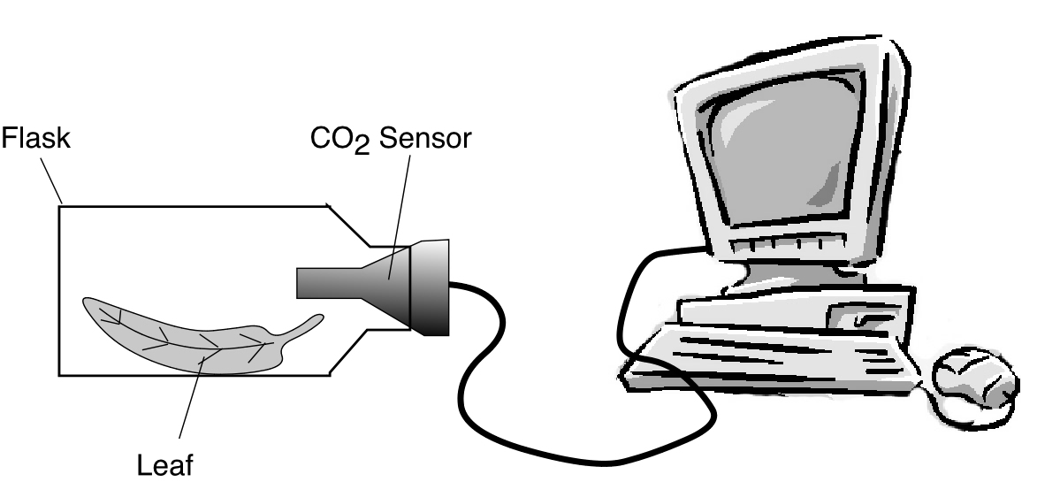
The rate of carbon dioxide consumption (the amount of CO₂ that the plant takes in per minute) is equal to the rate of photosynthesis. In other words, the more photosynthesis a plant is doing the faster it will remove CO₂ from the air. In today’s experiment you will place leaves in a sealed flask and then insert a sensor that detects the CO₂ concentration of the air in the flask. A computer will display a graph that shows the decreasing CO₂ as the leaf uses it for photosynthesis. From the graph you will determine the rate of photosynthesis under different conditions.

You might hypothesize that increasing light intensity would increase photosynthetic rate. A related question is whether some colors of light are better than others for photosynthesis. Your lab group will investigate both of these questions today. In addition, you will familiarize yourself with leaf structures under the microscope.

b) Setting up the CO₂ Sensor and the Computer for the Photosynthesis Experiments
1) Obtain a white cardboard box that contains the following items:
a) A LabPro box (a green plastic electronic device)
b) A black power adaptor plug for the LabPro
c) A long white USB cable
d) A short gray adaptor cable for the CO₂ sensor

Also obtain a CO₂ sensor and a laptop computer.

2) Plug one end of the power adaptor into your desktop power outlet. Plug the other end into in the LabPro box (see figure below). The LabPro should make a beep a few seconds after it has received power.

3) Plug the CO₂ sensor into the round end of the adaptor cable, then plug the adaptor cable into the Channel 1 of the LabPro box (see figure below).

4) Plug the square end of the USB cable into the LabPro box (see figure below).
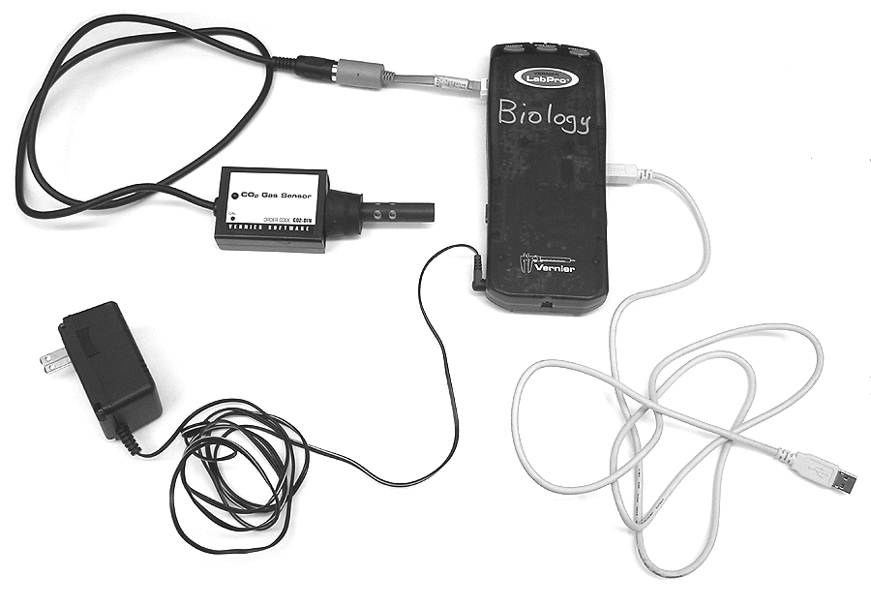

5) Obtain a laptop computer. Turn on the computer. After a few minutes, a log-on window will appear. Ask your instructor for the user name and password. Click the Log On button. The desktop screen should appear on the computer.

6) Plug the flat end of the USB cable into any USB port in the back of the computer. Click the Logger Pro icon on the desktop.

7) Find the File pulldown menu at the top of the screen. Starting with this menu, navigate as follows:

File>Open>Experiments>Biology with Vernier>11B Cell Resp

(If a window called “Sensor Confirmation” appears, click its Done
button)

8) Once the 11B experiment is opened, you must reset the experimental run time to 3 minutes, as follows: Click on the Data Collection icon (an image of a clock next to the green button at the top of the screen). A pop up window will appear. In the pop up window, set Length for 3 minutes and Sampling Rate for 30 samples per minute. Then click Done.

9) Test that your set up is working properly by doing the following:
a) The CO₂ level is displayed in the lower right of the screen.

b) Exhale a VERY TINY puff of air into a plastic flask, then insert
the CO₂ sensor firmly into the flask. The CO₂ levels in the flask
should rise to above 2000 ppm. If the CO₂ level does not rise
above 2000, try again with another small puff of air. But do not
add so much breath that the CO₂ rises above 4000 ppm.

c) Setting up the Photosynthesis Chamber

1) Your instructor will bring provide branches with leaves from a plant called Star Jasmine (Trachelospermum jasminoides), a common landscaping plant on campus. Break off two leaves (bigger leaves are better). Also obtain a pair of scissors, a black cardboard chamber that the flask fits into, a ruler, and a lamp.

2) Using the scissors, cut the two leaves into square pieces about half the size of postage stamps. You will need at least 12 leaf squares. Note that the leaf squares have a dark green side and a light green side.

3) Remove the CO₂ sensor from the flask. Holding the flask sideways, place the leaf squares, dark green side up, into the flask one at a time. Arrange them so that they do not cover each other. You may need to use a pencil or your fingers to correctly position the leaf squares. Your instructor has a sample flask on the front desk to use as a visual reference.

4) Carefully place the CO₂ sensor firmly back into the flask. If the CO₂ concentration is below 2000, remove the sensor and add another tiny puff of air, then replace the sensor back into the flask. But if the CO₂ goes above 4000, lower the CO₂ by opening the flask and fanning into it.

5) Gently slide the flask into the black cardboard chamber. The cardboard chamber has an open side on top to allow light to reach the flask. Be sure that the open side of the chamber does not have a colored light filter (a colored plastic sheet) on it.

6) Position the lamp so that it will shine directly down onto the flask through the opening at the top of the cardboard chamber. The lamp bulb should be very close (about one inch above) the flask. View the instructor’s demonstration set up on the front desk to make sure you have assembled everything correctly.

d) Photosynthesis in White Light
1) Turn the light on and allow it to shine onto the leaves in the flask for 3 minutes. The reason for shining the light on the leaves for 3 minutes is that it takes about 3 minutes for the photosynthesis “machinery” in the leaves to reach a steady rate of photosynthesis.

2) After 3 minutes of light shining, start collecting data by clicking the green Collect button in the upper right of the screen. If a pop-up window appears, click “Erase and Continue” A red line on the graph should begin to appear. The line shows the CO₂ levels inside the flask.

3) As soon as you have clicked the Collect button, record the initial values of the experiment in the blanks below. The initial CO₂ concentration is the CO₂ concentration on the screen for time zero. Use the ruler to measure the distance between the leaves and the lamp (this distance should be only about 2 - 3 centimeters).
Initial CO₂ concentration = ________ ppm.
Distance from leaves to bulb = _________ cm

The CO₂ levels should change during the experiment. The data collection will automatically halt after 3 minutes. During the 3 minute data collection, work on the microscopy part h of this laboratory.

4) After the data collection has halted at 3 minutes, record the final CO₂ concentration:
Final CO₂ concentration = ________ ppm.

5) Lastly, calculate the photosynthesis rate of the experiment. The graph on your computer shows CO₂ concentration (in ppm) on the Y-axis and time length of the experiment (3 minutes) on the X-axis. The slope of the graph line is the rate of photosynthesis. To calculate the slope of the line
(the rate of photosynthesis), divide the change in the amount of CO₂ by the change in time (3 minutes).

Final CO₂ ppm - Initial CO₂ ppm
________________________
3 minutes

Photosynthesis rate = __________ ppm/minute
6) Repeat steps 1 - 5 except first increase the distance between the lamp and the leaves. Your instructor will provide you with a box or test tube rack or other object to elevate the lamp. The lamp should now be about a foot above from the cardboard chamber. Record the new distance and the other new data in the blanks below:
Initial CO₂ concentration = ________ ppm.
Final CO₂ concentration = ________ ppm.
Photosynthesis rate = __________ ppm/minute
Distance from leaves to bulb = _________ cm

7) After completing the data table in step 6 above, turn off the light, then cover the cardboard chamber (with the flask inside) completely with a jacket or other light-proof material. The idea is to put the leaves in total darkness. Let the leaves sit in total darkness for 3 minutes. Keeping the leaves in total darkness, repeat steps 2 - 5. Use the blanks below to record the data for this experiment:
Initial CO₂ concentration = ________ ppm.
Final CO₂ concentration = ________ ppm.
CO₂ change rate = __________ ppm/minute

Show your instructor all the data in this section before continuing with the next section.

f) Photosynthesis in Blue, Green, and Red Light
1) Uncover the chamber with the flask inside. If the CO₂ concentration is below 2000, remove the sensor and add another very tiny puff of air, then replace the sensor into the flask. Open and fan the flask if the CO₂ is above 4000.

2) Place a green colored filter over the open top end of the chamber. Position the lamp so that it will shine directly down through the filter onto the leaves. The idea is that only green light will shine onto the leaves.

The lamp bulb should be very close (about one inch above) the flask. View the instructor’s demonstration set up on the front desk to make sure you have assembled everything correctly.

4) Turn the light on and allow it to shine through the colored filter onto the leaves in the flask for 3 minutes. After 3 minutes with the light on, proceed to step 5.

5) Start collecting data by clicking the green Collect button in the upper right of the screen. If a pop-up window appears, click “Erase and Continue”

6) As soon as you have clicked the Collect button, record the initial values of the experiment in the blanks below.
Color of light: ______________.
Initial CO₂ concentration = ________ ppm.

7) After the data collection has halted at 3 minutes, record the final CO₂ concentration:
Final CO₂ concentration = ________ ppm.

8) Lastly, calculate the photosynthesis rate of the experiment.

Final CO₂ ppm - Initial CO₂ ppm
________________________
3 minutes

Photosynthesis rate = __________ ppm/minute

9) Remove the green filter and replace it with a red filter. Repeat steps 4 - 8 using the red filter. Record the new color and the other new data in the blanks below:
Color of light: ______________.
Initial CO₂ concentration = ________ ppm.
Final CO₂ concentration = ________ ppm.
Photosynthesis rate = __________ ppm/minute

10) Remove the red filter and replace it with a blue filter. Repeat steps 4 - 8 using the blue filter. Record the new color and the other new data in the blanks below:
Color of light: ______________.
Initial CO₂ concentration = ________ ppm.
Final CO₂ concentration = ________ ppm.
Photosynthesis rate = __________ ppm/minute

Show your instructor these calculations before cleaning up

g) Clean up
1) Quit the LoggerPro program (don’t save your results). Next, shut down your computer using the Shut Down selection on the screen’s lower left menu. Wait until the screen has completely turned off before folding your computer closed.

2) Unplug all cables from the blue LabPro box and from the computer. Also unplug the gray adaptor cable from the CO₂ sensor. The CO₂ sensor goes in its own box, but all other cables go into the white cardboard Vernier box.

3) Wrap the lamp cord neatly around the lamp. Empty all leaf pieces out of the flask and dispose of them into the trash.

h) Viewing Leaf Cells

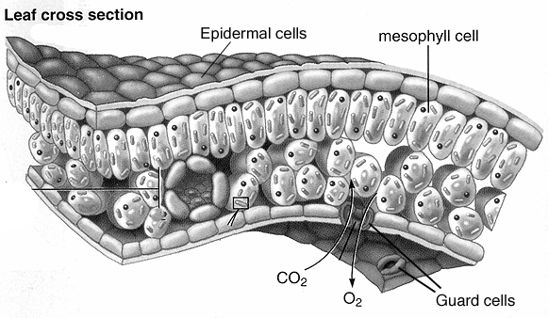
The cells that form the top and the bottom surface of a leaf are called epidermal cells. Their job is to form a water-tight skin to protect the leaf from dehydration. They do not perform photosynthesis. The cells located in the middle of the leaf, called mesophyll cells, are the ones that perform photosynthesis (see the illustration below).

The mesophyll cells need carbon dioxide from the air to perform photosynthesis, and they need a way to get rid of the oxygen produced by photosynthesis. To allow CO₂ and O₂ gases to travel between the mesophyll cells and the air, there are small openings in the lower surface of the leaf. These openings are called stomata. Each stoma is surrounded by a pair of lip-shaped cells called guard cells. The guard cells can open or close the stoma in the same way that your lips can open or close your mouth.

In this section you will observe mesophyll and guard cells using your microscope.

1) Obtain a microscope slide, a cover slip, and one leaf from the water plant elodea. Make a wet mount of one elodea leaf.

2) View the leaf using the 40X objective lens (remember to focus first on 5X and 10X). You should be able to clearly see the chloroplasts inside the mesophyll cells.

3) Sketch one mesophyll cell in
the space to the right. Label the cell wall,
the chloroplasts, and the cytoplasm in
your drawing.

4) Estimate the number of chloroplasts in the cell you sketched. Also Estimate the size of the cell you sketched. (You may need to refer back to your microscopy lab to recall how to estimate cell size). There are 1000 um per one mm.
Chloroplast number: ______ Cell size: _______ um.

5) Dispose of the elodea leaf. Obtain a leaf from the Mother of Thousands plant (scientific name: Kalanchoe daigremontiana).
Bend the leaf gently until it snaps. Peel off a piece of the epidermis, which is the thin outermost layer of cells (it looks like a piece of scotch tape). You may need forceps (tweezers) to pull off the epidermis.

6) Make a wet mount of the epidermis and view it under 40X. Notice that most of the cells have irregular shape like pieces of a jigsaw puzzle. Note that, unlike the illustration on the previous page, you are viewing the leaf epidermis face on, not as a cross section.

7) Find a pair of guard cells. They look like pairs of green lips. Each pair of guard cells surrounds one stomata (the hole in the leaf where the CO₂ enters and the O₂ exits). During hot days the guard cells block the stomata to prevent water from evaporation through the opening.

8) Sketch the guard cells in
the space to the right. Label
the guard cells and the stomata.
Include in your drawing several
of the jigsaw-like epidermal cells
around the guard cells.

9) Wash all slides and put them back in their boxes. The cover slips go into the glass waste box.

i) Review Questions A

1) Write the complete photosynthesis equation:

2) What is the function of epidermal cells? Of mesophyll cells? Of guard cells?

3) What gas or gases passes into the stomata? What gas or gases passes out of the stomata?

4) Guard cells have a bent shape (like kidney beans). If the plant needs to close the stomata, will the guard cells straighten or bend more?

5) What was the concentration of CO₂ in fresh air?

6) Did light intensity affect the rate of photosynthesis? If so, calculate the percent that the rate changed when you moved the light twice as far away:

7) When you covered the flask, no more photosynthesis occurred. It might seem at first that the CO₂ should not change at all, yet the CO₂ increased when the leaves where in darkness. Explain why this is so.

8) Which light color was best for photosynthesis? Which was worst?

9) Explain, in terms of pigments and light color absorption, why the worst color light for photosynthesis was the same color as the leaves.

10) Write the complete photosynthesis equation:

j) Review Questions B

11) The world is full of plants, and they all remove CO₂ from the air, yet the CO₂ concentration in the air is not decreasing. Why not? In other words, what natural process adds CO₂ back into the air?

12) The concentration of gases in the air is given in units called ppm. What does ppm stand for?

13) The air you breathe out has a higher/lower (circle one) concentration of CO₂ than fresh air. Explain why.

14) At the biochemical level, photosynthesis is described as taking place in two distinct stages. What are those stages called? Which of those stages (the first or the second) was not able to function well in reduced light intensity?

15) When you first turned the light on, the CO₂ concentration did not immediately begin to fall. Likewise, when you put the flask in darkness, the CO₂ continued to fall for a brief time before increasing. Why is there a lag time in each case?

16) Light that appears white to our eyes can be made by combining red, blue, and green light. Can plants also use a combination of these three colors to perform photosynthesis at the same rate as natural white light? To answer this question, calculate if the rate of photosynthesis in white light was roughly equal to the combined rates in red, blue, and green light. If the sum of the three color light rates was not equal to the rate in white light, hypothesize why it was not equal.

17) If you had used an oxygen sensor instead of a CO₂ sensor, what would the graph of the first experiment look like? Sketch the curve in the square below. Label the points on the curve where you turned the light on, where you moved the light further away, and where you put the flask in darkness.

Oxygen
(ppm)

Time

18) Since photosynthesis removes CO₂ gas from the air, you might think that you could have used an air pressure sensor instead of a CO₂ sensor to monitor the rate of photosynthesis by the drop in air pressure. Would this have worked? Why or why not? (hint: Review the photosynthesis equation).

19) As you saw from your experiment, plants consume carbon dioxide in the light (and make oxygen, since oxygen is a biproduct of photosynthesis). In the dark, they make CO₂ (and consume oxygen, since oxygen is needed for aerobic respiration). If we assume that plants spend about half the time in darkness and half the time in light, do they consume as much oxygen as they make? Why or why not? Use your data from the first experiment to justify your answer.

20) If you exhaled one normal breath into the flask, it would fill the flask with air that is 12,000 ppm CO₂. Using the photosynthesis rate from your first experiment, calculate how long would it take the two leaves in your flask to remove the CO₂ from one normal breath.

21) Using your answer from problem (20) as a starting point, calculate how many leaves it would take to remove the CO₂ from one breath in the time it takes for one breath (about five seconds).

22) There about 6 billion people on the earth. Using your answer from problem (21) as a starting point, calculate how many leaves are needed to remove the CO₂ that the entire human race puts into the air with each breath.

