These review questions are for Bio 1 Photosynthesis topic. The questions were adapted from several sources, including the textbook’s review questions.

1) Any organism that can make its own nutrients using CO₂ is...
A) an autotroph.
B) a eukaryote.
C) a photosynthesizer.
D) a heterotroph.
E) a plant.

2) Any organism that can make its own nutrients using CO₂ and sunlight is performing...
A) autotrophy.
B) solar production.
C) photosynthesis.
D) solar cell.
E) photoglycolysis.

3) Which of the following statements is a correct distinction between autotrophs and heterotrophs?
A) Only heterotrophs require molecules from the environment.
B) Cellular respiration only occurs to heterotrophs.
C) Only heterotrophs have mitochondria.
D) Autotrophs, but not heterotrophs, can make organic nutrients from CO₂.
E) Only heterotrophs require oxygen.

4) Which of the following are products of the light dependent reactions of photosynthesis that are utilized in the Calvin cycle?
A) CO₂ and glucose
B) H₂O and O₂
C) ADP and NADP+
D) electrons and H+
E) ATP and NADPH

5) Where does the Calvin cycle take place?
A) stroma of the chloroplast
B) thylakoid membrane
C) cytoplasm surrounding the chloroplast
D) interior of the thylakoid (thylakoid space)
E) outer membrane of the chloroplast

6) A certain plant has a unique photosynthetic pigment. The leaves of this plant appear to be reddish yellow. What wavelengths of visible light are being absorbed by this pigment?
A) red and yellow
B) blue, green, and violet
C) green and yellow
D) blue, green, and red
E) green, blue, and yellow

7) In the thylakoid membranes, what is the main role of most chloroplast pigment molecules?
A) split water and then release oxygen to the reaction-center chlorophylls
B) absorb photons and then transfer electrons to the reaction-center chlorophylls
C) synthesize ATP from ADP
D) transfer electrons to NADPH
E) concentrate photons within the stroma

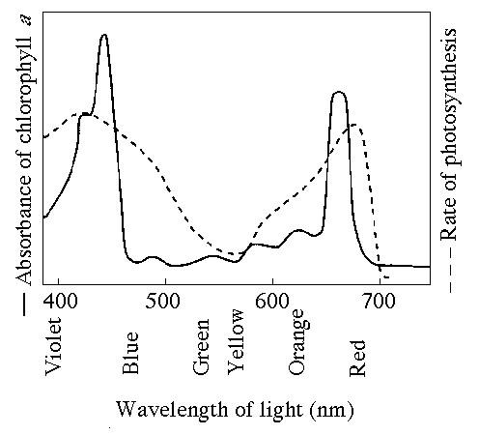

8) The figure above the solid line shows the absorption spectrum for chlorophyll and the dotted line shows action spectrum for photosynthesis (the action spectrum is the amount of photosynthesis that occurs). Why are they not exactly the same? (Note: This question requires information from the photosynthesis laboratory).
A) Green and yellow wavelengths inhibit the absorption of red and blue wavelengths.
B) Bright sunlight destroys photosynthetic pigments.
C) Oxygen given off during photosynthesis interferes with the absorption of light.
D) Accessory pigments absorb light in addition to chlorophyll.
E) Aerobic bacteria take up oxygen, which changes the measurement of the rate of photosynthesis.

9) In the question 8 figure the solid line shows the absorption spectrum for chlorophyll and the dotted line shows action spectrum for photosynthesis (the action spectrum is the amount of photosynthesis that occurs).

What wavelength of light in the figure above is most effective in driving photosynthesis?
A) 420 mm
B) 475 mm
C) 575 mm
D) 625 mm
E) 730 mm

10) In the question 8 figure the solid line shows the absorption spectrum for chlorophyll and the dotted line shows action spectrum for photosynthesis (the action spectrum is the amount of photosynthesis that occurs).

What color of light (based on the figure) is most effective in driving photosynthesis?
A) Red
B) Orange
C) Yellow
D) Green
E) Violet

11) In the question 8 figure the solid line shows the absorption spectrum for chlorophyll and the dotted line shows action spectrum for photosynthesis (the action spectrum is the amount of photosynthesis that occurs). Based on this figure answer the following question.

A gardener is concerned that her greenhouse is getting too hot from too much light, and seeks to shade her plants with colored translucent plastic sheets. What color should she not use because the plants will not use that color for photosynthesis?
A) green
B) blue
C) yellow
D) orange
E) any color will work equally well

12) In the question 8 figure the solid line shows the absorption spectrum for chlorophyll and the dotted line shows action spectrum for photosynthesis (the action spectrum is the amount of photosynthesis that occurs). Based on this figure answer the following question.

A spaceship is designed to support animal life for a multiyear voyage to the outer planets of the solar system. Plants will be grown to provide oxygen and to recycle carbon dioxide. Since the spaceship will be too far from the sun for photosynthesis, an artificial light source will be needed. What wavelengths of light should be used to maximize plant growth with a minimum of energy expenditure?
A) full-spectrum white light
B) green light
C) a mixture of violet and red light
D) yellow light

13) The light dependent reactions of photosynthesis supply the Calvin cycle with
A) light energy.
B) CO₂ and ATP.
C) H₂O and NADPH.
D) ATP and NADPH.
E) sugar and O₂.

14) Which statement below does not describe the functions of photosystem II?
A) Light energy excites electrons.
B) electrons are passed to the reaction-center chlorophylls.
C) The reaction center chlorophylls donate electrons to NADP+.
D) electrons derived from water enter photosystem II.

15) Which one of the following is directly done by the molecules of photosystem I?
A) making ATP
B) receiving electrons from the thylakoid electron transport system
C) generation of molecular oxygen
D) extraction of electrons by splitting of water

16) When oxygen is released as a result of photosynthesis, the oxygen is a direct by-product of
A) making NADPH.
B) splitting water molecules.
C) ATP production by ATP synthase enzyme.
D) the electron transfer system of photosystem I.
E) the Calvin cycle

17) Assume a thylakoid is somehow punctured so that the interior of the thylakoid is no longer separated from the stroma. This damage will have the most direct effect on which of the following processes?
A) the splitting of water
B) the absorption of light energy by chlorophyll
C) the flow of electrons from photosystem II to photosystem I
D) the production of ATP
E) the production of NADPH

18) Which process most directly supplies the energy for ATP production in the light dependent reaction?
A) movement of H⁺ out of the thylakoid membrane
B) movement of electrons through the thylakoid electron transport system
C) splitting of water molecules
D) movement of water by osmosis into the thylakoid space from the stroma
E) formation of glucose

19) Suppose the interior of the thylakoids of isolated chloroplasts were made acidic and then transferred in the dark to a pH 8 solution. What would be likely to happen?
A) The isolated chloroplasts will make ATP.
B) The Calvin cycle would generate oxygen by aerobic respiration
C) Photons will be generated.
D) The isolated chloroplasts will generate oxygen gas.
E) The isolated chloroplasts will produce NADPH.

20) Molecules called plastoquinone and plastocyanin are involved in photosynthesis. What exact part of photosynthesis do they participate in?
A) they absorb photons in photosystem 1
B) they absorb photons in photosystem 2
C) they carry electrons in the electron transport system
D) transport H⁺ within the chloroplasts
E) they are accessory pigments

21) The pH of the inner thylakoid space has been measured, as have the pH of the stroma and the pH of the cytoplasm of a particular plant cell. Which, if any, relationship would you expect to find?
A) The pH within the thylakoid is less than that of the stroma.
B) The pH of the stroma is lower than that of the other two measurements.
C) The pH of the stroma is lower than that of the thylakoid space and lower than that of the cytosol.
D) The pH of the thylakoid space is higher than that anywhere else in the cell.
E) There is no consistent relationship.
22) The light dependent reaction of photosynthesis is directly responsible for the production of…
A) Glucose
B) CO₂
C) ATP and NADPH
D) H₂O

23) Which one of the events listed below does not occur in the light dependent reaction of photosynthesis?
A) NADPH is produced.
B) CO₂ is produced.
C) ATP is made.
D) Hydrogen ions are pumped into the interior of the thylakoid space.

24) The reactions that produce molecular oxygen (O₂) take place in...
A) the light dependent reactions alone.
B) the Calvin cycle alone.
C) the light dependent reaction and the Calvin cycle.
D) neither the light dependent reactions nor the Calvin cycle.
E) the chloroplast, but are not part of photosynthesis.

25) Which region of the chloroplast is associated with the capture of light energy?
A) The thylakoid membrane
B) The outer membranes (the envelope)
C) The stroma
D) The thylakoid membrane and stroma

26) Reactions that require CO₂ take place in
A) the light reactions alone.
B) the Calvin cycle alone.
C) both the light reactions and the Calvin cycle.
D) neither the light reactions nor the Calvin cycle.
E) the chloroplast, but is not part of photosynthesis.

27) The ATP and the NADPH from the light reactions are used
A) To create an H⁺ gradient
B) Directly in most the biochemical reactions of the cell
C) During the reactions of the Calvin cycle to produce glucose
D) To synthesize chlorophyll

28) Which of the following sequences correctly represents the flow of electrons during photosynthesis?
A) NADPH -> O₂ -> CO₂
B) H₂O -> NADPH -> Calvin cycle
C) NADPH -> chlorophyll -> Calvin cycle
D) H₂O -> photosystem I -> photosystem II
E) NADPH -> electron transport chain -> O₂

29) Which of the following does not occur as part of the Calvin cycle?
A) carbon fixation.
B) NADPH is consumed.
C) oxygen is produced.
D) RuBP is regenerated.
E) ATP is consumed.

30) If photosynthesizing plants are provided with CO₂ containing radioactive carbon atoms and radioactive oxygen atoms, later analysis will show that all but one of the following molecules produced by the plants will contain radioactive atoms. Which molecule will not contain any radioactive atoms?
A) 3-phosphoglycerate (PGA)
B) glyceraldehyde 3-phosphate (PGAL).
C) glucose.
D) ribulose bisphosphate (RuBP).
E) O₂.

31) Where do the enzymatic reactions of the Calvin cycle take place?
A) stroma of the chloroplast
B) thylakoid membranes
C) matrix of the mitochondria
D) cytoplasm around the chloroplast
E) thylakoid space

32) What is the primary function of the Calvin cycle?
A) use ATP to release carbon dioxide
B) use NADPH to release carbon dioxide
C) split water and release oxygen
D) transport RuBP out of the chloroplast
E) synthesize glucose from carbon dioxide

33) NADPH contains electrons that were most recently in...
A) photosystem I.
B) photosystem II.
C) the Calvin cycle.
D) ATP synthase enzyme.
E) H⁺.

34) Three "turns" of the Calvin cycle generate one "surplus" molecule of glyceraldehyde 3-phosphate (PGAL), which is a C3 molecule. Which of the following is a consequence of this?
A) Formation of a molecule of glucose would require one "turn".
B) PGAL more readily forms sucrose and other disaccharides than it does monosaccharides.
C) Some plants would not taste sweet to us.
D) The formation of glucose in plants involves linking together two PGAL molecules.
E) Plants accumulate and store PGAL but not glucose itself.

35) In each "turn" of the Calvin cycle, one RuBP attaches to a CO₂ to briefly produce a six-carbon molecule, which is then split to produce two molecules of 3-phosphoglycerate (PGA). After phosphorylation and reduction the two PGA molecules are changed into two glyceraldehyde 3-phosphate (PGAL) molecules.

What more occurs in the Calvin cycle to complete one “turn” of the Calvin cycle?
A) splitting of water
B) inactivation of RuBP carboxylase enzyme
C) regeneration of ATP from ADP
D) regeneration of RuBP
E) regeneration of NADPH

36) The alternative pathway of photosynthesis used by C4 plants is less efficient than the photosynthesis pathway of C3 plants because in C4 plants the photosynthesis reactions...
A) take place only in hot sunny weather
B) take place only in cold damp weather
C) consume more ATP than in C3 plants
D) produce fewer glucose molecules per turn of the Calvin cycle
E) produce glucose that is partially oxidized

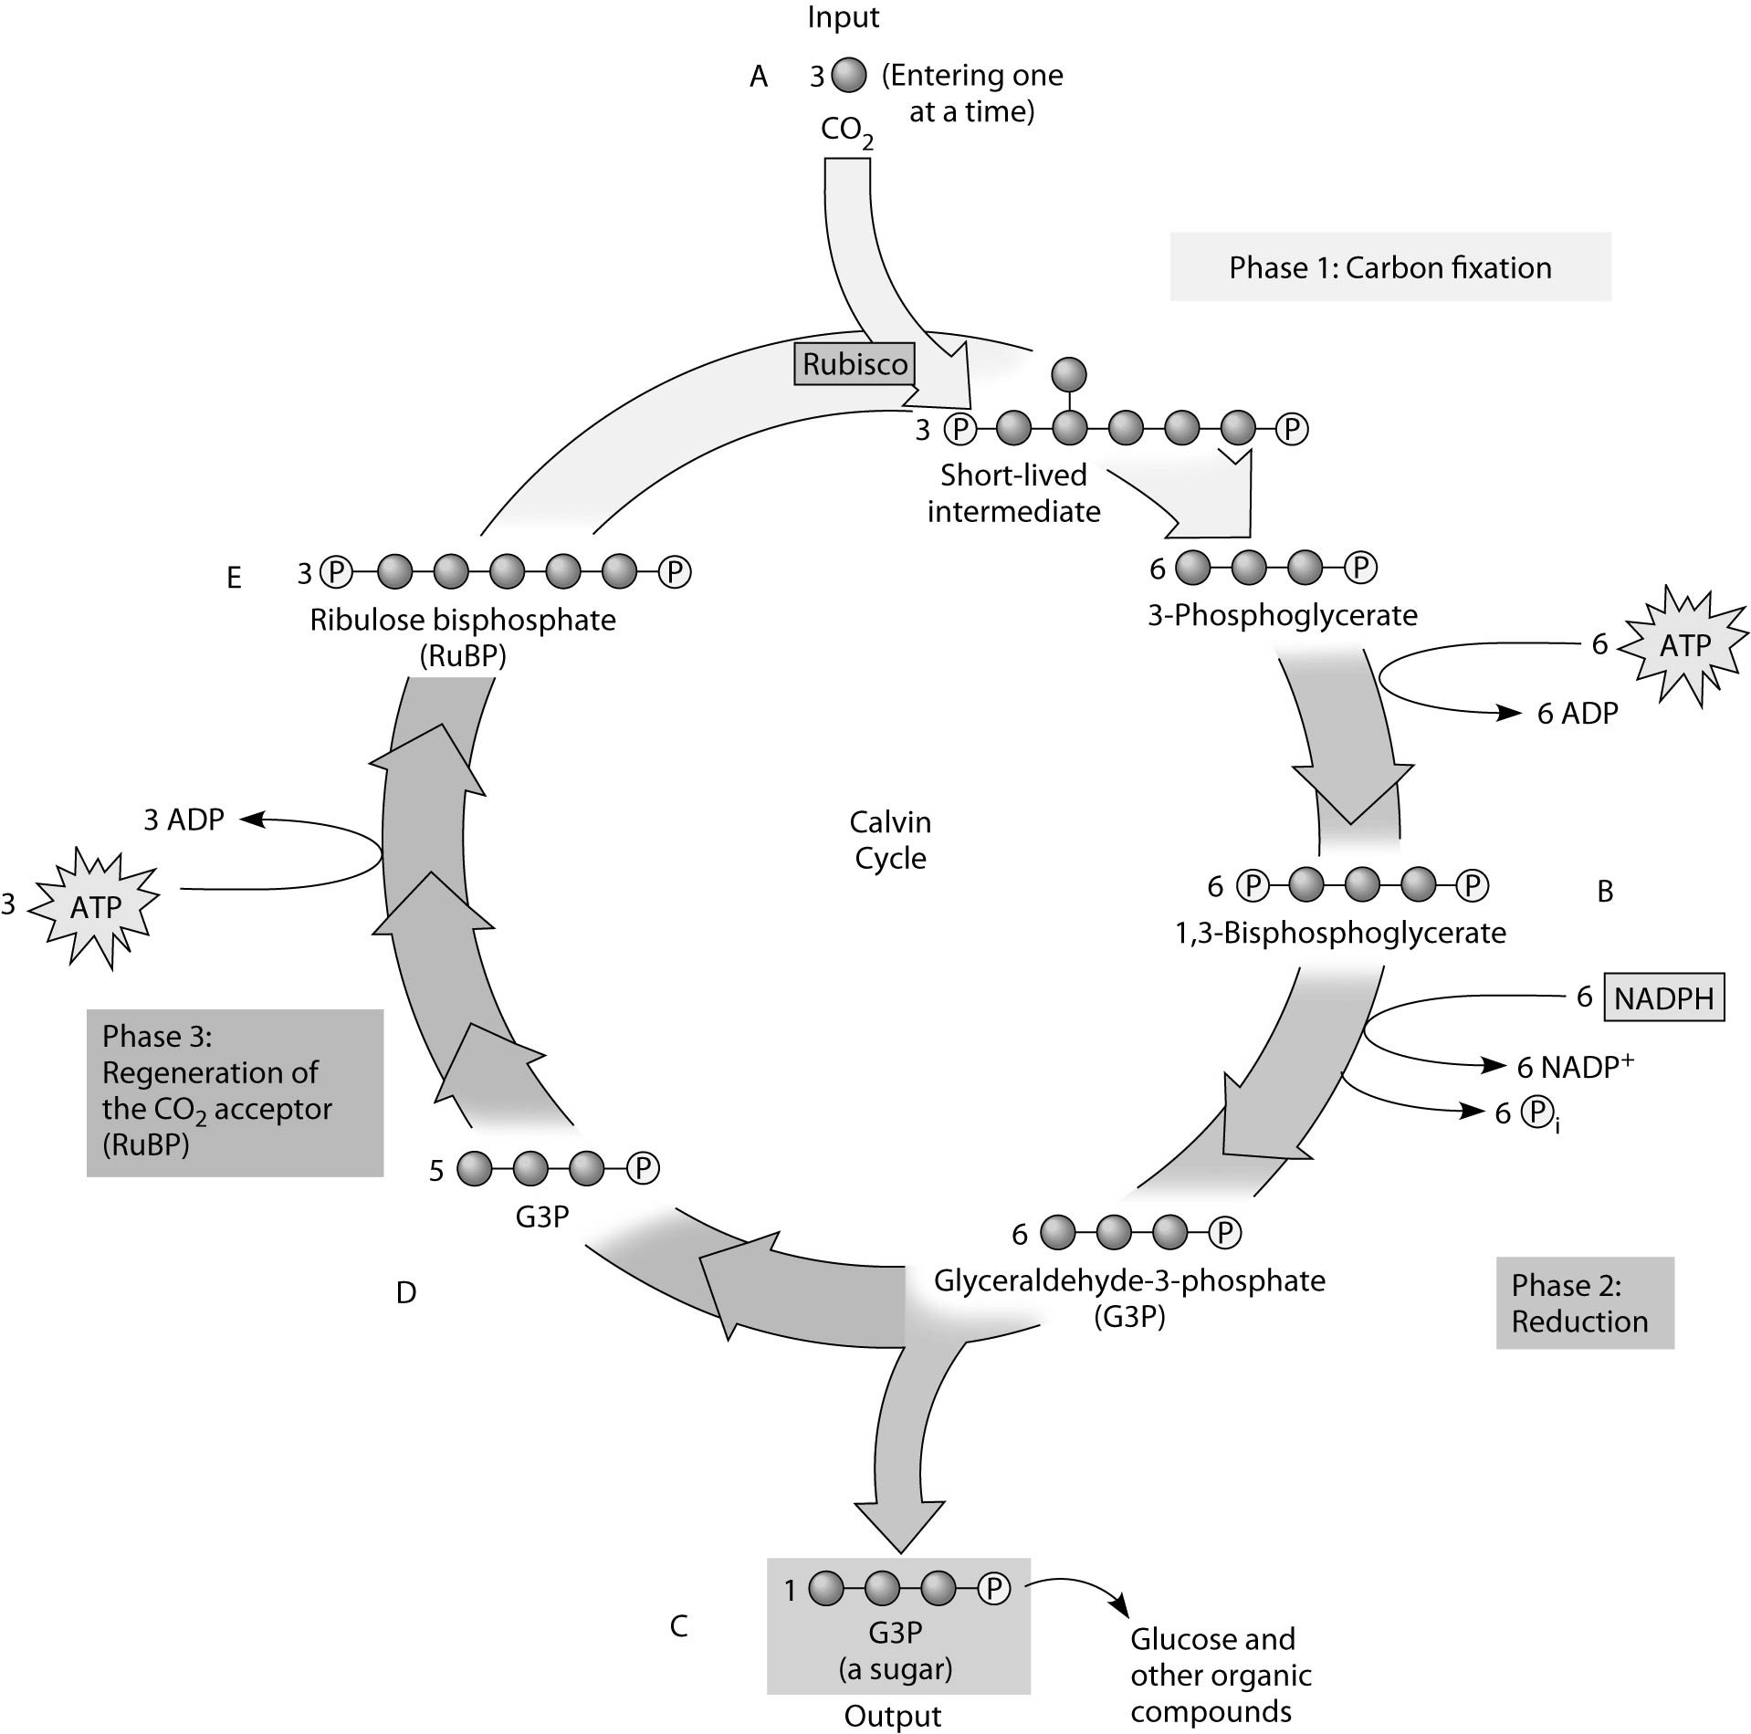

37) If the carbon atom of the CO2 molecule that enters the Calvin cycle is a radioactive isotope of carbon and the Calvin does several "turns", then all of the following molecules might become radioactive except...
A) PGA
B) PGAL
C) Glucose
D) RuBP
E) ATP

38) All plants close their stoma in hot weather to slow down water evaporation. When the stoma are closed, C3 plants don’t do photosynthesis efficiently because...
A) The CO₂ concentration inside the leaf becomes too high.
B) The CO₂ concentration inside the leaf becomes too low.
C) The O₂ concentration inside the leaf becomes too high.
D) NADPH becomes scarce.

39) In an experiment studying photosynthesis, you provide a C3 plant with radioactive carbon dioxide. The first stable molecule that the radioactive carbon dioxide is incorporated into is...
A) PGA
B) PGAL
C) a four carbon molecule
D) ATP
E) O₂

40) In an experiment studying photosynthesis, you provide a C4 plant with radioactive carbon dioxide. The first stable molecule that the radioactive carbon dioxide is incorporated into is...
A) PGA
B) PGAL
C) a four carbon molecule
D) ATP
E) O₂

41) What exactly do C4 plants do differently than C3 plants?
A) They do not perform the Calvin cycle.
B) They initially fix CO₂ as a four carbon molecule.
C) They are adapted to cold, wet climates.
D) They exclude oxygen from their tissues.

42) The alternative pathway of photosynthesis used by C4 plants is less efficient than the photosynthesis pathway of C3 plants when...
A) the weather is cold.
B) the weather is hot.
C) glucose is freely available.
D) the plants are in the dark.
E) the soil is missing certain vital nutrients.

43) Compared to C3 plants, C4 plants...
A) can continue to fix CO2 even at relatively low CO2 concentrations
B) always have higher rates of photosynthesis.
C) do not use RuBP in their photosynthesis reactions
D) grow better under cool, moist conditions.

Answers to multiple choice questions:

1) A
2) C
3) D
4) E
5) A
6) B
7) B
8) D
9) A
10) E
11) A
12) C
13) D
14) C
15) B
16) B
17) D
18) A
19) A
20) C
21) A
22) C
23) B
24) A
25) A
26) B
27) C
28) B
29) C
30) E
31) A
32) E
33) A
34) D
35) D
36) C
37) E
38) B
39) A
40) C
41) B
42) A
43) A

