These review questions are for Bio 1 Mitosis topic. The questions were adapted from several sources, including the textbook’s review questions.

1) What is a cleavage furrow?
A) a ring of vesicles forming a cell plate
B) the separation of divided prokaryotes
C) a groove in the plasma membrane of a dividing cell.
D) the metaphase plate where chromosomes attach to the spindle
E) the space that is created between two chromatids during anaphase

2) Through a microscope, you can see a cell plate beginning to develop across the middle of a cell and nuclei on either side of the cell plate. This cell is most likely...
A) an animal cell in the process of cytokinesis.
B) a plant cell in the process of cytokinesis.
C) an animal cell in the S phase of the cell cycle.
D) a bacterial cell dividing.
E) a plant cell in metaphase.

3) In the cells of some organisms, mitosis occurs without cytokinesis. This will result in...
A) cells with more than one nucleus.
B) cells that are unusually small.
C) cells lacking nuclei.
D) destruction of chromosomes.
E) cell cycles lacking an S phase.

4) Starting with a fertilized egg (zygote), a series of five cell divisions would produce an early embryo with how many cells?
A) 4
B) 8
C) 16
D) 32
E) 64

5) If there are 20 chromatids in a cell that has duplicated its DNA (in S phase), how many centromeres are there?
A) 10
B) 20
C) 30
D) 40
E) 80

6) What is the function of DNA polymerase III?
A) to unwind the DNA helix during replication
B) to seal together the broken ends of DNA strands
C) to add nucleotides to the 3' end of a growing DNA strand
D) to degrade damaged DNA molecules
E) to rejoin the two DNA strands (one new and one old) after replication

7) Which enzyme covalently connects segments of DNA?
A) DNA polymerase III
B) Ligase
C) Amylase
D) Primase
E) RNA polymerase

8) Which enzyme synthesizes short segments of RNA as part of duplicating the chromosomes?
A) DNA polymerase III
B) Ligase
C) Amylase
D) Primase
E) RNA polymerase

9) Which enzyme makes a complimentary DNA strand on a template DNA strand?
A) DNA polymerase III
B) Ligase
C) Amylase
D) Primase
E) RNA polymerase

10) Which enzyme elongates a DNA strand in the 5' → 3' direction?
A) Primase
B) DNA ligase
C) DNA polymerase III
D) Topoisomerase
E) Helicase

11) The elongation of the leading strand during DNA synthesis (S phase)...
A) progresses away from the replication fork.
B) produces Okazaki fragments.
C) requires the action of DNA polymerase III.
D) does not require a template strand.

12) One common feature of all DNA polymerase enzymes is that they...
A) Make DNA strands in the 3’ to 5’ direction
B) Make DNA strands in the 5’ to 3’ direction
C) Synthesize DNA in both directions
D) Do not require a primer
E) Do not require a template strand

13) A biochemist adds to a test tube some of the enzymes needed for DNA replication. Then she adds some chromosomal DNA, hoping that the DNA will be replicated. Replication occurs, but some DNA molecules consist of a normal strand paired with numerous segments of DNA a few hundred nucleotides long. What has she probably left out of the mixture?
A) DNA polymerase
B) DNA ligase
C) RNA polymerase
D) Okazaki fragments
E) primase

14) An Okazaki fragment (which is DNA and an RNA primer) has which of the following arrangements of nucleotides?
A) primase, polymerase, ligase
B) RNA nucleotides at its 3’ end, DNA nucleotides at its 5’ end
C) RNA nucleotides at its 5’ end, DNA nucleotides at its 3’ end
D) DNA polymerase I, DNA polymerase III
E) a mixture alternating RNA and DNA throughout the length of the Okazaki fragment

15) At a specific area of a chromosome, the sequence of nucleotides below is present where the DNA opens to form a replication fork:
3' C C T A G G C T G C A A T C C 5'
An RNA primer is formed starting at the underlined T (T) of the template. Which of the following represents the primer sequence?
A) 5' G C C T A G G 3'
B) 3' G C C T A G G 5'
C) 5' A C G T T A G G 3'
D) 5' A C G U U A G G 3'
E) 5' G C C U A G G 3'

16) The leading and the lagging strands differ in that...
A) the leading strand is synthesized in the same direction as the movement of the replication fork, and the lagging strand is synthesized in the opposite direction.
B) the leading strand is synthesized by adding nucleotides to the 3' end of the growing strand, and the lagging strand is synthesized by adding nucleotides to the 5' end.
C) the lagging strand is synthesized continuously, whereas the leading strand is synthesized in short fragments that are ultimately stitched together.
D) the leading strand is synthesized at twice the rate of the lagging strand.

17) What is the role of DNA ligase in the elongation of the lagging strand during DNA replication?
A) It synthesizes RNA nucleotides to make a primer.
B) It catalyzes the lengthening of telomeres.
C) It joins Okazaki fragments together.
D) It unwinds the parental double helix.
E) It stabilizes the unwound parental DNA.

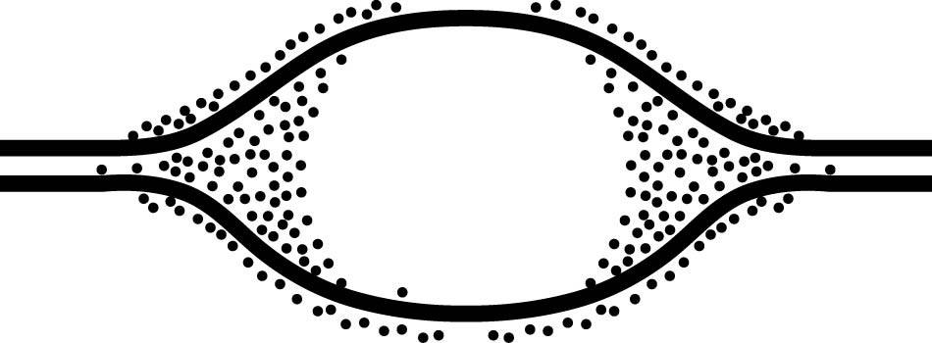

18) The solid lines on the diagram above represent the two DNA strands of a chromosome. The dots are molecules involved in duplicating the chromosome.

What is the term for the open space in the middle where the DNA is single stranded?
A) Replication bubble.
B) Replication fork.
C) Okazaki fragment.
D) Leading strand.
E) Lagging strand.

19) The solid lines on the previous diagram represent the two DNA strands of a chromosome. The dots are molecules involved in duplicating the chromosome.

What is the term for the Y-shaped regions on the left and right sides of the open space?
A) Replication bubble.
B) Replication fork.
C) Okazaki fragment.
D) Leading strand.
E) Lagging strand.

20) You briefly expose bacteria undergoing DNA replication to radioactively labeled DNA nucleotides. When you centrifuge the DNA isolated from the bacteria, the DNA separates into two classes. One class of labeled DNA includes very large molecules (thousands or even millions of nucleotides long), and the other includes short stretches of DNA (only a few hundred nucleotides in length). These two classes of DNA probably represent
A) leading strands and Okazaki fragments.
B) lagging strands and Okazaki fragments.
C) Okazaki fragments and RNA primers.
D) leading strands and RNA primers.
E) RNA primers and mitochondrial DNA.

21) If the activity of DNA ligase enzyme were removed from DNA replication, the majority of problems would occur in...
A) The completion of the lagging strand
B) The completion of the leading strand
C) Priming the DNA polymersase
D) Opening of the replication forks
E) Removing the RNA primers

22) Why might a mutation of one nucleotide in a gene make a difference in the level of protein's activity?
A) It might cleave a peptide bond.
B) It might exchange one stop codon for another stop codon.
C) It might exchange one serine codon for a different serine codon.
D) It might substitute an amino acid in the active site, reducing binding.
E) It might substitute the N-terminus of the polypeptide for the C-terminus.

23) What is the relationship between mutations and evolution?
A) Mutations usually make genes function better
B) Mutations create new alleles
C) Mutations happened early in evolution but not now
D) There is no relationship between evolution and mutations

24) A mutation is defined as...
A) A change that makes a protein function better
B) A change that cause new physical features in an organism (for example, extra sense organs)
C) A change in a protein
D) A change in the DNA sequence of a gene

25) A mutation that changes a codon into another codon for the same amino acid is...
A) a missense mutation
B) a frameshift mutation
C) a silent mutation
D) a nonsense mutation
E) not considered a type of mutation because it does not alter the protein product of the gene

26) A mutation that changes a codon into a codon for a different amino acid is...
A) a missense mutation
B) a frameshift mutation
C) a silent mutation
D) a nonsense mutation
E) not considered a type of mutation because it does not alter the protein product of the gene

27) A mutation that adds a new nucleotide (a new G, A, T or C) into a gene’s sequence is a type of...
A) a missense mutation
B) a frameshift mutation
C) a silent mutation
D) a nonsense mutation
E) not considered a type of mutation because it does not alter the protein product of the gene

28) A mutation that removes a nucleotide (G, A, T, or C) from a gene’s sequence is a type of...
A) a missense mutation
B) a frameshift mutation
C) a silent mutation
D) a nonsense mutation
E) not considered a type of mutation because it does not alter the protein product of the gene

29) A mutation that changes an amino acid’s codon into a stop codon is...
A) a missense mutation
B) a frameshift mutation
C) a silent mutation
D) a nonsense mutation
E) not considered a type of mutation because it does not alter the protein product of the gene

30) Which of the following types of mutation is likely to have the most serious effect on the protein encoded by a gene?
A) a deletion of one codon
B) a deletion of two nucleotides
C) a substitution of the third nucleotide in an ACC codon
D) a substitution of the first nucleotide of a GGG codon
E) an insertion of a codon

31) A nonsense mutation is a mutation that...
A) changes an amino acid into another amino acid in the encoded protein.
B) has no effect on the amino acid sequence of the encoded protein.
C) introduces a premature stop codon into the mRNA.
D) alters the reading frame of the mRNA.
E) prevents introns from being excised.

32) A frameshift mutation could result from...
A) a nucleotide insertion only.
B) a nucleotide deletion only.
C) a nucleotide substitution only.
D) deletion of three consecutive nucleotides
E) either an insertion or a deletion of a nucleotide.

33) Which of the following DNA mutations is the most likely to be damaging to the protein it specifies?
A) a base-pair deletion
B) a codon substitution
C) a substitution in the last base of a codon
D) a codon deletion
E) a silent mutation

34) Which mutation would be most likely to have a catastrophic effect on the functioning of a protein?
A) a nucleotide substitution.
B) a nucleotide deletion near the start of the coding region of a gene.
C) a nucleotide deletion near the end of the coding region of a gene.
D) deletion of three nucleotides near the start of the coding sequence.
E) a nucleotide insertion near the end of the coding region of a gene.

35) The most commonly occurring mutation in people with cystic fibrosis is a deletion of a single codon. This results in...
A) a nucleotide-pair substitution.
B) a nucleotide mismatch.
C) a frameshift mutation.
D) a polypeptide missing an amino acid.
E) a nonsense mutation.

36) A silent mutation is a mutation that...
A) Improves the protein encoded by the gene
B) Does not change the protein encoded by the gene
C) Stops the gene from being expressed
D) Is deadly to the organism (silent but deadly)

37) Measurements of the amount of DNA per nucleus were taken on a large number of cells from a growing fungus. The measured DNA levels ranged from 3 to 6 picograms per nucleus. Which was the first stage of the cell cycle that the nucleus began with 6 picograms of DNA?
A) G0
B) G1
C) S
D) G2
E) M

38) A group of cells is tested for DNA content immediately following mitosis and is found to have an average of 8 picograms of DNA per nucleus. How many picograms would be found at the end of S phase and at the end of G2 phase?
A) S = 8; G2 = 8
B) S = 8; G2 = 16
C) S = 16; G2 = 8
D) S = 16; G2 = 16
E) S = 12; G2 = 16

39) A plant-derived protein known as colchicine can be used to poison cells by blocking the formation of the spindle. Which of the following would result if colchicine is added to a sample of cells in G2?
A) The cells would immediately die.
B) The cell cycle would halt. Under a microscope, the cell's chromosomes would appear to be halted in prophase.
C) The cell cycle would halt. Under a microscope, the cell's chromosomes would appear to be halted in metaphase.
D) The cell cycle would halt. Under a microscope, the cell's chromosomes would appear to be halted in anaphase.
E) Mitosis would work correctly in that cell cycle, but each resultant daughter cell would have duplicated chromosomes.

40) Which of the following does not occur during prophase, metaphase, anaphase, or telophase of mitosis?
A) condensation of the chromosomes
B) replication of the DNA
C) separation of sister chromatids
D) spindle formation
E) Centrosomes appear at poles of the cell

41) Suppose you are provided with an actively dividing culture of cells to which radioactive thymine DNA nucleotide has been added. What would happen if each cell replicates once in the presence of this radioactive nucleotide?
A) One of the daughter cells, but not the other, would have radioactive DNA.
B) Neither of the two daughter cells would be radioactive.
C) All four bases of the DNA would be radioactive.
D) Radioactive thymine would pair with nonradioactive guanine.
E) DNA in both daughter cells would be radioactive.

42) Where do the microtubules of the spindle grow out of in animal cells?
A) centromere
B) centrosome
C) chromosome
D) chromatid
E) kinetochore

43) The kinetochore is a structure that functions to...
A) Connect the centromere to the spindle microtubules
B) Connect centrioles to the spindle microtubules
C) Aid in chromosome condensation (wrapping onto histones)
D) Aid in chromosome replication by priming DNA polymerase
E) Divide the cytoplasm at the cleavage furrow

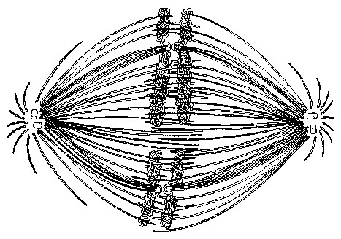

44) The figure above shows chromosomes lined up at the equator of the cell, attached to spindle fibers. At both the left and the right side of the figure are two small white structures in the middle of a starburst pattern of spindle fibers. What is the name of each of the small white structures?
A) centrosomes
B) centrioles
C) chromosomes
D) kinetochores
E) actin filaments

45) The previous figure shows chromosomes lined up at the equator of the cell, attached to spindle fibers. At both the left and the right side of the figure are two small white structures in the middle of a starburst pattern of spindle fibers. What is the name of each pair of the small white structures?
A) centrosomes
B) centrioles
C) chromosomes
D) kinetochores
E) actin filaments

46) Vinblastine is a standard chemotherapeutic drug used to treat cancer. Because it interferes with the assembly of microtubules, its effectiveness must be related to...
A) disruption of mitotic spindle formation.
B) inhibition of regulatory protein phosphorylation.
C) suppression proto-oncogene production.
D) actin denaturation and inhibition of cleavage furrow formation.
E) inhibition of DNA synthesis.

46) At which mitosis phase are chromosomes beginning to move apart to the poles of animal cells?
A) telophase
B) anaphase
C) cytokinesis
D) metaphase
E) prophase

48) If cells in the process of dividing are subjected to colchicine, a drug that interferes with the formation of the spindle apparatus, at which stage will the chromosomes first be in an abnormal location?
A) anaphase
B) prophase
C) telophase
D) metaphase
E) interphase

49) If there are 20 centromeres in a cell at anaphase, how many chromosomes are there in each daughter cell following cytokinesis?
A) 10
B) 20
C) 30
D) 40
E) 80

50) If you added a drug to a group of cells that had just started anaphase, the normal movement of the chromosomes would be disrupted if the drug...
A) reduced DNA polymerase concentrations.
B) increased DNA polymerase concentrations.
C) prevented elongation of microtubules.
D) prevented shortening of microtubules.
E) prevented attachment of the microtubules to the kinetochore.

51) Separation of sister chromatids from each other occurs first during...
A) telophase
B) anaphase
C) prophase
D) metaphase
E) cytokinesis

52) Cytokinesis is defined as...
A) The separation of chromosomes to opposite poles of the cell
B) The division of the membrane and cytoplasm
C) The signal that causes a cell to re-enter the cell cycle
D) The signal that allows the cell to halt at the checkpoint G₂ checkpoint

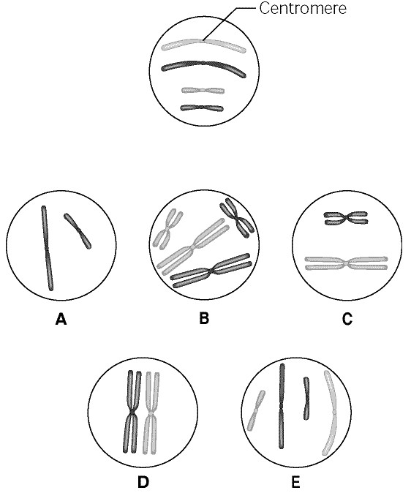

53) The circle at the top of the figure above shows a diploid nucleus with four chromosomes. There are two pairs of homologous chromosomes, one long and the other short. One haploid set is symbolized as black and the other haploid set is gray. The chromosomes in the top circle have not yet replicated. Choose one of the correct chromosomal conditions shown in the lettered circles to answer the following question:

What is the correct chromosomal condition at prophase of mitosis?
A) A
B) B
C) C
D) D
E) E

54) The circle at the top of the previous figure shows a diploid nucleus with four chromosomes. There are two pairs of homologous chromosomes, one long and the other short. One haploid set is symbolized as black and the other haploid set is gray. The chromosomes in the top circle have not yet replicated. Choose one of the correct chromosomal conditions shown in the lettered circles to answer the following question:

What is the correct chromosomal condition for the nucleus at telophase of mitosis?
A) A
B) B
C) C
D) D
E) E
F) None

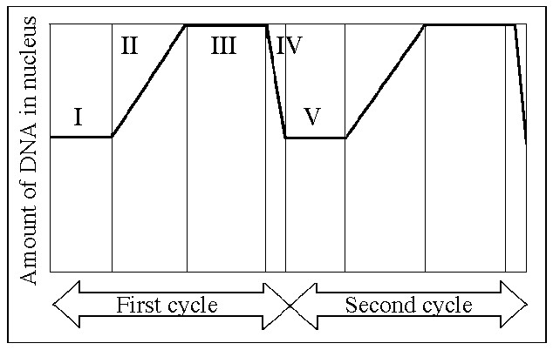

55) In the above figure, the black line represents the total amount of DNA in the nucleus. Prophase would occur during which numbered part of the cell cycle?
A) I
B) II
C) III
D) IV
E) V

56) In the previous figure, the black line represents the total amount of DNA in the nucleus. G1 is represented by which numbered part(s) of the cycle?
A) I or V
B) II or IV
C) III only
D) IV only
E) V only

57) In the previous figure, the black line represents the total amount of DNA in the nucleus. S phase is represented by which numbered part(s) of the cycle?
A) I
B) II
C) III
D) IV
E) V

58) In the previous figure, the black line represents the total amount of DNA in the nucleus. Which number represents the point in the cell cycle during which the chromosomes become replicated?
A) I
B) II
C) III
D) IV
E) V

59) In the previous figure, the black line represents the total amount of DNA in the nucleus. Metaphase would occur during which numbered part of the cell cycle?
A) I and IV
B) II only
C) III only
D) IV only
E) V only

60) A particular cell has half as much DNA as some other cells in a mitotically active tissue. The cell in question is most likely in...
A) G1.
B) G2.
C) prophase.
D) metaphase.
E) anaphase.

Answers to review questions:

1) C
2) B
3) A
4) D
5) A
6) C
7) B
8) D
9) A
10) C
11) C
12) B
13) B
14) C
15) D
16) A
17) C
18) A
19) B
20) A
21) A
22) D
23) B
24) D
25) C
26) A
27) B
28) B
29) D
30) B
31) C
32) E
33) A
34) B
35) D
36) B
37) D
38) D
39) B
40) B
41) E
42) B
43) A
44) B
45) A
46) A
47) B
48) D
49) A
50) D
51) B
52) B
53) B
54) F
55) C
56) A
57) B
58) B
59) C
60) A

