These review questions are for Bio 1 Meiosis topic. The questions were adapted from several sources, including the textbook’s review questions.

1) Meiosis makes...
A) haploid daughter cells from haploid sex cells (sperm and eggs).
B) diploid daughter cells from diploid mother cells.
C) haploid daughter cells from diploid mother cells.
D) diploid cells from fusion of two haploid cells.
E) diploid cells from fusion of four haploid cells.

2) Before a cell undergoes meiosis 1, what must take place?
A) The cell must be in G_{O} phase
B) Half the chromosomes must migrate to opposite poles
C) The cell must become haploid
D) meiosis 2 must occur
E) The chromosomes must be duplicated

3) At the end of meiosis 1, the daughter cells are...
A) Haploid with unduplicated chromosomes
B) Diploid with unduplicated chromosomes
C) Haploid with duplicated chromosomes
D) Diploid with duplicated chromosomes
E) Diploid with half the chromosomes duplicated and half unduplicated

4) Before a cell undergoes meiosis 2, what must take place?
A) The cell must be in G_{O} phase
B) The duplicated chromosomes must duplicate again (4n total)
C) The cell must be diploid
D) meiosis 1 must be completed
E) The chromosomes must be unduplicated

5) At the end of meiosis 2, the daughter cells are...
A) Haploid with unduplicated chromosomes
B) Diploid with unduplicated chromosomes
C) Haploid with duplicated chromosomes
D) Diploid with duplicated chromosomes
E) Diploid with half the chromosomes duplicated and half unduplicated

6) Which of these statements is false?
A) In humans, meiosis produces 4 sperm cells from each diploid mother cell.
B) In humans, meiosis produces 1 egg cell from each diploid mother cell.
C) In humans, meiosis produces three polar bodies for each egg cell produced.
D) Sperm cell production results in more polar bodies than egg cell production.
E) The polar bodies have the same number of chromosomes as the egg cell.

7) A given diploid organism has 46 chromosomes in its karyotype. Which of the following must be true?
A) It must be human.
B) It must be a primate.
C) It must be an animal.
D) It must be a plant.
E) Its gametes must have 23 chromosomes.

8) If a cell has completed meiosis 1 and is just beginning meiosis 2, which of the following is an appropriate description of its contents?
A) It has half the amount of DNA as the mother cell that began meiosis 1.
B) It has the same number of chromosomes as the mother cell but they are unduplicated.
C) It has half the chromosomes but twice the DNA of the mother cell.
D) It has one-fourth the DNA and one-half the chromosomes as the mother cell.
E) The alleles it contains are the same as the other daughter cell of meiosis 1.

9) After meiosis 1, the chromosomal makeup of each daughter cell is...
A) diploid, and the chromosomes are each composed of a single chromatid.
B) diploid, and the chromosomes are each composed of two chromatids.
C) haploid, and the chromosomes are each composed of a single chromatid.
D) haploid, and the chromosomes are each composed of two chromatids.
E) tetraploid, and the chromosomes are each composed of two chromatids.

10) Compared to mother cells that have replicated their DNA and are just about to begin meiosis 1, cells that have just completed meiosis 2...
A) have twice the amount of cytoplasm and half the amount of DNA.
B) have half the number of chromosomes and half the amount of DNA.
C) have the same number of chromosomes and half the amount of DNA.
D) have half the number of chromosomes and one-fourth the amount of DNA.
E) have half the amount of cytoplasm and twice the amount of DNA.

11) Which of the following happens at the conclusion of meiosis 1?
A) Homologous chromosome pairs are separated into separate daughter cells.
B) The chromosome number per cell is the same as the mother cell.
C) Sister chromatids are separated.
D) Four daughter cells are formed.
E) The chromosomes are unduplicated.

12) What occurs during anaphase of meiosis 1?
A) Sister chromatids separate and move to opposite poles
B) Homologous chromosomes move to opposite poles
C) Homologous chromosomes align at the middle of the cell
D) All the chromosomes align independently at the middle of the cell
E) Sister chromatids cross over

13) Meiosis II is similar to mitosis in that...
A) sister chromatids separate during anaphase.
B) DNA replicates before the division.
C) the daughter cells are diploid.
D) homologous chromosomes cross over.
E) the chromosome number is reduced.

14) In meiosis, when do centromeres of sister chromatids disjoin and chromatids separate?
A) late prophase of meiosis I
B) during fertilization or fusion of gametes
C) anaphase of meiosis I
D) mid-prophase of meiosis II
E) anaphase of meiosis II

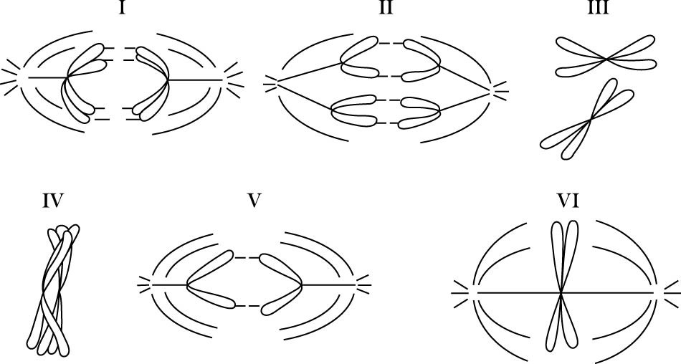

15) In the figure above, parts I, III, and IV show a pair of homologous chromosomes. Which part of the figure represents anaphase of meiosis 1?
A) I
B) II
C) IV
D) V
E) VI

16) In the previous figure, which diagram represents anaphase II of meiosis?
A) II only
B) III only
C) IV only
D) V only
E) either II or V

17) Sister chromatids are separated from each other.
A) The statement is true for mitosis only.
B) The statement is true for meiosis I only.
C) The statement is true for meiosis II only.
D) The statement is true for mitosis and meiosis I.
E) The statement is true for mitosis and meiosis II.

18) What occurs in anaphase of meiosis 2?
A) The homologous chromosomes align
B) Sister chromatids are pulled to opposite poles
C) Homologous chromosomes are pulled to opposite poles
D) The haploid chromosomes line up

19) If the DNA content of a diploid cell in the G1 phase of the cell cycle is x, then the DNA content of the same cell at metaphase of meiosis 1 would be...
A) 0.25x.
B) 0.5x.
C) x.
D) 2x.
E) 4x.

20) If the DNA content of a diploid cell in the G1 phase of the cell cycle is x, then the DNA content of a single cell at metaphase of meiosis II would be...
A) 0.25x.
B) 0.5x.
C) x.
D) 2x.
E) 4x.

21) If the DNA content of a diploid cell in the G1 phase of the cell cycle is x, then the DNA content of a single daughter cell of meiosis II would be...
A) 0.25x.
B) 0.5x.
C) x.
D) 2x.
E) 4x.

22) Independent assortment of chromosomes occurs...
A) in mitosis only.
B) in meiosis I only.
C) in meiosis II only.
D) in mitosis and meiosis I.

23) By independent assortment, how many different combinations of maternal and paternal chromosomes can be packaged in gametes made by an organism with a diploid (2n) number of 8?
A) 2
B) 4
C) 8
D) 16
E) 32

24) When does crossing over occur?
A) Meiosis I
B) During fertilization (fusion of gametes)
C) Meiosis II
D) Mitosis and Meiosis I
E) Mitosis and Meiosis II

25) Which of the following occurs in meiosis but not in mitosis?
A) chromosome replication
B) synapsis of chromosomes
C) production of daughter cells
D) alignment of chromosomes at the cell equator
E) condensation of chromatin

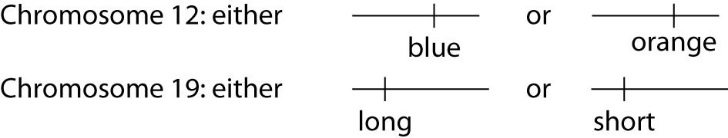

26) A certain (hypothetical) organism is diploid. This organism may have blue or orange wings as the consequence of one of its genes on chromosome 12, and it may have either long or short wings as the result of a second gene on chromosome 19, as shown in the figure above. Use this information to answer the following question.

A certain female's number 12 chromosomes both have the blue gene and her number 19 chromosomes both have the long gene. As cells in her ovaries undergo meiosis, her resulting eggs (ova) may have which of the following?
A) either two number 12 chromosomes with blue genes or two with orange genes
B) either two number 19 chromosomes with long genes or two with short genes
C) either one blue or one orange gene in addition to either one long or one short gene
D) one chromosome 12 with one blue gene and one chromosome 19 with one long gene

27) A certain (hypothetical) organism is diploid. This organism may have blue or orange wings as the consequence of one of its genes on chromosome 12, and it may have either long or short wings as the result of a second gene on chromosome 19, as shown in the previous figure. Use this information to answer the following question.

If a female of this species has one chromosome 12 with a blue gene and another chromosome 12 with an orange gene, and has both number 19 chromosomes with short genes, she will produce which of the following egg types?
A) only blue short gene eggs
B) only orange short gene eggs
C) one-half blue short and one-half orange short gene eggs
D) three-fourths blue long and one-fourth orange short gene eggs
E) three-fourths blue short and one-fourth orange short gene eggs

28) A certain (hypothetical) organism is diploid. This organism may have blue or orange wings as the consequence of one of its genes on chromosome 12, and it may have either long or short wings as the result of a second gene on chromosome 19, as shown in the previous figure. Use this information to answer the following question.

A female inherited from her father one orange wing gene and one long wing gene. This same female inherited from her mother one blue wing gene and one short wing gene. This female is expected to produce which of the following types of eggs after meiosis?
A) All eggs will have maternal types of gene combinations (genes for blue short wings).
B) All eggs will have paternal types of gene combinations (genes for orange long wings).
C) Half the eggs will have maternal (genes for blue short wings) and half will have paternal (genes for orange long wings).combinations.
D) Each egg has a one-fourth chance of having either blue long, blue short, orange long, or orange short combinations.
E) Each egg has a three-fourths chance of having blue long, one-fourth blue short, three-fourths orange long, or one-fourth orange short combinations.

29) Imagine a type of organism that does not do crossing over in its cells. A cell from this organism divides to produce two daughter cells that are genetically different from each other.
A) The statement is true for mitosis only.
B) The statement is true for meiosis I only.
C) The statement is true for meiosis II only.
D) The statement is true for mitosis and meiosis I.
E) The statement is true for mitosis and meiosis II.

30) In comparing normal body cells (such as skin cells or nerve cells) with gametes (sperm and eggs), the normal body cells are...
A) Diploid with half the number of chromosomes as gametes
B) Haploid with half the number of chromosomes as gametes
C) Diploid with twice the number of chromosomes as gametes
D) Haploid with twice the number of chromosomes as gametes

31) If you were observing a dividing cell using a microscope and you saw duplicated homologous chromosomes move toward opposite poles of the cell (in other words, a duplicated chromosome 1 was moving toward the top pole of the cell and a duplicated chromosome 1 was moving toward the bottom pole of the cell), the cell must be in...
A) mitosis.
B) meiosis I.
C) meiosis II.
D) fertilization.
E) binary fission.

Answers to review questions:

1) C
2) E
3) C
4) D
5) A
6) D
7) E
8) A
9) D
10) D
11) A
12) B
13) A
14) E
15) A
16) E
17) E
18) B
19) D
20) C
21) B
22) B
23) D
24) A
25) B
26) D
27) C
28) D
29) B
30) C
31) B

