These review questions are for the Bio 1 Genomes topic. These questions were adapted from several sources, including the textbook’s review questions.

Multiple choice review questions:

Genome

5) Which of the following defines a genome?
A) representation of a complete set of a cell's polypeptides
B) the complete set of an organism's polypeptides
C) the complete set of a species' polypeptides
D) a karyotype
E) the complete set of an organism's genes
Answer: E
Topic: Concept 13.1
Skill: Knowledge/Comprehension

97) Which of the following statements about the DNA in one of your brain cells is true?
A) Most of the DNA codes for protein.
B) The majority of genes are likely to be transcribed.
C) Each gene lies immediately adjacent to an enhancer.
D) Many genes are grouped into operon-like clusters.
E) It is the same as the DNA in one of your heart cells.
Answer: E
Topic: End-of-Chapter Questions
Skill: Application/Analysis

Differential gene expression’

91) Muscle cells differ from nerve cells mainly because they
A) express different genes.
B) contain different genes.
C) use different genetic codes.
D) have unique ribosomes.
E) have different chromosomes.
Answer: A
Topic: End-of-Chapter Questions
Skill: Knowledge/Comprehension

Control elements, enhancers, activators regulate expression

23) In eukaryotes, general transcription factors
A) are required for the expression of specific protein-encoding genes.
B) usually bind to a sequence element within the promoter such as the TATA box.
C) inhibit RNA polymerase binding to the promoter and begin transcribing.
D) usually lead to a high level of transcription even without additional specific transcription factors.
E) bind to sequences just after the start site of transcription.
Answer: B
Topic: Concept 18.2
Skill: Knowledge/Comprehension

92) The functioning of enhancers is an example of
A) transcriptional control of gene expression.
B) a post-transcriptional mechanism to regulate mRNA.
C) the stimulation of translation by initiation factors.
D) post-translational control that activates certain proteins.
E) a eukaryotic equivalent of prokaryotic promoter functioning.
Answer: A
Topic: End-of-Chapter Questions
Skill: Knowledge/Comprehension

Repressors by blocking activators and by changing chromatin and my methylation

41) Why do histones bind tightly to DNA?
A) Histones are positively charged, and DNA is negatively charged.
B) Histones are negatively charged, and DNA is positively charged.
C) Both histones and DNA are strongly hydrophobic.
D) Histones are covalently linked to the DNA.
E) Histones are highly hydrophobic, and DNA is hydrophilic.
Answer: A
Topic: Concept 16.3
Skill: Knowledge/Comprehension
43) Which of the following statements describes chromatin?
A) Heterochromatin is composed of DNA, whereas euchromatin is made of DNA and RNA.
B) Both heterochromatin and euchromatin are found in the cytoplasm.
C) Heterochromatin is highly condensed, whereas euchromatin is less compact.
D) Euchromatin is not transcribed, whereas heterochromatin is transcribed.
E) Only euchromatin is visible under the light microscope.
Answer: C
Topic: Concept 16.3
Skill: Knowledge/Comprehension

21) Two methods that eukaryotic cells use to regulate transcription are
A) DNA methylation and histone amplification.
B) DNA amplification and histone methylation.
C) DNA acetylation and methylation.
D) DNA methylation and histone modification.
E) histone amplification and DNA acetylation.
Answer: D
Topic: Concept 18.2
Skill: Knowledge/Comprehension

18) If you were to observe the activity of methylated DNA, you would expect it to
A) be replicating nearly continuously.
B) be unwinding in preparation for protein synthesis.
C) have turned off or slowed down the process of transcription.
D) be very actively transcribed and translated.
E) induce protein synthesis by not allowing repressors to bind to it.
Answer: C
Topic: Concept 18.2
Skill: Knowledge/Comprehension

A researcher found a method she could use to manipulate and quantify phosphorylation and methylation in embryonic cells in culture.

72) One of her colleagues suggested she try increased methylation of C nucleotides in a mammalian system. Which of the following results would she most likely see?
A) increased chromatin condensation
B) decreased chromatin condensation
C) abnormalities of mouse embryos
D) decreased binding of transcription factors
E) inactivation of the selected genes
Answer: E
Topic: Concept 18.2
Skill: Application/Analysis

Regulation by other means (alt splicing, interfereing RNA, etc.

94) Which of the following is an example of post-transcriptional control of gene expression?
A) the addition of methyl groups to cytosine bases of DNA
B) the binding of transcription factors to a promoter
C) the removal of introns and alternative splicing of exons
D) gene amplification contributing to cancer
E) the folding of DNA to form heterochromatin
Answer: C
Topic: End-of-Chapter Questions
Skill: Knowledge/Comprehension

28) Which of the following is most likely to have a small protein called ubiquitin attached to it?
A) a protein in the cytoplasm that is no longer required
B) a cell surface protein that is required for transport of glucose into the cell
C) an mRNA that is leaving the nucleus to be translated
D) an enzyme that is used for the Krebs cycle
E) an mRNA produced by an egg cell that will be retained until after fertilization
Answer: A
Topic: Concept 18.2
Skill: Synthesis/Evaluation

30) The phenomenon in which RNA molecules in a cell are destroyed if they have a sequence complementary to an introduced double-stranded RNA is called
A) RNA interference.
B) RNA obstruction.
C) RNA blocking.
D) RNA targeting.
E) RNA disposal.
Answer: A
Topic: Concept 18.3
Skill: Knowledge/Comprehension

33) Which of the following best describes siRNA?
A) a short RNA strand that can complement and inactivate a sequence of mRNA
B) a single-stranded RNA that can, where it has internal complementary base pairs, fold into cloverleaf patterns
C) a double-stranded DNA that is formed by cleavage of hairpin loops in a larger precursor
D) a portion of rRNA that allows it to bind to several ribosomal proteins in forming large or small subunits
E) a molecule, known as Dicer, that can degrade other mRNA sequences
Answer: A
Topic: Concept 18.3
Skill: Knowledge/Comprehension

34) One way scientists hope to use the recent knowledge gained about siRNAs lies with the possibilities for their use in medicine. Of the following scenarios for future research, which would you expect to gain most from siRNA research?
A) exploring a way to turn on the expression of pseudogenes
B) targeting siRNAs to disable the expression of an allele associated with autosomal recessive disease
C) targeting siRNAs to disable the expression of an allele associated with autosomal dominant disease
D) looking for a way to introduce viruses to human cells
Answer: C
Topic: Concept 18.3
Skill: Synthesis/Evaluation

35) Which of the following describes the function of an enzyme known as Dicer?
A) It degrades single-stranded DNA into individual nucleitides.
B) It degrades single-stranded mRNA into individual nucleitides.
C) It degrades mRNA with no poly-A tail.
D) It trims small double-stranded RNAs into molecules that can block translation.
E) It chops up single-stranded DNAs from infecting viruses.
Answer: D
Topic: Concept 18.3
Skill: Knowledge/Comprehension

A researcher introduces double-stranded RNA into a culture of mammalian cells, and can identify its location or that of its smaller subsections experimentally, using a fluorescent probe.

74) Within the first quarter hour, the researcher sees that the intact RNA is found in the cells. After 3 hours, she is not surprised to find that
A) Dicer enzyme has reduced it to smaller double-stranded pieces.
B) the RNA is degraded by 5' and 3' exonucleases.
C) the double-stranded RNA replicates itself.
D) the double-stranded RNA binds to mRNAs to prevent translation.
E) the double-stranded RNA binds to tRNAs to prevent translation.
Answer: A
Topic: Concept 18.3
Skill: Application/Analysis
75) Some time later, she finds that the introduced strand separates into single-stranded RNAs, one of which is degraded. What does this enable the remaining strand to do?
A) attach to histones in the chromatin
B) bind to complementary regions of target mRNAs
C) bind to Dicer enzymes to destroy other RNAs
D) activate other siRNAs in the cell
E) bind to noncomplementary RNA sequences
Answer: B
Topic: Concept 18.3
Skill: Application/Analysis

76) In addition, she finds what other evidence of this single-stranded RNA piece's activity?
A) She can measure the degradation rate of the remaining single strand.
B) She can measure the decrease in the concentration of Dicer.
C) The rate of accumulation of the polypeptide to be translated from the target mRNA is reduced.
D) The amount of miRNA is multiplied by its replication.
E) The cell's translation ability is entirely shut down.
Answer: C
Topic: Concept 18.3
Skill: Application/Analysis

98) Within a cell, the amount of protein made using a given mRNA molecule depends partly on
A) the degree of DNA methylation.
B) the rate at which the mRNA is degraded.
C) the presence of certain transcription factors.
D) the number of introns present in the mRNA.
E) the types of ribosomes present in the cytoplasm.
Answer: B
Topic: End-of-Chapter Questions
Skill: Application/Analysis

Human genome (general and duplications)

Transposable elements

22) Alu elements account for about 10% of the human genome. What does this mean?
A) Alu elements cannot be transcribed into RNA.
B) Alu elements evolved in very ancient times, before mammalian radiation.
C) Alu elements represent the result of transposition.
D) No Alu elements are found within individual genes.
E) Alu elements are cDNA and therefore related to retrotransposons.
Answer: C
Topic: Concept 21.4
Skill: Synthesis/Evaluation

40) One of the characteristics of retrotransposons is that
A) they code for an enzyme that synthesizes DNA using an RNA template.
B) they are found only in animal cells.
C) they generally move by a cut-and-paste mechanism.
D) they contribute a significant portion of the genetic variability seen within a population of gametes.
E) their amplification is dependent on a retrovirus.
Answer: A
Topic: End-of-Chapter Questions
Skill: Knowledge/Comprehension

26) Unequal crossing over during prophase I can result in one sister chromosome with a deletion and another with a duplication. A mutated form of hemoglobin, known as hemoglobin Lepore, is known in the human population. Hemoglobin Lepore has a deleted set of amino acids. If it was caused by unequal crossing over, what would be an expected consequence?
A) If it is still maintained in the human population, hemoglobin Lepore must be selected for in evolution.
B) There should also be persons born with, if not living long lives with, an anti-Lepore mutation or duplication.
C) Each of the genes in the hemoglobin gene family must show the same deletion.
D) The deleted gene must have undergone exon shuffling.
E) The deleted region must be located in a different area of the individual's genome.
Answer: B
Topic: Concept 21.5
Skill: Synthesis/Evaluation

27) When does exon shuffling occur?
A) during splicing of DNA
B) during mitotic recombination
C) as an alternative splicing pattern in post-transcriptional processing
D) as an alternative cleavage or modification post-translationally
E) as the result of faulty DNA repair
Answer: C
Topic: Concept 21.5
Skill: Knowledge/Comprehension

Use the following figure to answer the next few questions.

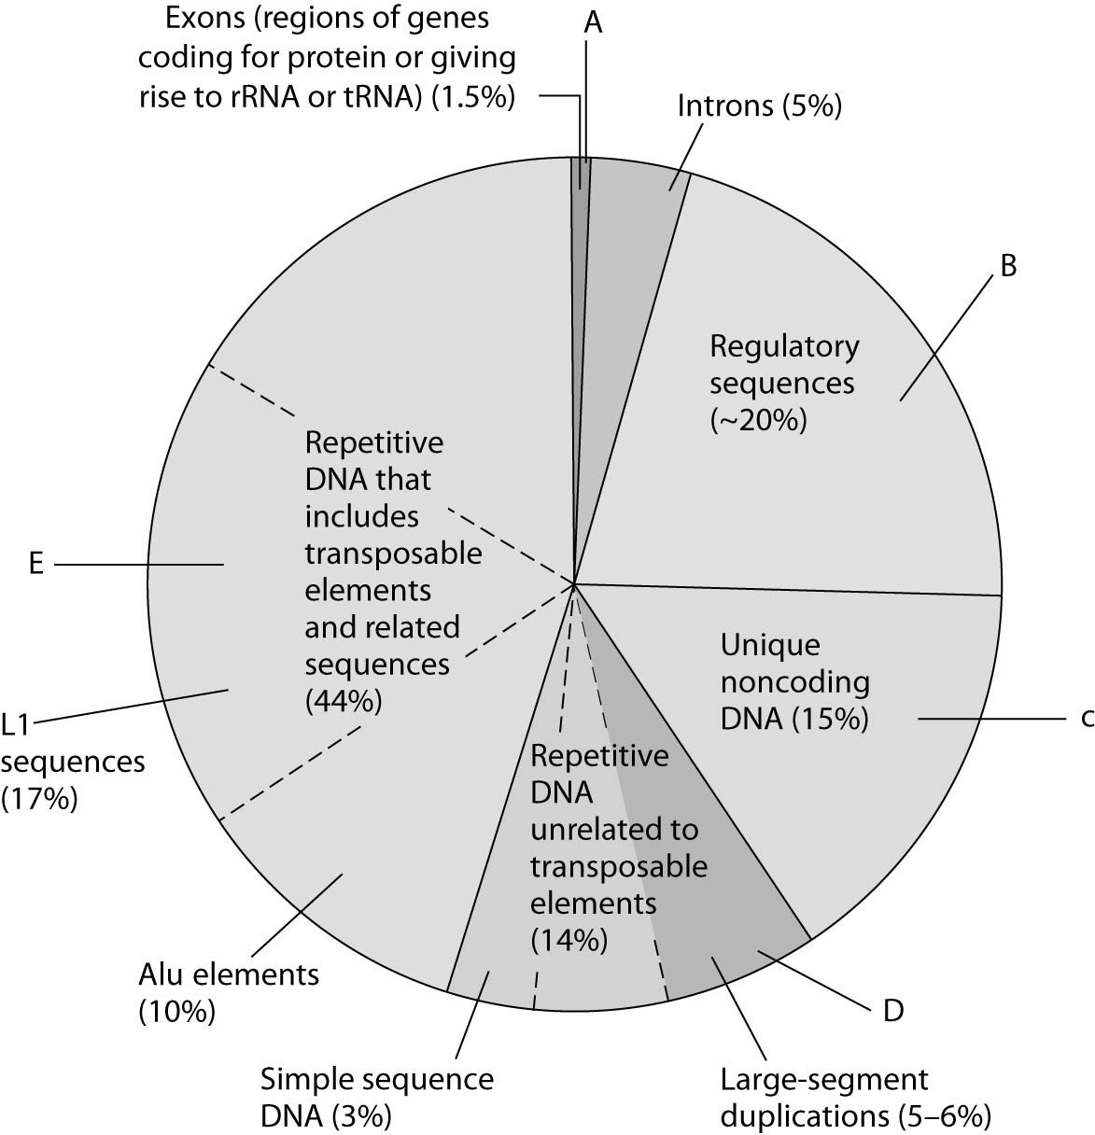

Figure 21.1 Types of DNA sequences in the human genome.

The pie chart in Figure 21.1 represents the relative frequencies of the following in the human genome:
I. repetitive DNA unrelated to transposons
II. repetitive DNA that includes transposons
III. unique noncoding DNA
IV. introns and regulatory sequences
V. exons

33) Which region is occupied by exons only (V)?
A) A
B) B
C) C
D) D
E) E
Answer: A
Topic: Concept 21.4
Skill: Application/Analysis

34) Which region includes Alu elements and LI sequences?
A) A
B) B
C) C
D) D
E) E
Answer: E
Topic: Concept 21.4
Skill: Application/Analysis

Multi gene families

20) What is the best description of pseudogenes?
A) They are genes that had a function at one time, but that have lost their function because they have been translocated to a new location.
B) They are genes that have accumulated mutations to such a degree that they would code for different functional products if activated.
C) They are duplicates or near duplicates of functional genes but cannot function because they would provide inappropriate dosage of protein products.
D) They are genes with significant inverted sequences.
E) They are genes that are not expressed, even though they have nearly identical sequences to expressed genes.
Answer: E
Topic: Concept 21.4
Skill: Synthesis/Evaluation

23) A multigene family is composed of
A) multiple genes whose products must be coordinately expressed.
B) genes whose sequences are very similar and that probably arose by duplication.
C) the many tandem repeats such as those found in centromeres and telomeres.
D) a gene whose exons can be spliced in a number of different ways.
E) a highly conserved gene found in a number of different species.
Answer: B
Topic: Concept 21.4
Skill: Knowledge/Comprehension

39) In humans, the embryonic and fetal forms of hemoglobin have a higher affinity for oxygen than that of adults. This is due to
A) nonidentical genes that produce different versions of globins during development.
B) identical genes that generate many copies of the ribosomes needed for fetal globin production.
C) pseudogenes, which interfere with gene expression in adults.
D) the attachment of methyl groups to cytosine following birth, which changes the type of hemoglobin produced.
E) histone proteins changing shape during embryonic development.
Answer: A
Topic: Concept 18.4
Skill: Knowledge/Comprehension

38) Several of the different globin genes are expressed in humans, but at different times in development. What mechanism could allow for this?
A) exon shuffling
B) intron activation
C) pseudogene activation
D) differential translation of mRNAs
E) differential gene regulation over time
Answer: E
Topic: Concept 21.4
Skill: Synthesis/Evaluation

42) Two eukaryotic proteins have one domain in common but are otherwise very different. Which of the following processes is most likely to have contributed to this similarity?
A) gene duplication
B) RNA splicing
C) exon shuffling
D) histone modification
E) random point mutations
Answer: C
Topic: End-of-Chapter Questions
Skill: Application/Analysis

Answers to multiple choice questions:

1 =
2 =
3 =
4 =
5 =
6 =
7 =
8 =
9 =
10 =
11 =
12 =
13 =
14 =
15 =
16 =
17 =
18 =
19 =
20 =
21 =
22 =
23 =
24 =
25 =
26 =
27 =
28 =
29 =
30 =
31 =
32 =
33 =
34 =
35 =
36 =
37 =
38 =
39 =
40 =
41 =
42 =
43 =
44 =
45 =
46 =
47 =
48 =
49 =
50 =
51 =
52 =
53 =
54 =
55 =
56 =
57 =
58 =
59 =
60 =
61 =
62 =
63 =
64 =
65 =
66 =
67 =
68 =
69 =
70 =
71 =
72 =
73 =
74 =
75 =
76 =
77 =
78 =
79 =
80 =
81 =

