These review questions are for Bio 1 DNA Technology topic. The questions were adapted from several sources, including the textbook’s review questions.

1) Gene cloning always involves...
A) Methods of preparing large amounts of DNA and PCR
B) Reverse transcriptase enzyme and making recombinant DNA
C) Making recombinant DNA and methods of preparing large amounts of DNA
D) Reverse transcriptase enzyme and TAQ DNA polymerase enzyme
E) cDNA and mRNA

2) A genomic library is...
A) An international storehouse of all DNA data that has been collected to date
B) The entire genetic code of human beings from the human genome project
C) All the plasmids in one bacteria
D) All the genes in a bacteria
E) A collection of cloned DNA pieces from a species' chromosomes

3) The numbered steps listed below are all steps in making recombinant DNA by joining human genomic DNA to bacterial plasmid DNA. But the steps are not listed in their correct order. Which answer lists the steps in the correct order for joining the human genomic DNA to the plasmid and inserting the recombinant plasmid into a bacteria?

(1) Mix the recombinant DNA molecule with the bacterial culture in the same test tube.
(2) Cut the plasmid DNA and the genomic DNA using the same restriction enzyme.
(3) Add calcium ions and perform a heat shock to transform the bacteria.
(4) Allow the sticky ends of the plasmid DNA and genomic DNA fragments to hydrogen bond.
(5) Use ligase to seal the plasmid DNA to the genomic DNA.

A) 1,. 2, 4, 3, 5
B) 2, 4, 5, 1, 3
C) 3, 2, 4, 5, 1
D) 5, 4, 2, 3, 1
E) 4, 5, 1, 2, 3

4) You are a molecular biologist trying to insert human gene A into a plasmid. Someone gives you a preparation of human genomic DNA that has been cut with restriction enzyme X. Gene A does not have a restriction site for enzyme X but it has sites on both ends for cutting by restriction enzyme Y. You have a plasmid with a single site for Y, but not for X. Your strategy should be to...
A) Mix the human genomic fragments cut with restriction enzyme X with the plasmid without cutting the plasmid. Then add ligase enzyme.
B) Add restriction enzyme X to the plasmid and then mix the human genomic DNA fragments cut with restriction enzyme X with the plasmid. Then add ligase enzyme.
C) Cut the plasmid cut with restriction enzyme Y and cut the human genomic DNA again with restriction enzyme Y. Mix the two cut DNAs. Then add ligase enzyme.
D) Mix the human genomic fragments cut with restriction enzyme X with the plasmid without cutting the plasmid. Do not ligase enzyme. Instead, add restriction enzyme Y.

5) What does the enzyme reverse transcriptase do?
A) Turns single stranded DNA into double stranded DNA
B) Makes a DNA strand from an RNA template
C) Turns double stranded DNA into single stranded DNA
D) Joins to pieces of DNA into a single piece
E) Makes a complementary RNA strand from an RNA template

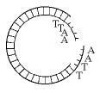

6) The letters on the plasmid above represent regions of single stranded DNA. Which enzyme was used to produce the plasmid shown in the figure above?
A) ligase
B) transcriptase
C) a restriction enzyme
D) RNA polymerase
E) DNA polymerase

7) Which enzyme joins together the phosphate-ribose backbones of two DNA pieces, thereby making the two into one single piece of DNA?
A) Reverse transcriptase
B) Restriction enzyme
C) TAQ DNA polymerase
D) RNA polymerase II
E) Ligase

8) Which of the following is used to make complementary DNA (cDNA) from RNA?
A) restriction enzymes
B) gene cloning
C) DNA ligase
D) gel electrophoresis
E) reverse transcriptase

9) In recombinant DNA methods, the term vector can refer to
A) the enzyme that cuts DNA into restriction fragments.
B) the sticky end of a DNA fragment.
C) a bacteria
D) a plasmid used to transfer DNA into a living cell.
E) a DNA probe used to identify a particular gene.

10) The most common cloning vector is...
A) Bacteria
B) Jelly fish
C) Eukaryotic genomic DNA
D) Plasmids
E) Mice

11) One test tube contains a eukaryotic gene that has "sticky ends" produced by the restriction enzyme EcoRI. In a separate test tube is a plasmid that has also been digested with EcoRI. The plasmid carries two genes conferring antibiotic resistance, one to the antibiotic ampicillin and one to the antibiotic tetracycline. The plasmid has one restriction site for EcoRI and it is located within the tetracycline resistance gene. The eukaryotic DNA and the plasmid DNA are mixed together, and then the mixture is incubated for several hours, exposed to DNA ligase, and then added to bacteria growing in nutrient broth. The bacteria are allowed to grow overnight and are streaked on a plate using a technique that produces isolated colonies that are clones of the original. Samples of these colonies are then grown in four different media: nutrient broth plus ampicillin, nutrient broth plus tetracycline, nutrient broth plus ampicillin and tetracycline, and nutrient broth without antibiotics.

Bacteria that contain "empty" plasmid, (plasmid without the eukaryotic gene) would grow...
A) in the nutrient broth plus ampicillin, but not in the broth containing tetracycline.
B) only in the broth containing both antibiotics.
C) in the broth containing tetracycline, but not in the broth containing ampicillin.
D) in all four types of broth.
E) in the nutrient broth without antibiotics only.

12) One test tube contains a eukaryotic gene that has "sticky ends" produced by the restriction enzyme EcoRI. In a separate test tube is a plasmid that has also been digested with EcoRI. The plasmid carries two genes conferring antibiotic resistance, one to the antibiotic ampicillin and one to the antibiotic tetracycline. The plasmid has one restriction site for EcoRI and it is located within the tetracycline resistance gene. The eukaryotic DNA and the plasmid DNA are mixed together, and then the mixture is incubated for several hours, exposed to DNA ligase, and then added to bacteria growing in nutrient broth. The bacteria are allowed to grow overnight and are streaked on a plate using a technique that produces isolated colonies that are clones of the original. Samples of these colonies are then grown in four different media: nutrient broth plus ampicillin, nutrient broth plus tetracycline, nutrient broth plus ampicillin and tetracycline, and nutrient broth without antibiotics.

Bacteria containing a plasmid into which the eukaryotic gene has been spliced in would grow in...
A) the nutrient broth only.
B) the nutrient broth and the tetracycline broth only.
C) the nutrient broth, the ampicillin broth, and the tetracycline broth.
D) all four types of broth.
E) the ampicillin broth and the nutrient broth without antibiotics.

13) One test tube contains a eukaryotic gene that has "sticky ends" produced by the restriction enzyme EcoRI. In a separate test tube is a plasmid that has also been digested with EcoRI. The plasmid carries two genes conferring antibiotic resistance, one to the antibiotic ampicillin and one to the antibiotic tetracycline. The plasmid has one restriction site for EcoRI and it is located within the tetracycline resistance gene. The eukaryotic DNA and the plasmid DNA are mixed together, and then the mixture is incubated for several hours, exposed to DNA ligase, and then added to bacteria growing in nutrient broth. The bacteria are allowed to grow overnight and are streaked on a plate using a technique that produces isolated colonies that are clones of the original. Samples of these colonies are then grown in four different media: nutrient broth plus ampicillin, nutrient broth plus tetracycline, nutrient broth plus ampicillin and tetracycline, and nutrient broth without antibiotics.

Bacteria that do not take up any plasmids would grow on which media?
A) the nutrient broth without antibiotics only
B) the nutrient broth and the tetracycline broth
C) the nutrient broth and the ampicillin broth
D) the tetracycline broth and the ampicillin broth
E) all three broths

14) A small piece of DNA or RNA, which is usually radioactive, and that is used to locate one’s gene of interest in a cloned DNA library, is known as a...
A) Primer
B) Probe
C) Polymerase
D) Vector
E) Bacteriophage

15) When screening a genomic library for a gene of interest, a molecule called a DNA probe is often used. To work correctly, a DNA probe must...
A) Have the same sequence as the gene of interest
B) Be cloned into the same cloning vector as the gene of interest
C) Be expressed in eukaryotes but not in bacteria
D) Be complementary to the gene of interest
E) Be expressed in bacteria but not in eukaryotes

16) Screening a library means...
A) Keeping the window screens closed in the learning resource center to prevent insects from eating the books
B) Inserting cloned DNA into plasmids
C) Inserting plasmids into bacteria
D) Finding the cloned gene of interest
E) Digesting the genomic DNA with restriction enzymes

17) The numbered steps listed below are all steps for screening a genomic library. But the steps are not listed in their correct order. Which answer lists the steps in the correct order for screening a genomic library?

(1) Hybridizing a nylon filter with a probe for the gene of interest
(2) Laying a nylon filter in a plate of bacteria colonies
(3) Inserting plasmids into bacteria
(4) Exposing photographic film
(5) Aligning dots on the film with bacterial colonies on the plate

A) 1,. 2, 4, 3, 5
B) 2, 4, 5, 1, 3
C) 3, 2, 1, 4, 5
D) 5, 4, 2, 3, 1
E) 4, 5, 1, 2, 3

18) The numbered steps listed below are steps that occur in each cycle of PCR. But the steps are not listed in their correct order. Which answer lists the steps in the correct order for the steps in a PCR cycle?

(1) The primers hybridize to the target DNA.
(2) The double-stranded target DNA denatures.
(3) The temperature of the test tube and its contents becomes 70 degrees C
(4) DNA polymerase extends the primers to make a copy of the target DNA.
(5) The temperature of the test tube and its contents becomes 100 degrees C

A) 2, 1, 4, 5, 3
B) 1, 3, 2, 4, 5
C) 3, 4, 1, 5, 2
D) 5, 2, 3, 1, 4
E) 4, 2, 3, 4, 1

19) The reason for using TAQ DNA polymerase enzyme in PCR (instead of using other types of DNA polymerase enzymes) is that TAQ DNA polymerase enzyme...
A) it is heat resistant.
B) it has a much lower error rate than other DNA polymerases.
C) it binds more readily than other polymerases to primer.
D) it has regions that are complementary to primers.
E) All of these answers are correct.

20) A paleontologist has recovered a single intact cell from the 400-year-old preserved skin of an extinct dodo (a bird). To compare a specific gene of the DNA from the cell with the same gene in living birds, which of the following would be most useful for increasing the amount of that gene from the dodo genomic DNA in the cell?
A) restriction enzyme digestion
B) polymerase chain reaction
C) ligase enzyme
D) gel electrophoresis

21) The segment of DNA shown above has two restriction sites (I and II) for a restriction enzyme. Digestion with the enzyme will create restriction fragments A, B, and C. Which of the agarose gels produced by electrophoresis shown below best represents the correct order and identity of these three fragments? (the + is the positive (red) electrode and the - is the negative (black) electrode).

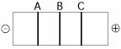

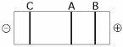

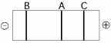

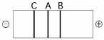

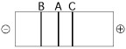

A) Gel 1
B) Gel 2
C) Gel 3
D) Gel 4
E) Gel 5

22) Which of the following modifications is least likely to alter the rate at which a DNA fragment moves through a gel during electrophoresis?
A) altering the nucleotide sequence of the DNA fragment
B) applying more voltage to the gel.
C) increasing the length of the DNA fragment
D) decreasing the length of the DNA fragment
E) neutralizing the negative charges within the DNA fragment

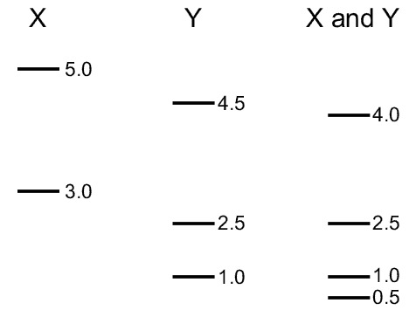

23) A linear piece of viral DNA of 8 kb was cut with two restriction enzymes (X and Y), individually and then with a double digest of both enzymes together. The figure above shows the restriction fragments from each digestion after each digestion was subjected to agarose gel electrophoresis. The size of each fragment is shown in kilobases on the right of each band in the gel.

Of the possible locations of the restriction sites shown below on the linear piece of DNA, which one is most likely?

A)
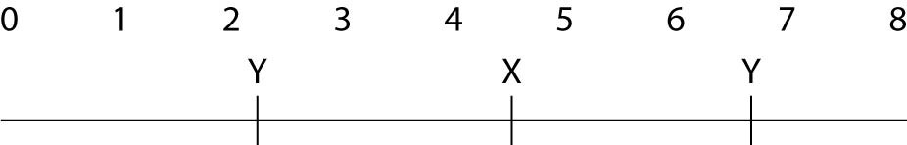

B)

C)
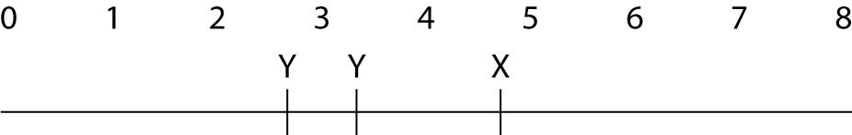

D)

E)
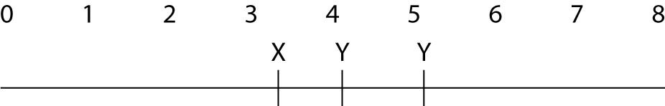

24) What characteristic of short tandem repeat DNA at a VNTR locus makes it useful for DNA fingerprinting?
A) At a given locus, the basic repeated sequence varies (for example, one allele of this locus might have AATA repeated many times, and a different allele at this locus might have ACAC repeated many times).
B) At a given locus, the number of times that the basic sequence repeats varies (for example, one allele of this locus might have AATA repeated 5 times, and a different allele at this locus might have AATA repeated 6 times).
C) No two people can have the same genotype at a given locus.
D) Every racial and ethnic group has inherited different short tandem repeats.

25) Which of the following tools of recombinant DNA technology is incorrectly paired with its use?
A) restriction enzyme is used to cut DNA
B) DNA ligase is used to make a strand of DNA that is complimentary to a template DNA strand
C) DNA polymerase is used for polymerase chain reaction to amplify sections of DNA
D) reverse transcriptase is used for production of cDNA from mRNA
E) electrophoresis is used for separation of DNA fragments

26) At a certain VNTR locus on a chromosome, humans can have 5 - 9 repeats of the sequence TTAAAG. How many possible different alleles are there at this VNTR locus?
A) 4
B) 9
C) 10
D) 6
E) 5

27) At a certain VNTR locus on a chromosome, humans can have 18 - 27 repeats of the sequence GGGGC. How many possible different alleles are there at this VNTR locus?
A) 27
B) 28
C) 10
D) 18
E) 9

28) At a certain VNTR locus there are 5 different alleles. How many genotypes (2 allele combinations) are possible at this VNTR locus?
A) 10
B) 18
C) 36
D) 15

29) At a certain VNTR locus there are 9 different alleles. How many genotypes (2 allele combinations) are possible at this VNTR locus?
A) 9
B) 28
C) 36
D) 45

Answers to review questions:

1) C
2) E
3) B
4) C
5) B
6) C
7) E
8) E
9) D
10) D
11) D
12) E
13) A
14) B
15) D
16) D
17) C
18) D
19) A
20) B
21) B
22) A
23) B
24) B
25) B
26) E
27) C
28) D
29) D

