These review questions are for Bio 1 Cells topic. The questions were adapted from several sources, including the textbook’s review questions.

1) All cells have all of the following except...
A) Plasma membrane
B) Genetic material (chromosome)
C) Cytoplasm
D) Cell wall
E) Ribosomes

2) Eukaryotic cells are more complex than prokaryotic cells. Which of the following is only found in eukaryotic cells?
A) Cell wall
B) Plasma membrane
C) Endoplasmic reticulum
D) Ribosomes

3) Which one of the following is present in a prokaryotic cell?
A) mitochondrion
B) cytoplasm
C) nuclear envelope
D) chloroplast
E) endoplasmic reticulum

4) Which one of the following statements concerning bacteria and archaea cells is correct?
A) Archaea cells contain small membrane-enclosed organelles; bacteria do not.
B) Archaea cells contain a membrane-bound nucleus; bacteria do not.
C) DNA is present in both archaea cells and bacteria cells.
D) DNA is present in the mitochondria of both bacteria and archaea cells.

5) Prokaryotes are classified as belonging to two different domains. What are the domains?
A) Bacteria and Eukarya
B) Bacteria and Archaea
C) Archaea and Protista
D) Bacteria and Protista
E) Bacteria and Fungi

6) Which of the following types of molecules are the major structural components of the cell membrane?
A) phospholipids and cellulose
B) nucleic acids and proteins
C) phospholipids and proteins
D) proteins and cellulose
E) glycoproteins and cholesterol

7) What kind of molecule passes directly through cell membrane most easily?
A) hydrophobic
B) small polar
C) large polar
D) ionic
E) monosaccharides such as glucose

8) Large numbers of ribosomes are present in cells that specialize in producing which of the following molecules?
A) lipids
B) glycogen
C) proteins
D) cellulose
E) nucleic acids

9) Which of the following is not true of a codon?
A) It consists of three nucleotides.
B) It may code for the same amino acid as another codon.
C) It may code for more than one amino acid.
D) It is part of DNA and mRNA molecules.
E) It is the basic unit of the genetic code.

10) The codons that do not specify any amino acid are _______ codons.
A) start
B) unused
C) redundant
D) stop
E) prokaryotic

11) In the genetic code, each codon (other than stop codons)
A) Consists of three bases
B) Specifies a single amino acid
C) Specifies more than one amino acid
D) Consists of three bases and specifies a single amino acid

12) A particular codon in a gene in the DNA is AGT. The corresponding codon as it appears in the mRNA is...
A) UCA
B) AGT
C) GGG
D) TGA
E) AGU

13) A particular codon in a gene in the DNA is AGT. The corresponding anticodon as it appears in the tRNA is...
A) UCA
B) AGT
C) GGG
D) TGA
E) AGU

14) The amino acid phenylalanine can be encoded by the codon UUU or by the codon UUC. A mutant bacterial cell has a defective enzyme that attaches a lysine amino acid to tRNAs with the anticodon AAA instead of the normal phenylalanine amino acid. The consequence of this for the cell will be that
A) none of the proteins in the cell will contain phenylalanine.
B) proteins in the cell will include lysine instead of phenylalanine at amino acid positions specified by the codon UUU.
C) the cell will compensate for the defect by attaching phenylalanine to tRNAs with lysine-specifying anticodons.
D) the ribosome will skip a codon every time a UUU is encountered.
E) none of the options will occur; the cell will recognize the error and destroy itself.

15) The following questions refer to this table of mRNA codons.

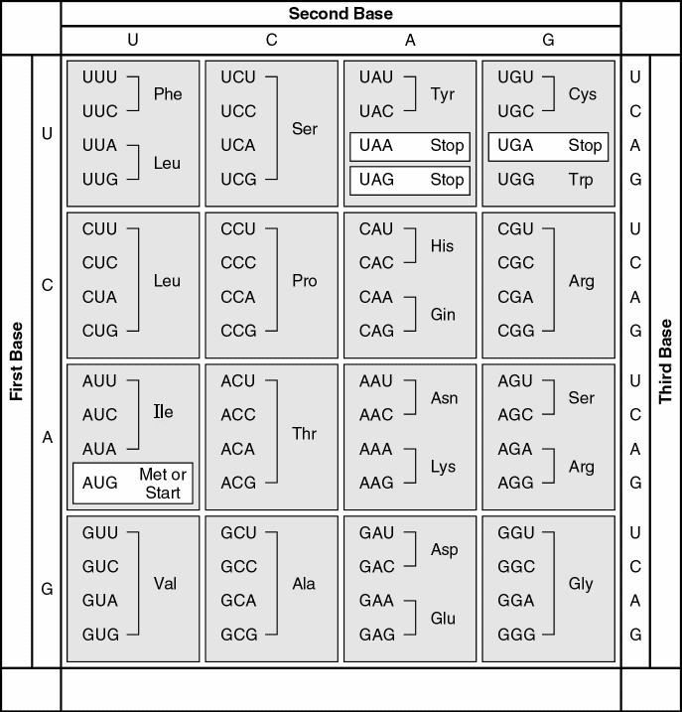

Use the genetic code table above to answer this question: A possible sequence of nucleotides in the DNA that would code for the protein sequence phe-leu-ile-val would be
A) TTG-CTA-CAG-TAG.
B) AAC-GAC-GUC-AUA
C) TTC-TTG-ATT-GTT
D) AAA-AAT-ATA-ACA
E) AAA-GAA-TAA-CAA

16) Use the genetic code table above to answer this question: What amino acid sequence will be generated, based on the following mRNA codon sequence?
AUG-UCU-UCG-UUA-UCC-UUG
A) met-arg-glu-arg-glu-arg
B) met-glu-arg-arg-glu-leu
C) met-ser-leu-ser-leu-ser
D) met-ser-ser-leu-ser-leu
E) met-leu-phe-arg-glu-glu

17) Use the genetic code table above to answer this question: A peptide has the sequence phe-pro-lys-gly-phe-pro. Which of the following sequences in the DNA could code for this peptide?
A) UUU-CCC-AAA-GGG-UUU-CCC
B) AUG-AAA-GGG-TTT-CCC-AAA-GGG
C) TTT-CCC-AAA-GGG-TTT-CCC
D) GGG-AAA-TTT-AAA-CCC-ACT-GGG
E) ACT-TAC-CAT-AAA-CAT-TAC-UGA

18) The anticodon of a particular tRNA molecule
A) is complementary to part of the mRNA.
B) is complementary to part of the ribosome.
C) is the part of tRNA that bonds to a specific amino acid.
D) binds to the gene in the DNA.
E) can destroy the corresponding codon in a gene.

19) Which component is not directly involved in translation?
A) mRNA
B) DNA
C) tRNA
D) ribosomes
E) amino acids

20) A cell with many ribosomes floating freely in the cytoplasm but very few ribosomes attached to the rough endoplasmic reticulum is most likely a cell…
A) producing primarily proteins for secretion.
B) producing primarily cytoplasmic proteins.
C) constructing an extensive cell wall or extracellular matrix.
D) digesting large food particles.
E) enlarging its vacuole.

21) The smooth endoplasmic reticulum is
A) Where the ribosomes makes proteins from amino acids
B) A site of protein degradation
C) Where lipids are made
D) Where ATP is made
E) Where food vacuoles are digested

22) Which structure is the site where proteins that may be exported from the cell are made?
A) rough ER
B) lysosomes
C) plasmodesmata
D) Golgi vesicles
E) free cytoplasmic ribosomes

23) The liver is involved in detoxification of many poisons and drugs. Which of the following structures is primarily involved in this process and therefore abundant in liver cells?
A) rough ER
B) smooth ER
C) Golgi apparatus
D) nuclear envelope
E) transport vesicles

24) The fact that the outer membrane of the nuclear membrane has bound ribosomes allows one to most reliably conclude that
A) at least some of the proteins that function in the nuclear envelope are made by the ribosomes on the nuclear envelope.
B) the nuclear envelope is not part of the endomembrane system.
C) the nuclear envelope is physically separated from the endoplasmic reticulum.
D) small vesicles from the Golgi fuse with the nuclear envelope.

25) Eukaryotic cells have an organelle which contains digestive enzymes and acids, which are used to digest food molecules that enter the cell. Which of the following organelles contains these digestive enzymes and acids?
A) chloroplast
B) lysosome
C) central vacuole
D) golgi apparatus
E) vesicle

26) Proteins that are exported out of the cell are made by ribosomes in which part of a eukaryotic cell?
A) mitochondria
B) cytoplasm
C) nuclear envelope
D) Golgi apparatus
E) rough ER

27) Which answer below gives the pathway in the correct order of a newly made protein? (In the answers, SER = Smooth endoplasmic reticulum and RER = Rough endoplasmic reticulum).
A) SER, RER, transport vesicle, Golgi
B) RER, lysosome, Golgi, SER
C) RER, SER, transport vesicle, Golgi
D) Golgi, Transport vesicle, RER, final destination
E) Golgi, Transport vesicle, SER, final destination

28) In endocytosis, molecules from outside the cell are brought into the cell. Where exactly do these molecules end up immediately after endocytosis?
A) on the outside of vesicles
B) on the inside surface of the cell membrane
C) on the inside of vesicles
D) on the outer surface of the nucleus
E) on the ER

29) A food vacuole taken into a cell by endocytosis will be digested by acids and enzymes contained in
A) peroxisomes.
B) lysosomes.
C) Golgi vesicles.
D) vacuoles.
E) secretory vesicles.

30) Which of the following organelles uses oxygen and enzymes to break down fats?
A) lysosome
B) vacuole
C) mitochondrion
D) Golgi apparatus
E) peroxisome

31) Which organelle often takes up most of the volume of a plant cell?
A) lysosome
B) vacuole
C) mitochondrion
D) Golgi apparatus
E) peroxisome

32) Which organelle is the primary site of ATP synthesis in eukaryotic cells?
A) lysosome
B) vacuole
C) mitochondrion
D) Golgi apparatus
E) peroxisome

33) Why isn't the mitochondrion classified as part of the endomembrane system?
A) It is a static structure.
B) Its lipids and proteins do not come from the ER or Golgi.
C) It has too many vesicles.
D) It is not involved in protein synthesis.
E) It is not attached to the outer nuclear envelope.

34) Cyanide binds with at least one molecule involved in producing ATP. If a cell is exposed to cyanide, most of the cyanide will be found within the
A) mitochondria.
B) ribosomes.
C) peroxisomes.
D) lysosomes.
E) endoplasmic reticulum.

35) Which two organelles contain their own DNA and ribosomes?
A) chloroplast and central vacuole
B) central vacuole and mitochondrion
C) mitochondrion and chloroplast
D) Golgi apparatus and peroxysome
E) peroxisome and chloroplast

36) In a plant cell, DNA may be found
A) only in the nucleus.
B) only in the nucleus and mitochondria.
C) only in the nucleus and chloroplasts.
D) in the nucleus, mitochondria, and chloroplasts.
E) in the nucleus, mitochondria, chloroplasts, and peroxisomes.

37) What types of proteins are not synthesized in the rough ER?
A) endoplasmic reticulum proteins
B) lysosome proteins
C) secreted proteins
D) mitochondrial proteins
E) plasma membrane proteins

38) Which structure is not part of the endomembrane system?
A) nuclear envelope
B) chloroplast
C) Golgi apparatus
D) plasma membrane
E) ER

39) Which structure is found in plant and animal cells?
A) chloroplast
B) wall made of cellulose
C) central vacuole
D) mitochondrion

40) A cell has the following molecules and structures: enzymes, DNA, ribosomes, plasma membrane, and mitochondria. It could be a cell from
A) only a bacterium.
B) an animal, but not a plant.
C) any eukaryotic organism.
D) only multicellular organism, like a plant or an animal.
E) any kind of organism.

41) Which type of organelle is found in plant cells but not in animal cells?
A) ribosomes
B) mitochondria
C) nuclei
D) chloroplasts
E) none of these

42) Moving vesicles within the cell move along "railroad tracks" which are...
A) microtubules
B) actin filaments and microtubules
C) actin filaments and ribosomes
D) centrioles and motor proteins
E) actin filaments and motor proteins

43) Cells require which two structures to form cilia or flagella?
A) basal body and vacuoles
B) vacuoles and lysosomes
C) lysosomes and microtubules
D) microtubules and basal bodies
E) secretory vesicles and microtubules

44) Which structure-function pair is mismatched?
A) vesicle; protein transport
B) lysosome; intracellular digestion
C) ribosome; protein synthesis
D) Golgi; protein sorting
E) microtubule; ATP production

45) When a potassium ion (K+) moves from the soil into the vacuole of a cell on the surface of a root, it must pass through several cellular structures. Which of the following correctly describes the order in which these structures will be encountered by the ion?
A) plasma membrane -> cell wall -> cytoplasm -> vacuole
B) plasma membrane -> cell wall -> vacuole
C) cell wall -> plasma membrane -> cytoplasm-> vacuole
D) cell wall -> plasma membrane -> golgi apparatus -> cytoplasm -> vacuole

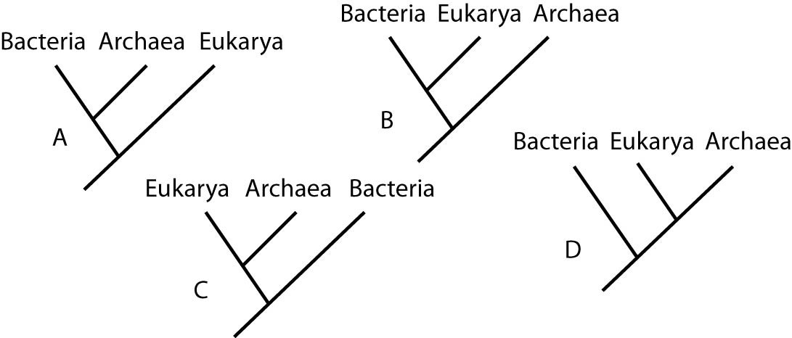
46) Which of the trees in the figure above groups the domains of life according to similarities in cellular size and internal structures?
A) A
B) B
C) C
D) D

47) Anticodons are found on which type of RNA?
A) snRNPs
B) mRNA
C) tRNA
D) Ribosomal RNA
E) miRNA

48) The amino acids Phe and Leu can both be encoded by more than one codon. tRNAs with the anticodon AAA normally carry Phe amino acid. Suppose that a mutation alters the formation of the tRNAs that have the anticodon AAA such that the tRNA now carries the amino acid Leu instead of the amino acid Phe. What will be the result?
A) In all proteins, the amino acid Phe will be found wherever Leu is normally found.
B) In all proteins, the amino acid Leu will be found wherever Phe is normally found.
C) In all proteins, the amino acid Phe may be found wherever Leu is normally found, but some Leu locations in proteins may still have Leu amino acid.
D) In all proteins, the amino acid Leu may be found wherever Phe is normally found, but some Phe locations in proteins may still have Phe amino acid.
E) The mutated tRNA will not be able to bind to the mRNA.

49) Which of the following types of mutation, resulting in an error in the mRNA just after the AUG start of translation, is likely to have the most serious effect on the function of the protein product?
A) a deletion of a codon
B) a deletion of two nucleotides
C) a substitution of the third nucleotide in an ACC codon
D) a substitution of the first nucleotide of a GGG codon
E) an insertion of an extra codon

Answers to multiple choice questions:

1) D
2) C
3) B
4) C
5) B
6) C
7) A
8) C
9) C
10) D
11) D
12) E
13) A
14) B
15) C
16) D
17) C
18) A
19) B
20) B
21) C
22) A
23) B
24) A
25) B
26) E
27) C
28) C
29) B
30) E
31) B
32) C
33) B
34) A
35) C
36) D
37) D
38) B
39) D
40) C
41) D
42) A
43) D
44) E
45) C
46) A
47) C
48) D
49) B

