These review questions are for the Bio 1 carbon chemistry topic. These questions were adapted from several sources, including the textbook’s review questions.

Multiple choice review questions:

1) The element present in all organic molecules is
A) hydrogen.
B) oxygen.
C) carbon.
D) nitrogen.
E) phosphorus.

2) Organic chemistry is defined as
A) the study of compounds made only by living cells.
B) the study of carbon compounds.
C) the study of vital forces.
D) the study of natural (as opposed to synthetic) compounds.
E) the study of hydrocarbons.

3) A carbon atom is most likely to form what kind of bond(s) with hydrogen atoms?
A) ionic
B) hydrogen
C) polar covalent
D) non-polar covalent
E) ionic bonds, covalent bonds, and hydrogen bonds

4) An organic molecule contains hydroxyl groups as its predominant functional group. Which of the following statements is true concerning this molecule?
A) It can substitute for water in normal cellular metabolic reactions.
B) It should dissolve in water.
C) It should dissolve in a nonpolar solvent.
D) It won't form hydrogen bonds with water.
E) It is hydrophobic.

5) Which of the following is a false statement concerning amino groups?
A) They are basic in pH.
B) They can be ionic.
C) They contain nitrogen.
D) They are nonpolar.
E) The absorb H⁺ ions.

6) Which chemical group is most likely to be responsible for an organic molecule behaving as a base?
A) hydroxyl
B) carbonyl
C) carboxylic acid
D) amine

7) Which two functional groups are always found in amino acids?
A) hydroxyl and amine
B) carboxylic acid and amine
C) carboxylic acid and hydroxyl
D) amine and amine
E) hydroxyl and carboxylic acid

8) Amino acids are acids because they always possess which functional group?
A) amino
B) carbonyl
C) carboxylic acid
D) phosphate
E) hydroxyl

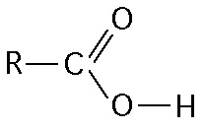
9) What is the name of the entire functional group shown in the figure above?
A) phosphate
B) amine
C) carboxylic acid
D) hydroxyl

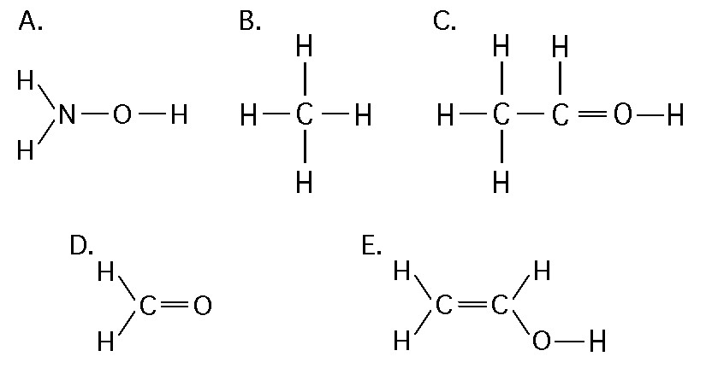

10) Which of the structures illustrated above contain a hydroxyl functional group?
A) A
B) C and D
C) C
D) D
E) C and E
F) E

11) Which functional group can dissociate and add H+ into a solution?
A) phosphate
B) amine
C) carboxylic acid
D) hydroxyl

12) Which functional group can accept H+ and become positively charged?
A) phosphate
B) amine
C) carboxylic acid
D) hydroxyl

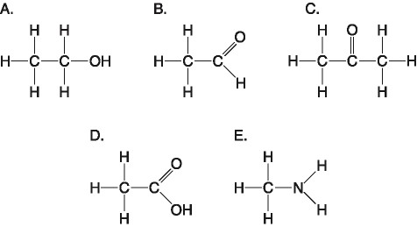

13) Which molecule shown above contains a carboxyl group?
A) A
B) B
C) C
D) D
E) E

14) Which molecule shown above can increase the concentration of hydrogen ions in a solution and is therefore an organic acid?
A) A
B) B
C) C
D) D
E) E

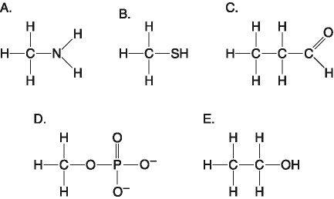

15) Which molecule shown above contains an amine functional group?
A) A
B) B
C) C
D) D
E) E

16) Which molecule shown above can function as a base?
A) A
B) B
C) C
D) D
E) E

17) Which functional group is not present in the molecules shown above?
A) carboxylic acid
B) phosphate
C) hydroxyl
D) amino

18) Molecules with which functional groups may form polymers via dehydration reactions?
A) hydroxyl groups
B) carbonyl groups
C) carboxyl groups
D) either carbonyl or carboxyl groups
E) either hydroxyl or carboxyl groups

19) In animal metabolism, food macromolecules are metabolized to provide energy. This type of metabolism involves breaking apart large polymer molecules into smaller monomers. Only a small portion of these monomers are used for synthesis of new macromolecules. The net result is that
A) water is generated by animal metabolism.
B) water is consumed by animal metabolism.
C) the water consumed is exactly balanced by the water generated, to maintain homeostasis.
D) water is generated only during periods of growth.
E) water is consumed only during periods of growth.

20) When two monomers become linked to form a polymer, which answer below best describes how the monomers become linked together?
A) A new covalent bond forms between a carbon atom on one monomer and a carbon atom on the other
monomer (a new C-C bond)
B) By the removal of an –OH from one monomer and a hydrogen atom from the other monomer
(dehydration synthesis)
C) By the addition of an –OH to one monomer and a hydrogen atom to the other monomer (hydrolysis)
D) Through hydrogen bonding between the monomers
E) By hydrophobic interaction between the two monomers

21) How many molecules of water are needed to completely hydrolyze a polymer that is 11 monomers long?
A) 12
B) 11
C) 10
D) 9
E) 8

Answers to multiple choice questions:

1) C
2) B
3) D
4) B
5) D
6) D
7) B
8) C
9) C
10) E
11) C
12) B
13) D
14) D
15) A
16) A
17) A
18) E
19) B
20) B
21) C

